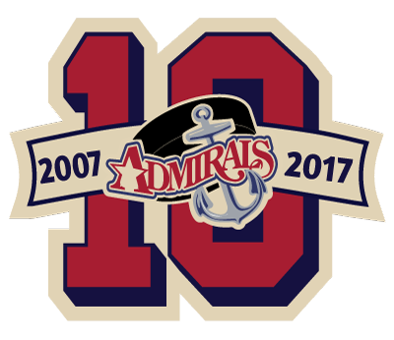 | Admirals Picture Days  Team Schedule 2017-2018
US 8 Selects | Tuesday 11/14/17 4:30 PM
10U NIHL AA Powers | Tuesday 11/14/17 5:30 PM
10U NIHL A1 Rack | Tuesday 11/14/17 5:30 PM
10U NWHL Red Tomasek | Thursday 11/16/17 5:20 PM
12U NIHL AA Moravick | Tuesday 11/14/17 7:00 PM
12U NIHL A1 Islieb | Tuesday 11/14/17 7:00 PM
12U NIHL A2 Galvin | Tuesday 11/14/17 6:20 PM
12U NIHL A3 Cebulski | Tuesday 11/14/17 6:20 PM
12U NWHL Red Matker | TBD
12U NWHL White Gonzalez | TBD
14U NIHL AA Benton | Tuesday 11/14/17 7:40 PM
14U NIHL A1 Rohde | Tuesday 11/14/17 7:40 PM
14U NIHL A2 McLaughlin | Tuesday 11/14/17 8:20 PM
14U NWHL Red Augustyn | TBD
14U NWHL White Nemec | TBD
Girls U10 Brogan | Thursday 11/16/17 5:20 PM
Girls U14 Webb | Thursday 11/16/17 6:30 PM
Girls U16 Schoner | Thursday 11/16/17 6:30 PM
Girls U19 Schoner | Thursday 11/16/17 6:30 PM

