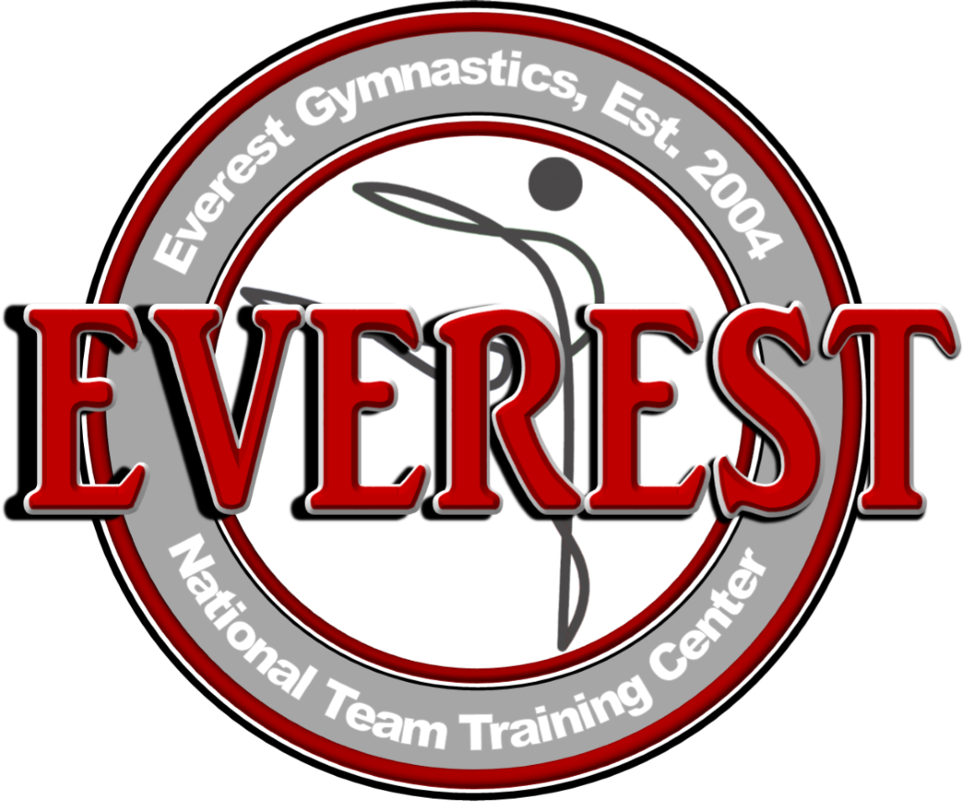
For more information, contact:
Anna Roesler
anna@mckeemanpr.com
919.703.7771

LOCAL GYMNASTS COMPETE AND PLACE IN
12th ANNUAL EVEREST CHALLENGE CUP

HUNTERSVILLE, N.C., October 25, 2017 – Everest Gymnastics recently hosted the 12th Annual Everest Challenge Cup this past weekend at their training center in Huntersville. This year, gymnasts in USAG Levels 2-5 from all over the Carolinas attended and performed their routines on the vault, bars, beam and floor.

“It’s a true privilege to see old and new faces competing and growing in their skill level each and every year,” said Qi Han, owner and coach at Everest Gymnastics. “We are very proud of our gymnasts and want to thank each gym that was a part of the weekend celebrations.”

Each individual gymnast competed within a USA Gymnastics (USAG) Level, indicating the competitor’s skill. Along with the individual achievements of the local Everest gymnasts, all four Everest teams, representing each level, placed in the top three gymnastics teams for that level. The Level 5 Everest Team placed first in their level, the Level 4 Everest Team placed first in their level, the Level 3 Everest Team placed second in their level and the Level 2 Everest Team placed third in their level.

Other gyms that competed include: First in Flight Gymnastics in Gastonia, NC; Sonshine Gymnastics in Holly Springs, NC; Spartanburg Gymnastics Training Center in Roebuck, SC; Enso Elite in Huntersville, NC; and Shooting Stars Gymnastics in Hickory, NC.

About Everest Gymnastics

Qi Han and Yiwen Chen opened Everest Gymnastics Training Center, Inc. in 2004. Named after the highest mountain in the world, Everest hopes to share that there is no mountain you can’t conquer with heart, hard work and dedication. As of 2015, Everest Gymnastics Training Center is the only U.S. National Team Training Facility in North Carolina. It hosts a variety of programs including recreational gymnastics, competitive teams, trampoline and tumbling, afterschool programs and even skill clinics. For more information visit Everest-gym.com.

Please see the names of all Everest gymnasts and their hometowns listed here:

Gymnast | Hometown
USA Gymnastics Level 2 Team
Kaprice Selland | Charlotte
Sophia Arrowood | Forest City
Lucy Cole | Huntersville
Maya McKay | Charlotte
Maliyah Simmons | Charlotte
Jenna Melin | Huntersville
Olivia Barnes | Cornelius
USA Gymnastics Level 3 Team
Emmy Cunningham | Davidson
Anneliese Lynn | Huntersville
Anna Miller | Charlotte
Maddie Smithey | Huntersville
Katherine Jones | Davidson
Olivia Hale | Huntersville
Aubri McDonald | Huntersville
USA Gymnastics Level 4 Team
Evelyn Fickes | Davidson
Kylie Ryan | Huntersville
Sydney Baldwin | Cornelius
Ryleigh McCoy | High Point
Isabella Rockel | Harrisburg
Josephine Ferrari | Cornelius
Tessa Sims | Huntersville
Chloe Owenby | Stanley
Mackenzie Showers | Huntersville
Logan Stump | Harrisburg
Reagan Melin | Huntersville
USA Gymnastics Level 5 Team
Emma Ivey | Huntersville
Maya Bradley | Cornelius
Sarah Savisky | Cornelius
Leya Headen | Charlotte
AaRena Byrd | Charlotte
Madelyn Demarest-Rice | Cornelius

###

