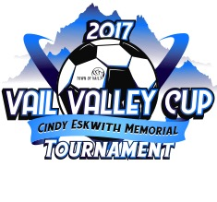
Vail Valley Cup 2017 Important Information

Please visit www.vailsoccer.com for Rules of Play, Guest Player Form and other various information that might be of use to you.

Vail Cup Check in

When: Friday, October 6, 5-9 pm
Where: Lionshead Welcome Center 395 E. Lionshead Circle, Vail, CO.
- Bottom Level of the Lionshead Parking Structure.
(*if you are playing a Friday night game you will check in at your game location)

ALL VVSC Teams will need to check in THIS WEDNESDAY at PROSIT!
Check in will be from 5:30 pm – 7:30 pm. Team manager or Coach can do this.
- Please email director@vailsoccer.com if you can’t make it.

ADDRESS: 82 East Beaver Creek Blvd., Avon, CO 81620

What to Bring to Registration
- All player passes/cards including guest players
- Medical release form for each player including guest players
- 2 officially signed copies of your roster
- 2 copies of guest player form (if you are using these for guest players)

Guest Player Rules Reminder
- You are allowed up to 5 total guest players. The lending coach must sign the guest player form. (Bring these to registration).

Trainers

There will be trainers available in two locations throughout the tournament. There will be an AED available at all locations as well.

- Freedom Park, Edwards
- Homestake Peak, Eagle-Vail
- Eagle Fairgrounds, Eagle
- Ford Park, Vail

If you have an athlete that would like an ankle wrapped they must provide their own materials such as pre-wrap and tape.

Field Locations (**NO dogs allowed at any of the FIELD locations during the event)
Please pay attention to SPECIAL parking information that might pertain to the fields your team will be playing on. PLEASE pass this information on to all Parents/Spectators.

Link to all Playing Fields:

http://www.gotsport.com/asp/directors/tournament/fields.asp?

SPECIAL INFORMATION ON PARKING

- Parking Freedom Park
- No Parking in ECO bus area
- You can park at Coloraado Mtn. College Lot
- You can park at Battle Mtn. High School staff parking lot that is East of the school and directly across from the Freedom Park playing fields
- NO RV’s can be parked at Freedom park
- NO dogs (service dogs with proper credentials are allowed)

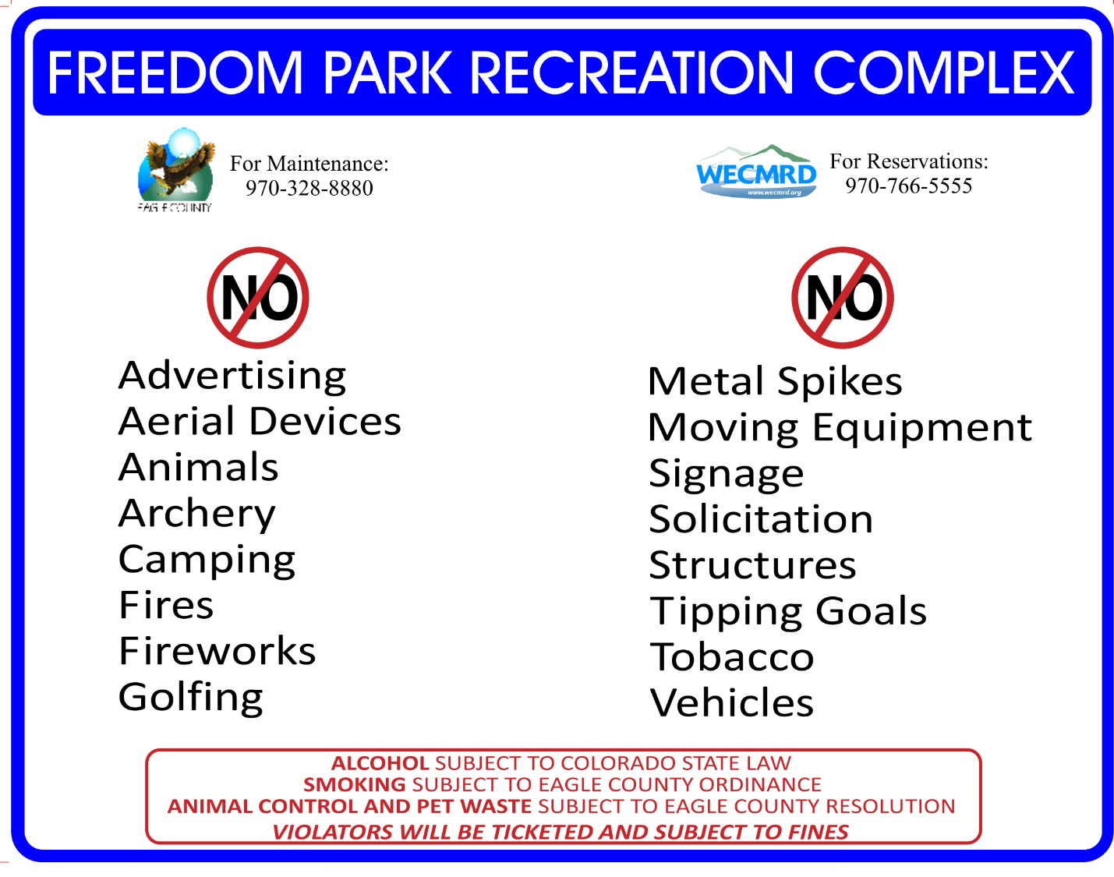

During the tournament there will be a “FINE DESIGNS” kiosk set up at most locations for official tournament apparel purchases. If there is not a kiosk at your field then there will be one at a field close by.

