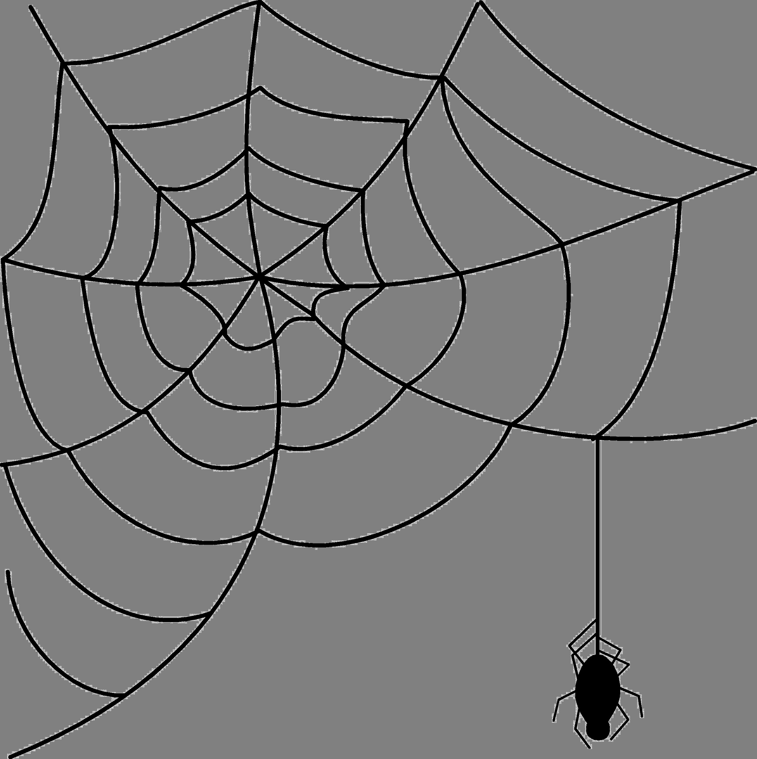
What’s Up
October 2017?
President’s Message
A parable is told about a pencil-maker who was preparing to put an important pencil in a box. Before doing so, though, he took the pencil aside. “There are five things you need to know,” he said. “If you can remember these five things, you will become the best pencil you can be.”
You will be able to do many great things, but only if you allow yourself to in someone else’s hand.
- You will be able to do many great things.
- Sharpening is painful, but it is critical if you want to write sharply.
- Since you have an eraser, you can correct most mistakes you make, though some may be harder to erase than others.
- Remember, it’s what’s inside that’s most important.
- Whatever surface you are on, make sure you leave your mark. No matter how hard, rough, or easy, you must continue to write. (More pages 4-5)

HALLOWEEN GAMES
Check out our October Facebook posts- they will have many great Halloween themed games, just like the ones below!
HALLOWEEN BOWLING
http://www.ciraontario.com/halloweenbowling
Equipment: 2L plastic bottles (filled with a little water), small pumpkins
Objective: Knock down bowling pins with a pumpkin
How to Play:
- Set up the bottles as bowling pins
- Players roll the pumpkins and see how many bottles they can knock over on each roll
- Award points to the players who can knock over the most pins
JACK-O-LANTERN *This game is for 2-4 players ages 6+
http://www.ciraontario.com/jackolantern
Equipment: a piece of paper, a pencil and one die
Objective: Complete a drawing of a jack-o-lantern before the other players do
How to Play:
- Players roll the die to see who starts
- The player with the highest number goes first
- You must roll the exact number to draw each item
- Each item must be drawn in order
- If you cannot draw what you have rolled, the turn passes to the next player
Rolls:
- a One = Draw a circle for a pumpkin
- a TWO = Draw a Stem
- a THREE = Draw one Eye
- a FOUR = Draw the other Eye
- a FIVE = Draw the nose
- a SIX = Draw the Mouth
Variation: For older players, carve the pumpkin instead of drawing

Looking for a Workshop Leader?
CIRA Ontario provides workshop leaders for TGfU, Leadership,
Active Recess, DPA, etc.
Each year CIRA Ontario leads over 100 workshops and we would love to lead a workshop for you! We could lead a workshop for a group of schools at a conference, professional development day, or any other time and place.
The bottom line is to help all kids enjoy fun active participation and help teachers simplify this process- our resources will do just this!
For more information, visit: http://www.ciraontario.com/workshops
To discuss your event, please email Anna Bishop at ciraontario@gmail.com or by phone at (905) 648-2226

Workshops done in partnership with:

Leadership: It's what you make of it
This post is adapted from "Becoming the New Boss," a new leadership book by Naphtali Hoff, PsyD, (@impactfulcoach). He became an executive coach and organizational consultant following a career as an educator and school administrator. Read his blog at impactfulcoaching.com/blog.
Leadership is the ability to not only understand and utilize your innate talents, but to also effectively leverage the natural strengths of your team to accomplish the mission. There is no one-size-fits-all approach, answer key or formula to leadership. Leadership should be the humble, authentic expression of your unique personality in pursuit of bettering whatever environment you are in. – Katie Christy, founder, Activate Your Talent
This parable shares powerful lessons for every leader:
- Be humble. You can achieve greatness, but not when you go it alone. Allow yourself to be taught and coached by others and identify the strengths of those around you to help advance the cause.
- Stay sharp. Strong leaders find ways to keep learning and sharpening their skills. Feedback can be painful at times, but without it, you will become dull.
- Accept mistakes. We all err. Though mistakes may make for challenging moments, they are ultimately part of a process of becoming a better leader. Embrace your mistakes as opportunities to learn, erase, and become better! As John Maxwell once said, “A good leader is a person who takes a little more than his share of the blame and a little less than his share of the credit.”
- Your best is what’s inside you. You may be good-looking, dress well, and have a great personality. But what makes you who you are and the person with whom others want to connect is your character. Seek to continually grow and refine your character so that you can lead and serve with utmost integrity.
- Stick with it. There will be times when you think that you’re making no imprint and that your actions are not having an effect. But people will still depend on you, so you need to keep on going. Hold to your vision and your dreams, even when it seems they have dimmed.
I have attempted to offer guidance to you, the new leader, as you assume your leadership position. By now, one thing should be clear: Leadership is not easy. It takes much effort to position yourself to achieve a leadership post, and perhaps, even more, work to build a sustainable leadership platform.
But it is doable. And the world needs you.
In a 1913 address to students at Swarthmore College, Woodrow Wilson said, “You are not here merely to make a living. You are here to enable the world to live more amply, with greater vision, with a finer spirit of hope and achievement. You are here to enrich the world, and you impoverish yourself if you forget the errand.”
The fact that you have been promoted into leadership means that you have the tools and energy to make it happen. Things will get in your way, but if you continue to believe in yourself, you can become the leader that everyone around you hopes that you will be.
Leadership blogger and Minister Brian Dodd summarized the roles and opportunities of a leader as follows:
- Leaders provide vision and offer direction.
- Leaders believe in others and give them confidence.
- Leaders stretch others’ thinking and make them look at things differently.
- Leaders sharpen others’ skills and help them become better at what they do.
- Leaders support others and provide what is needed to be successful.
- Leaders make hard decisions. They pay the price so others don’t have to.
- Leaders take the bullets and bear responsibility.
- Leaders create experiences that help others see things in a new and different light.
- Leaders raise others’ self-image and make them feel better about themselves.
These are many of the opportunities that leaders have each day to impact those around them.

With thanks to a friend for sharing the above. John B.

OASPHE and CIRA Ontario Conference, 2018

Register at:
http://www.ciraontario.com/conference

