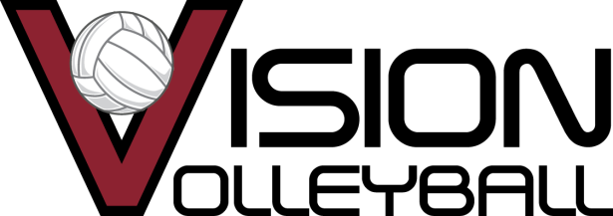

2018 Vision Club Volleyball Season Tryout Dates & Informational Meetings
Informational Meetings
September 19th 6pm @ Mt. Vernon Middle School
September 24th 5pm @ Vision
October 4th 7pm @ Vision
October 15th noon @ Vision
8-11U Tryouts 12U Tryouts 13U Tryouts
October 28 9-11:30AM October 22 11:30-2pm October 22 2:30-5
October 29 10:30-12:30 October 24 5:30-7:30pm October 24 5:30-7:30pm
*includes ages 8, 9, 10, 11 October 28 12-2pm October 26 5:30-7:30pm
October 29 1-3pm October 29 3:30-5:30

14U Tryouts 15U Tryouts
October 22 5:30-8pm November 5 10:30-1pm
October 23 5:30-7:30pm November 7 5:30-7:30pm
October 25 5:30-7:30pm November 8 5:30-7pm
October 26 5:30-7:30pm November 11 10-noon

16U Tryouts 17U/18U Tryouts
November 5 1-3:30pm November 5 3:30-6pm
November 6 7:30-9pm November 6 5:30-7:30
November 8 7-9pm November 7 7:30-9pm
November 9 7:30-9pm November 9 6-7:30pm

Vision Volleyball Club is located on 96th Street off I-69 right behind the Home Depot.
9325 Uptown Dr. Indianapolis, IN 46256. Email: info@visionvb.com Phone: 317-436-7456
What age does my daughter tryout for?
How old will she be on Sept. 1st, 2018? This is the age she will tryout for this fall.

