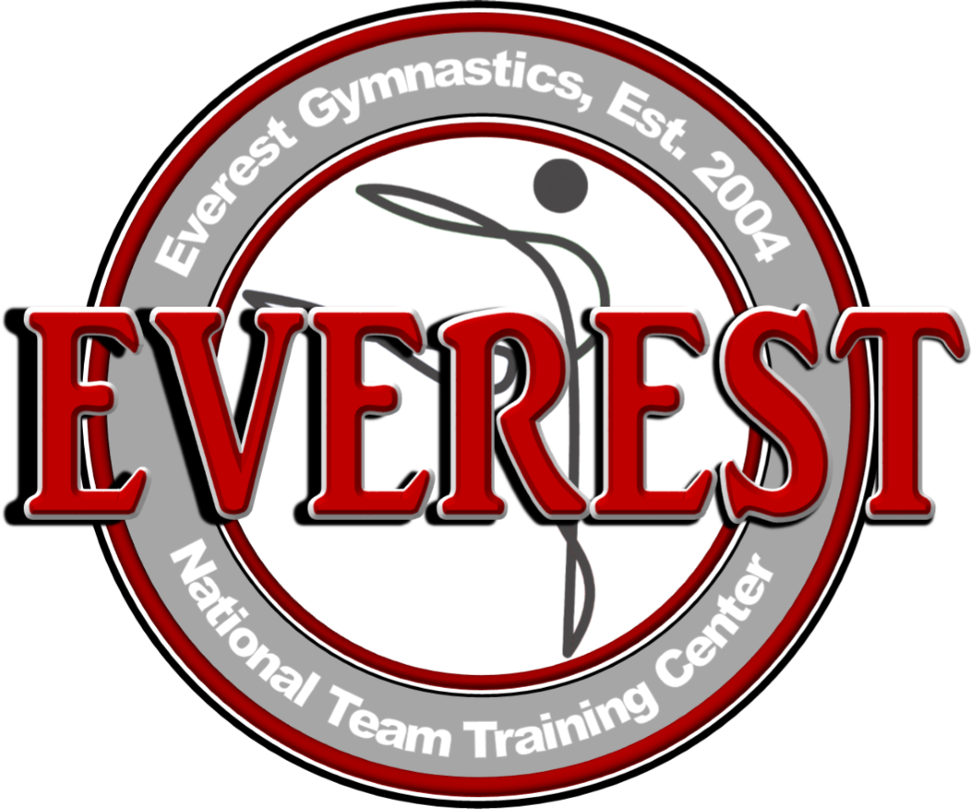
For more information, contact:
Leah Galloway
Leah@mckeemanpr.com
704.618.3648

THREE LOCAL GYMNASTS COMPETE IN P&G NATIONAL CHAMPIONSHIP

HUNTERSVILLE, N.C. – August 24, 2017 – Each year, America’s top gymnasts are chosen to compete at the P&G Championship for national titles and berths on the U.S. National Team. This year, three Everest Gymnastics gymnasts were chosen to represent North Carolina and compete with 54 others in the competition that took place this past weekend in Anaheim, California. Ashton Locklear, 19 of Hamlet, N.C., Marissa Oakley, 18 of Huntersville, N.C. and Lauren Little, 13 of Mooresville, N.C. competed in the Junior and Senior competitions, taking home 2nd and 3rd place on bars.

Senior International Elite Gymnast, Ashton Locklear, who’s practiced gymnastics for 18 years, placed second on the Senior Competition uneven bars and tenth on the beam. She was also named to the 2017 U.S. National Team, an honor she has received for four straight years. Locklear represented the U.S. during the 2016 Olympic Games in Rio.
Marissa Oakley, who’s practiced gymnastics for 14 years, tied for third on the Senior Competition uneven bars and attends the University of Georgia. Lauren Little, who’s practiced gymnastics for 12 years, finished sixteenth in the Junior competition overall.
All three girls train with Qi Han and Yiwen Chen, head coaches and owners of Everest Gymnastics Training Center.
“What a tremendous honor it is to have three of our own Everest gymnasts compete in the P&G Gymnastics Championship,” said Qi Han. “They’ve worked hard to have this opportunity and we’re very proud of their results.”

About Everest Gymnastics

Qi Han and Yiwen Chen opened Everest Gymnastics Training Center, Inc. in 2004. Named after the highest mountain in the world, Everest hopes to share that there is no mountain you can’t conquer with heart, hard work and dedication. As of 2015, Everest Gymnastics Training Center is the only U.S. National Team Training Facility in North Carolina. It hosts a variety of programs including recreational gymnastics, competitive teams, trampoline and tumbling, afterschool programs and even skill clinics. For more information visit Everest-gym.com.

###

