What’s Up
September 2017?
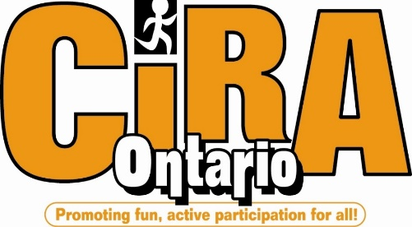
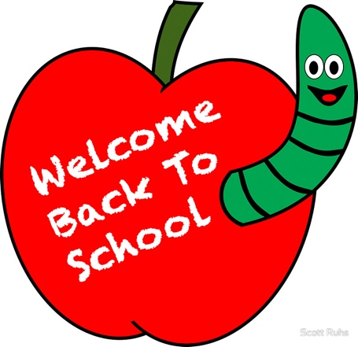

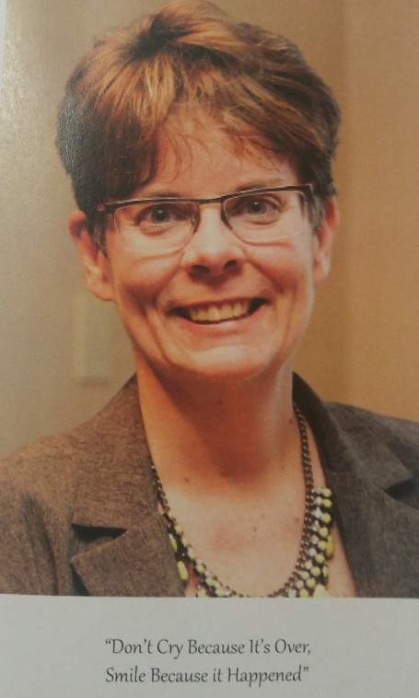

President’s Message
Life is about beginnings and endings. This week school begins with all of the excitement and anxiety that comes along with that. Here is to hoping you have a great year and hoping you have an amazing intramural program to bless your students with.
Life also has endings and we wish to remember Glenn and Kasey as they (and we) mourn the loss of Michelle Harkness. Michelle was CIRA Ontario President from 1990-1992 and a part-time employee as Executive Assistant from 1993-2003.

UPCOMING NEWS
Ontario Physical Literacy Summit #OPLS2017
Don’t miss out- register now and join us there!
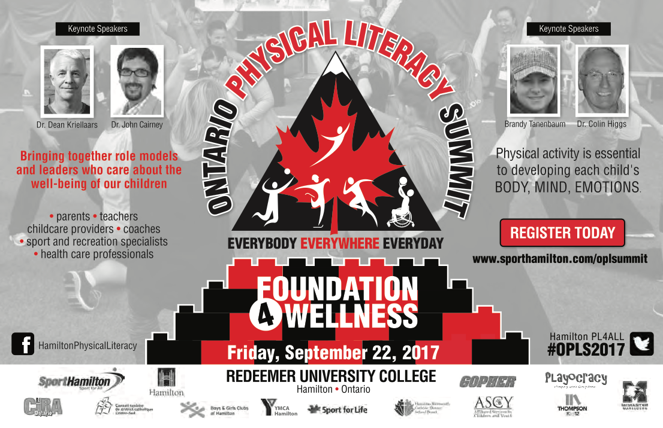
More Conferences
Conference Season is upon us and CIRA Ontario will be presenting workshops at many Conferences—See you there!
For a list of dates and conference locations, visit: http://www.ciraontario.com/page/show/1146920-calendar

OASPHE and CIRA Ontario Conference, 2018
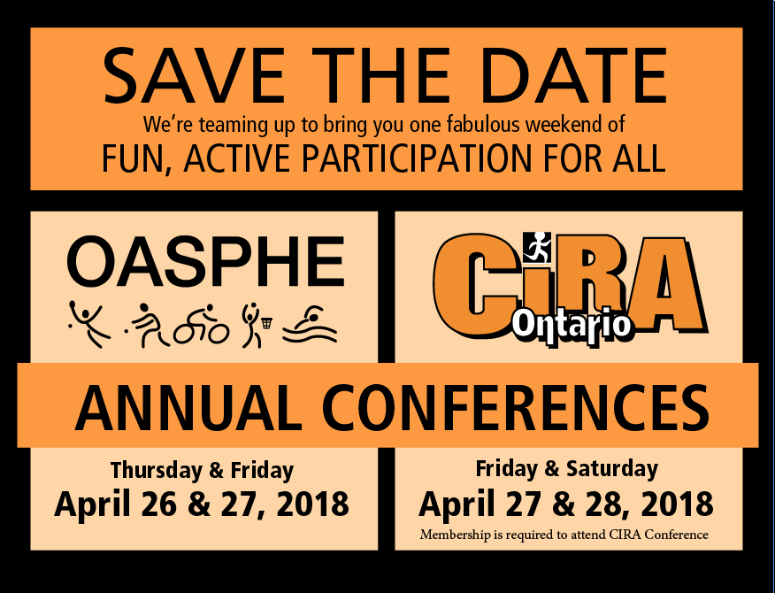

Register at:
http://www.ciraontario.com/conference

New CIRA Ontario Games APP
- We are excited to announce that we will be launching a Games App Launch in September!

Back to School Games
Start your school year off strong by playing some
of these great games below!
Games for Class Organization
http://assets.ngin.com/attachments/document/0054/7367/forum-organization-and-ideas-class-organization.pdf
Ideas for Learning Names
http://assets.ngin.com/attachments/document/0054/7372/forum-organization-and-ideas-ideas-for-learning-names.pdf
DPA Activities
http://assets.ngin.com/attachments/document/0054/7381/forum-organization-and-ideas-warm-up-dpa-activities.pdf

