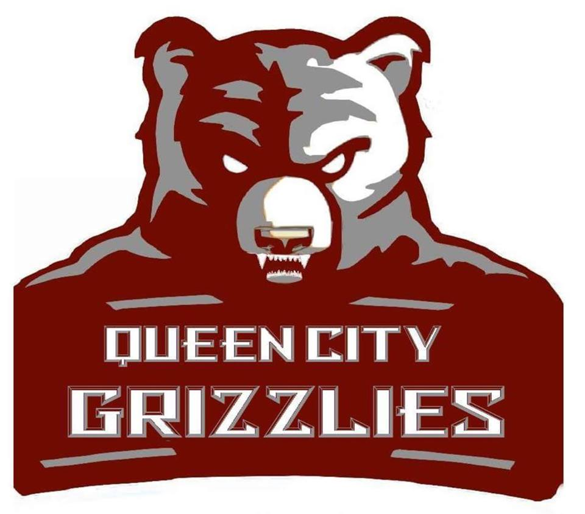
2018 Sponsorship Proposal

MINOR-LEAGUE FOOTBALL TEAM

Message from our Owner

Dear Prospective Sponsor and Partner,
Hello and welcome to The Queen City Grizzlies , and the Central Football League . First, I would like to thank you personally for allowing us the opportunity to present you with our sponsorship proposal. The Grizzlies take part in the CFL’s (Central Football League) ten-game regular season schedule beginning approximately the first week of March, with post-season play consisting of quarterfinals, semifinals, and a championship game. The Grizzlies have been a part of the CFL since 2015, reaching the semi finals . All Sponsors and Supporters that join the Queen City Grizzlies family become a part of our success!
The Queen City Grizzlies organization has designed a number of packages which will give sponsors the opportunity to support the team at all levels. Our sponsorship packages have been developed to provide businesses with an excellent return on investment. Our packages offer our sponsors brand exposure through a variety of mediums including, social media, print, and signage . In return for your investment, the Queen City Grizzlies can help your business increase your brand awareness and image, to gain new customers and to develop relationships with existing customers. In doing this, you showcase your devoted involvement in supporting the local community and the Queen City Grizzlies.
If you have any questions regarding any of our sponsorship packages please don’t hesitate to contact me!
In finishing, I would like to extend my sincere thanks for taking the time to read our sponsorship proposal. We believe our sponsorship proposal will provide an exciting marketing opportunity for your business and we would relish the opportunity of working in partnership with your business. The Queen City Grizzlies organization looks forward to welcoming you to our family!
Antonio Kelly
Owner
417-552-3771

SPONSORSHIP PACKAGES

The Queen City Grizzlies can’t wait to have you as part of our family! We are a loyal and hard-working team who loves football as well as giving families the opportunity to get out and enjoy a day of fun. Our organization is looking forward to building a great relationship with your company and introducing you to all of our loyal fans.
Do you need a guest at your company’s fundraiser or charity event? Players are available for individual appearances also! This option is negotiable in all levels of the advertising packages or on an individual basis.
The Queen City Grizzlies organization has designed a number of packages which will give businesses the opportunity to support the team at all levels. Please see below for an overview of the packages and their benefits. Let us know which one work best for you!

Uniform Ad Package
In return of your investment, you will receive the following benefits:
Advertising Benefits
• Premium home page website link
• Social media links
• Coupon/Advertising for fans at all Home Games
• Ability to set up tent/table at all Home Games (sponsor provides)
• 1 Banners displayed at all Home Games (sponsor provides)
• Verbal Ad announcements at all Home Games
Hospitality Benefits
• You will receive 2 invitations to the End of Season Presentation
• You will receive 4 season tickets to all Home Games
• You will receive 2 team T-shirts
• You have the right to use the Queen City Grizzlies logo on approved merchandise or material
• You will receive an official certificate of sponsorship

*Investment: $3000.000

Official Ad Package
In return of your investment, you will receive the following benefits:
Advertising Benefits
• Company logo on all printed schedules and flyers
• Premium home page website link
• 1 banners displayed at all Home Games (sponsor provides)
• Verbal Ad announcements at all Home Games
• Opportunity to set up tent/table at all Home Games (sponsor provides)
• Coupon/Flyer advertising for fans at all Home Games
• Opportunity to host a team event at your place of business
Hospitality Benefits
• You will receive 4 season tickets to all Home Games
• You will receive 2 team T-shirts
• You have the right to use the Queen City Grizzlies logo on approved merchandise or material
• You will receive an official certificate of sponsorship

*Investment: $ 1500.00
Game Day Ad Package
In return of your investment, you will receive the following benefits:
Advertising Benefits
• Halftime recognition on YOUR GAME DAY
• Your company logo on all printed schedules
• Direct company link from our website
• Opportunity to set up tent/table at all Home Games (sponsor provides)
• Company banner to be displayed at all Home Games (sponsor provides)
• Verbal Advertising during all Home Games
Hospitality Benefits
• 2 season tickets to all Home Games
• 2 team T-shirts
• You have the right to use the Queen City Grizzlies logo on approved merchandise or material
• You will receive an official certificate of sponsorship

*Investment: $ 750.00

Player Ad Package
In return of your investment, you will receive the following benefits:
Advertising Benefits
• Direct link to company from our website
• Autographed photo by the sponsored player
Hospitality Benefits

• 1 Season ticket to all Home Games
• You will receive 1 team T-shirt
• You will receive an official certificate of sponsorship

*Investment: $ 300.00
Field Ad Package
In return of your investment, you will receive the following benefits:
Advertising Benefits
• Direct link to your company from our website
• Opportunity to display company banner at all Home Games (sponsor provides)
Hospitality Benefits
• 1 Season ticket to all Home Games
• You will receive 1 team T-shirt
• You will receive an official certificate of sponsorship

*Investment: $ 200.00
Fan Ad Package
In return of your investment, you will receive the following benefits:
Advertising Benefits
• Direct link to your company from our website
Hospitality Benefits
• 1 Season ticket to all Home Games
• 1 team T-shirt General Benefits
• You will receive an official certificate of sponsorship
*Investment: $ 100.00
Thank you for taking the time to view our sponsorship package. The Queen City Grizzlies organization is dedicated to marketing their sponsors to ensure optimal benefits for both parties. We will assist in activating your sponsorship in an innovative and creative way. All packages can be tailored to your specific needs. Please review the following sponsorship form and contact us today!

Antonio Kelly Owner
Ph: 417-522-3771
Email: QCGrizzliespr@gmail.com
Website: https://www.facebook.com/QueenCityGrizzlies/

Sponsorship Contract

Business Name: _____________________________________________
Contact: ___________________________________________________
Address:____________________________________________________
Phone: ____________________________
Email: _____________________________________________________
Which package are you choosing? Uniform _____ Official _____ Game Day _____
Player _____ Field _____ Fan _____
Can’t find one that works for you? Customize one! Please specify below: __________________________________________________________________________________________________________________________________________________________________________ __________________________________________________________________________________________________________________________________________________________________________ __________________________________________________________________________________________________________________________________________________________________________
On this _______ day of ____________________, 20____, I enter into this sponsorship agreement with Antonio Kelly and the Queen City Grizzlies organization.

I agree to the sponsorship amount of $ _____________ and to the terms of the above described package. I understand that I will receive the benefits listed in the package details. The following benefits have been added/removed to fit my company’s needs: _________________________________________________________________________________ _________________________________________________________________________________ _________________________________________________________________________________

Signature of Sponsor: _________________________________________
Printed Name: _______________________
Title: _______________________
Signature of Grizzlies Representative: _____________________________________________________

