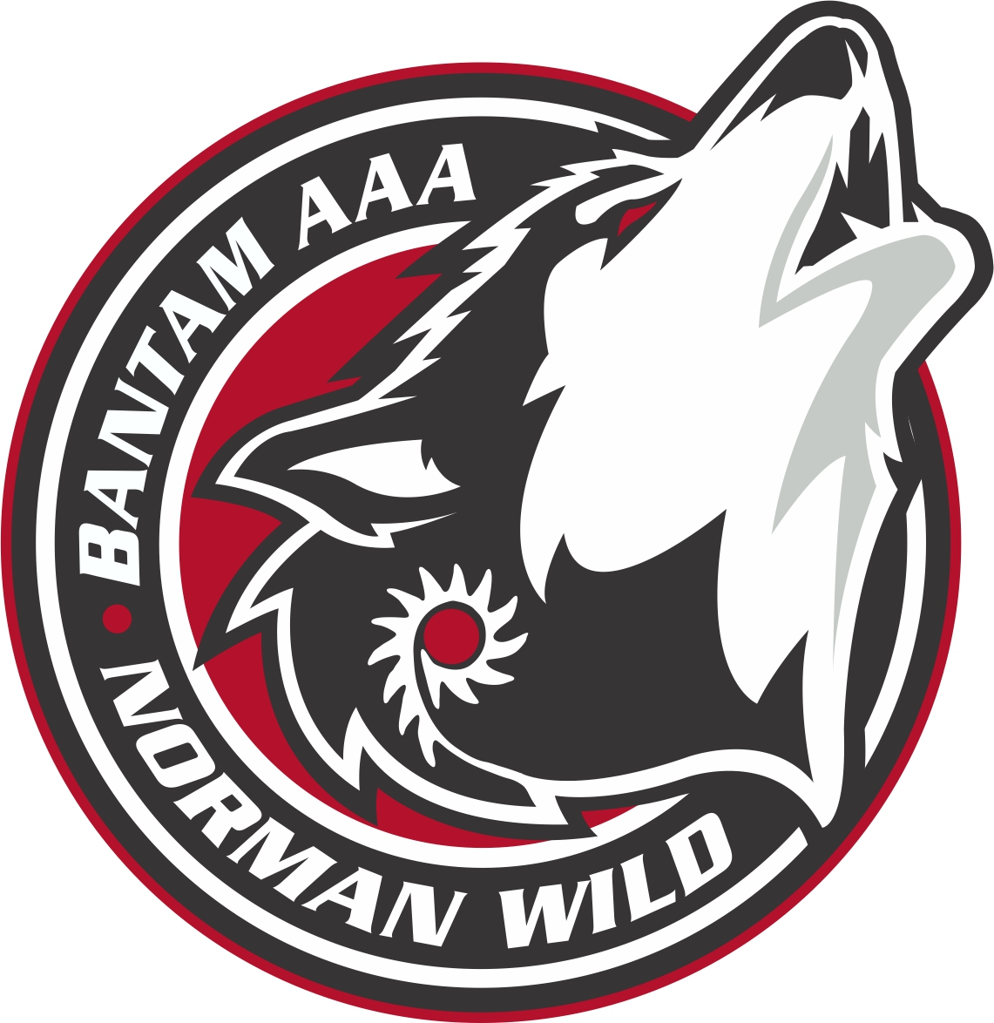
Norman Wild
Female Bantam AAA
Pre-Registration Form
Registration Aug. 26, 10 a.m. Whitney Forum
Try-Out Fee: $125 Due at registration
Fee includes mandatory Hockey MB insurance

Name of Player: ____________________________ Date of Birth: _____/_____/_____
D M Y

_____ First Year Bantam ______ Second Year Bantam

Player Position: ________________________________

Player Shoots: ________________________________

Player Contact Information: ________________________ (Cell) E-mail: __________________________________

Medical Health Registration # (6 Digits): _______________ PHIN# (9 Digits): _________________________

Contact Information:

Mother: _______________________________________ Father: _______________________________________

Address: ______________________________________ Address: _____________________________________

______________________________________ _____________________________________

Phone: ______________________________________ (H) Phone: ______________________________________ (H)

______________________________________(C) ______________________________________(C)

E-mail: ______________________________________ E-mail: ______________________________________

Please return complete preregistration forms to:
Mail: Karl Steppan
P.O. Box 1153
The Pas MB R9A 1L2
E-mail: ksteppan@mymts.net

