Minnesota Hockey Membership Benefits

- 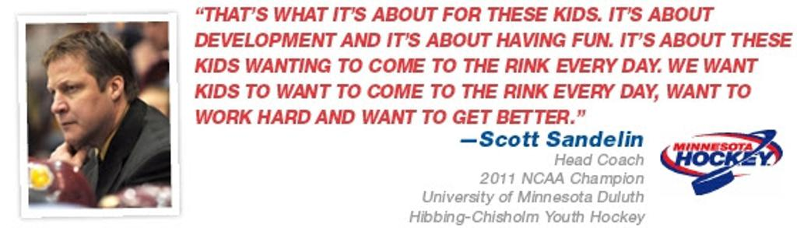

All Members
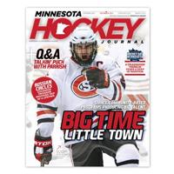
- Subscription to Minnesota Hockey Journal, a magazine published four times a year and delivered directly to your home
- Automatically receive the top weekly e-mail newsletter in Minnesota, including regular tips for players, parents, coaches and more
- Membership in the organization viewed as the nation's premier development model for youth hockey players, community-based hockey
- Take advantage of our extensive Hockey Education Program (HEP) to initiate a positive change on your child's skill development, sportsmanship and passion for the game
- Exclusive offers through our Corporate Partners including fundraising opportunities, grant programs and discounted rates
- USA Hockey Membership Benefits

Youth Players
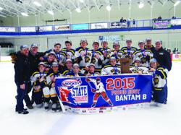
- Participate in community based hockey programs that prioritize player development on and off the ice while maximizing a passion for the game
- Compete for an opportunity to play for you community in the nation's only official State Tournaments
- Play for a program that will prepare you for success on your local high school hockey team
- Register for the chance to be included in our world-class player development programs including the Reebok High Performance Programs, Dave Peterson Goalie Camp and USA Hockey Player Development Camps
- Choose a level (A, B, C and Rec) of hockey that fits your desire for participation and commitment
- Grow up playing hockey with your friends, developing life-long memories and bonds that will never be broken

Coaches
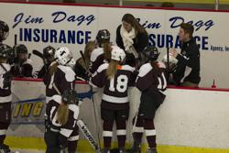
- Obtain certification through youth sports' gold standard in coach education at a nearby location
- View online age-specific coaching modules to ensure each coach has the most age-appropriate training information and materials
- Be recognized through Minnesota Hockey's Coaching Excellence Program and have the opportunity to watch a Minnesota Wild practice
- Access a database of prepared, age-appropriate practice plans
- Download USA Hockey's Mobile Coach app for access to practice plans, a whiteboad and much more on your digital device
- Leave a legacy in the minds of your players by teaching them to play and love the greatest game in the world, while also passing on critical life lessons

Administrators
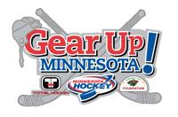
- Apply online for the top equipment grant program in the country, Gear Up Minnesota!, which has provided over 1,400 starter sets to Minnesota players in the last four years
- Secure a $2,500 subsidy for hard cross ice dividers through Minnesota Hockey's Hard Divider Program
- Foster local growth with a variety of resources and grants
- Gain access to a universal, easy-to-use web platform for all affiliate associations through Sport Ngin
- Free training through the most comprehensive off-ice safety program in the country, USA Hockey SafeSport
- Make a lasting impression on your community and the kids that call it home

