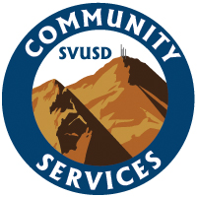
Laguna Hills Baseball
2017 Youth Camp

Laguna Hills Head Baseball Coach Drew Hillman and his Varsity Staff will be conducting a two-week summer camp. The Laguna Hills Baseball Program is excited to be back working with the community of Laguna Hills and its surrounding areas. This camp will be a developmental baseball camp, participants will be taught the fundamentals of running, throwing, fielding, hitting, and infield and outfield play. Players will also learn several drills and routines that Coach Hillman learned through his playing days in the Philadelphia Phillies Organization. Players will need to be dressed in baseball attire and will need to bring their own cleats, glove, helmet and bat.

Location: Laguna Hills Varsity Baseball Field
25401 Paseo De Valencia Laguna Hills, Ca. 92653
Time: Tuesday & Thursday from 10:30-12:30
Dates: 6/20, 6/22, 6/27, 6/29
Fee: $100 per player
Grades: Players entering 4-8th Grade
Register at: https://apm.activecommunities.com/svusdcommservices/Home
Search Laguna Hills Youth Baseball Camp
Contact: Tasha Johansen
SVUSD Community Services Supervisor
(949) 460-2730
Tasha.johansen@svusd.org

