Pleasant View Park
Corner of Pleasant View Drive and Willow Lane, North Mankato
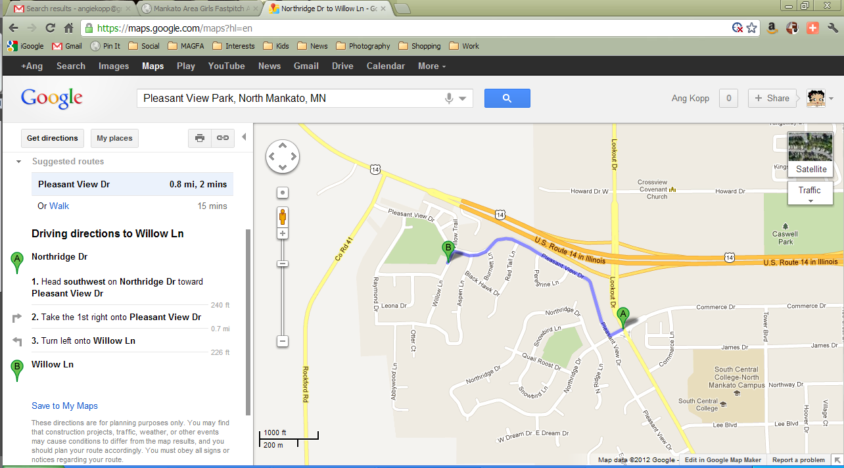
https://maps.google.com/maps?saddr=Northridge+Dr&daddr=Willow+Ln&hl=en&ll=44.179219,-94.058118&spn=0.016097,0.038581&sll=44.179434,-94.049749&sspn=0.016096,0.038581&geocode=FeoYogIdBtxk-g%3BFQ8logIdkK9k-g&oq=1750+Tower&mra=dme&mrsp=0&sz=15&t=m&z=15
----------------------------------------------------------------------------------------------------------------------------------------
North Ridge Park
Corner of Northridge Drive and Snowbird Lane, North Mankato
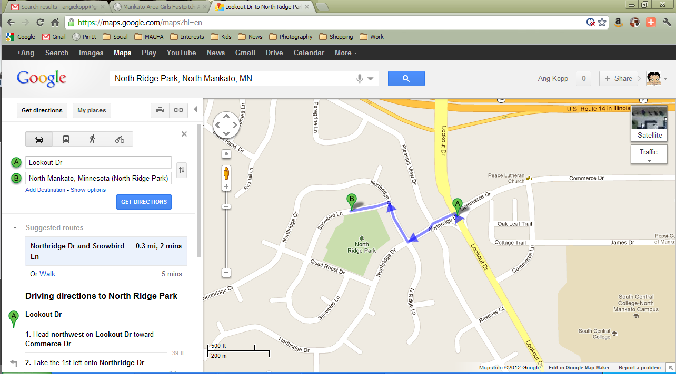
https://maps.google.com/maps?saddr=Lookout+Dr&daddr=North+Mankato,+Minnesota+(North+Ridge+Park)&hl=en&ll=44.176987,-94.053891&spn=0.008049,0.01929&sll=44.178634,-94.050908&sspn=0.008048,0.01929&geocode=FawYogIdptxk-g%3BFeUVogIds8xk-iGEzGVQqwaUeA&oq=1900+Howard&mra=dme&mrsp=0&sz=16&t=m&z=16

Roe Crest Park
Corner of Clare Drive and Clare Court off of Roe Crest Drive, North Mankato
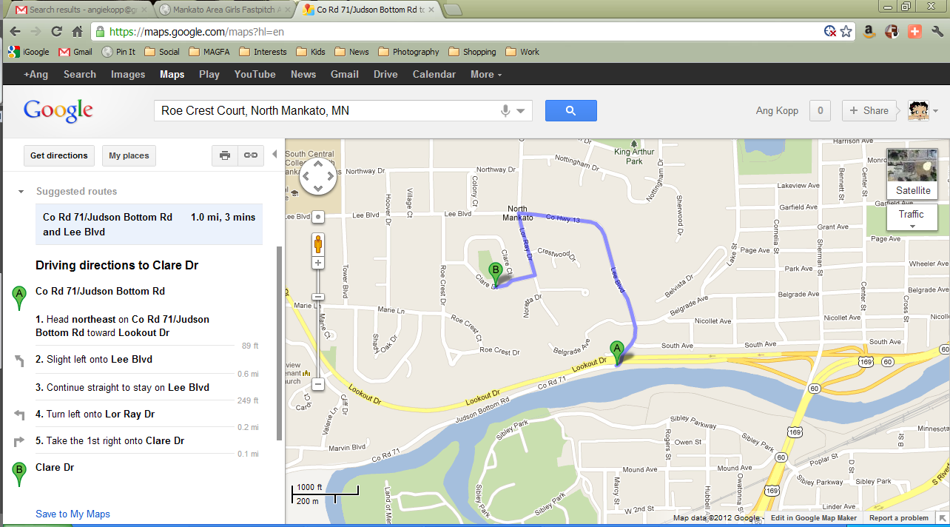
https://maps.google.com/maps?saddr=Co+Rd+71%2FJudson+Bottom+Rd&daddr=Clare+Dr&hl=en&sll=44.168322,-94.027991&sspn=0.0161,0.038581&geocode=FTDvoQIdsj5l-g%3BFfb7oQIdPCNl-g&oq=commer&mra=dme&mrsp=0&sz=15&t=m&z=15
--------------------------------------------------------------------------------------------------------------------------------------------
Forest Heights Park
Marie Lane, North Mankato
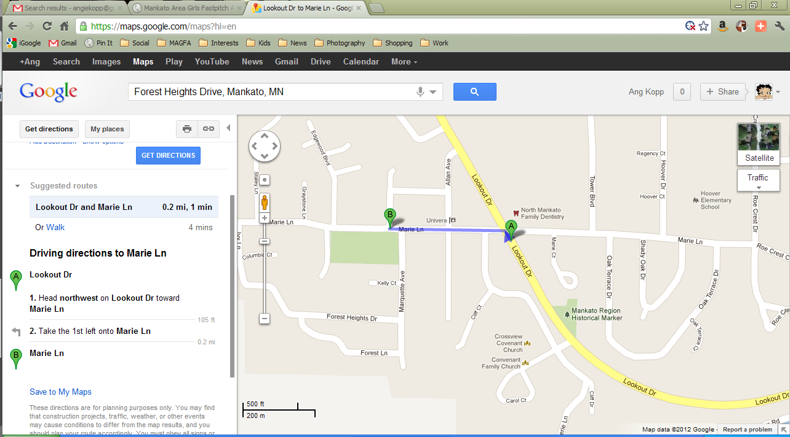

https://maps.google.com/maps?saddr=Lookout+Dr&daddr=Marie+Ln&hl=en&ll=44.168338,-94.046552&spn=0.00805,0.01929&sll=44.167768,-94.040866&sspn=0.0161,0.038581&geocode=FQr4oQIdLfZk-g%3BFTr5oQIdouVk-g&oq=look&mra=dme&mrsp=0&sz=15&t=m&z=16

South Central College Fields (SCC)
Corner of Tower Blvd and James Drive off of Lee Blvd, North Mankato
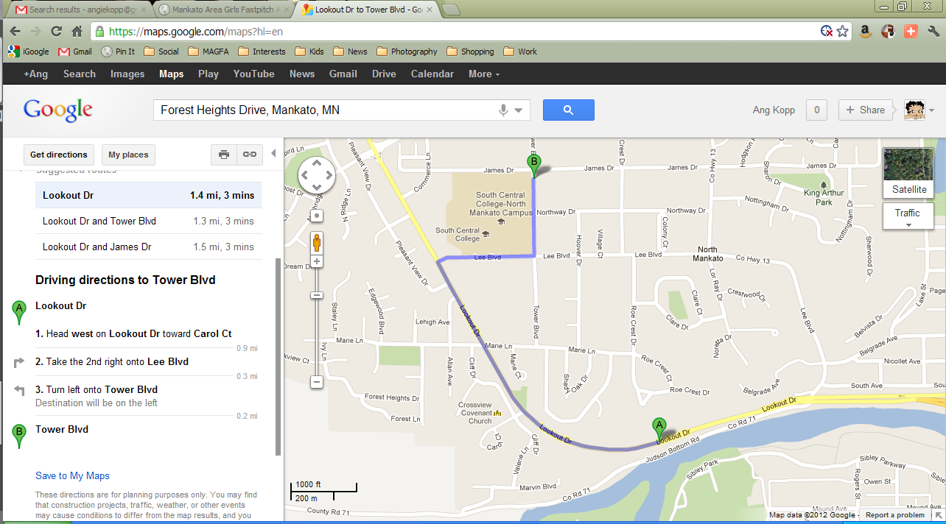
https://maps.google.com/maps?saddr=Lookout+Dr&daddr=Tower+Blvd&hl=en&sll=44.170077,-94.039192&sspn=0.016099,0.038581&geocode=FTbpoQIdHh1l-g%3BFUYUogIdqABl-g&oq=lee&mra=dme&mrsp=1&sz=15&t=m&z=15
-------------------------------------------------------------------------------------------------------------------------------------
Sibley Park Ball Fields
Riverside of Park by Water treatment plant. Sibley Parkway, Mankato
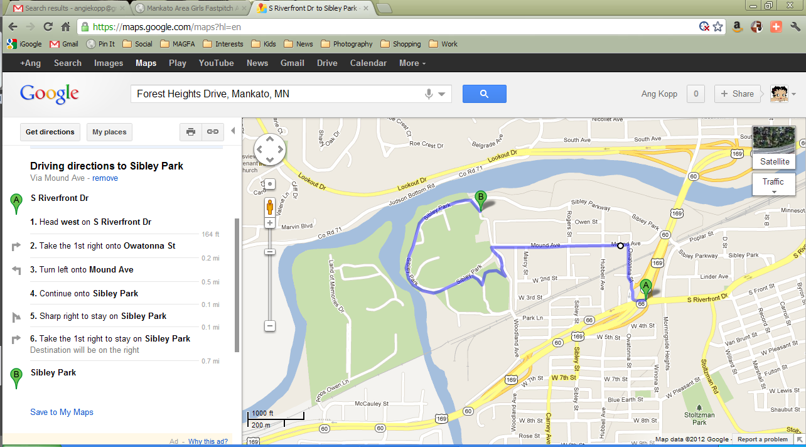
https://maps.google.com/maps?saddr=S+Riverfront+Dr&daddr=44.1626251,-94.021645+to:Sibley+Park&hl=en&ll=44.160811,-94.028163&spn=0.016102,0.038581&sll=44.158132,-94.024172&sspn=0.016102,0.038581&geocode=FcnToQIdmF5l-g%3BFUHeoQId81dl-ikPZ6ovyTn0hzGFTIFlnKBt2Q%3BFc_koQIdjzJl-g&mra=dme&mrsp=2&sz=15&via=1&t=m&z=15

