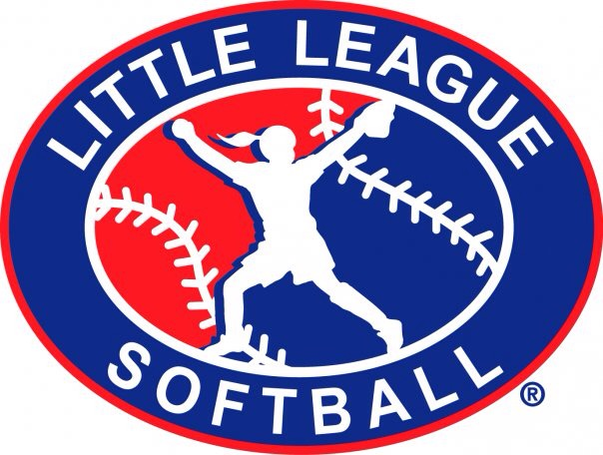
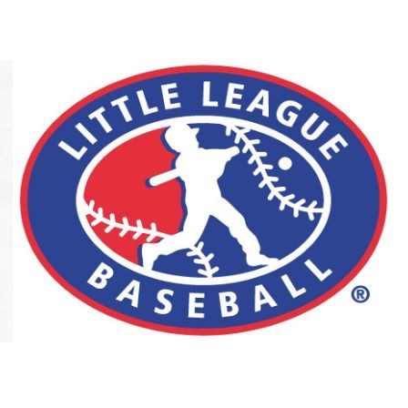

Baker Little League
ASAP Plan 2016

Table of Contents

Index:

Cover Page Page 1
Table of Contents Page 2
Safety Officer Page 3
Distribution Page 3
Emergency/Key Officials Page 4
Little League Applications Page 5
Fundamentals Page 5
Concussion/First Aid Training Page 6
Inspection Requirements Page 7
Facility Survey Page 7
Concession Stand Page 8
Equipment Inspection Page 9
Accident Reporting Page 9
First Aid Kits Page 10
Enforcement of LL rules Page 10
Player Registration Data Page 11
ASAP Plan Page 11
Concession Safety Appendix A
Coaches Checklist Appendix B

ASAP Plan

Safety Officer:

- League safety officer: Dustin Newman on file with Little League headquarters.

Distribution:

- Baker Little League will distribute a paper copy of this safety Manual to all managers/coaches, league volunteers and the District administrator.

ASAP Plan

Emergency Contact and Key Officials:

Emergency Phone #: 911
Baker City Police Department 541-523-3644
Baker City Fire Department 541-523-3711

President- Jake Hester 541-403-2711
VP baseball- Kevin Logsdon 503-551-9011
President softball- TJ Hester 541-403-0427
Secretary- Hayley Hester 541-519-1386
Treasurer- Mike Rudi 541-403-1922
Player Agent BB- Hayley Hester 541-519-1386
Player Agent SB- Shannon Conklin 541-519-5218
Concessions BB- Sydney Slobig 541-403-4447
Concessions SB- Farrah Chastain 541-403-1480
Safety- Dustin Newman 503-932-6124
Umpire and Chief-
Field maintenance- Jake Hester 541-403-2711

✔️ This list will be posted in the concession stand.

ASAP Plan

Little League Applications:

- The Baker Little League will use the official Little League Volunteer Application form to screen all of our volunteers.

Fundamentals Training:

- Each coach will receive a fundamentals training book to read and apply to practices.

ASAP Plan

Concussion/ First Aid training:

- Baker Little League will require all manager/ coaches to have Heads Up concussion training before the first practice. We will also require at least one coach to have basic first aid training.

- Concussion training website
www.cdc.gov/HeadsUp/youthsports/training/index.html

- Every manager/coach will have basic first aid training. Baker LL will provide a mandatory first aid class for each manager/coach on March 21st or 22nd of 2017.

ASAP Plan

Inspection Requirement:

- A coach from both teams will be required to walk and inspect the field prior to all practices and games.

- Umpires will also be required to walk the
field for hazards before each game.

Facility Inspection:

- Baker Little League will complete a 2017 Facility survey online by the end of March 2017.

ASAP Plan

Concessions stand training:

- The concession menu will be posted and approved by the league president and by the safety officer.

Our Concessions Safety Procedures Will Be Posted Throughout the Stand.

ASAP Plan

Equipment Inspections:

- The safety officer and equipment manager will inspect the equipment at the start of the season.

Requirement:

- Managers/Coaches/Umpires will inspect the equipment before each game.

Accident Reporting:

The league will use the provided incident tracking form from the LL website and will provide completed Accident form to the safety officer no later than 48 hours of the incident occurring. Please see attached form.

ASAP Plan

First Aid Kits:

- Each team will be provided with a first aid kit in their equipment bag.

Requirement:

- A first aid kit is required at every practice and game.

Little League Rules:

- Baker LL will require all teams to enforce all LL rules. Including proper equipment for catchers.

a. No on deck batters.
b. Coaches will not warm up pitchers.
c. Bases will disengage on all fields.

ASAP Plan

Player Registration Data:

- League player data and coaches and managers data must be submitted via the LL data center at www.littleLeague.org.

ASAP Plan:

- Baker Little League will submit a Quality safety plan registration form along with the ASAP Plan for approval.

