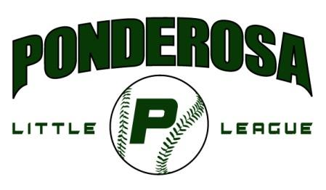

2017 Ponderosa Little League
Sponsorship Form

Ponderosa Little League is a non-profit program funded by contributions from individuals and business owners like you. We are seeking help with the youth of this community by requesting your sponsorship or donation. Ponderosa Little League is a youth organization within Little League Baseball, Incorporated, which provides boys and girls in our community a positive experience in competitive sports.
Remember, sponsorships and donations are tax deductible. (Tax ID#23-7067344)
Below are the levels of sponsorship that are available. Please mark the one that would best meet your needs.
Level | Ad Size | Banner | Plaque | Website | Uniforms | Showcase
Diamond | Back Cover | 8x4 Banner | Premier Plaque | Yes |  | Opening Day & Cap Nights
Home Run | Full | No | Yes | Yes | Yes
Perfect Game | ½ Page | No | Yes | Yes | Yes
Triple Play | ½ Page | 4 x4 Banner | Yes | Yes | Yes | Majors Only

_____Diamond Sponsorship (1 available) $2500
Be the premier sponsor of Ponderosa Little League during their 2017 season. Sponsorship at this level includes a full page advertisement on the back cover of the league roster book that is distributed to over 500 families, 8x4 foot outfield banner at Dave West Field for the entire season, deluxe sponsorship plaque, opportunity to showcase your service/products at opening day event. Your company will be noted on our website and any publications as our Diamond level premier sponsor for the entire season.

Team Sponsorships
_____Home Run Sponsorship $500 (t-ball – AAA & Jr. teams only)
Sponsorships at this level includes a full page advertisement in the league roster book that is distributed to over 600 families, a sponsorship plaque, recognized as a Home Run Sponsor, company will be advertised on an 4x4 sponsor banner at the field snack bar, and your business’ name will be printed on the back of the team jerseys.
*Jr. Team sponsorships will be printed on the sleeve of the uniform not the back.
If this sponsorship is for a particular team please note their division/team/name
Division________________ Team___________________ Player Name________________________________
_____Perfect Game Sponsorship $300 (t-ball – AAA & Jr. Teams only)
Sponsorships at this level includes a ½ page advertisement in the league roster book that is distributed to over 600 families, a sponsorship plaque, recognized as a Perfect Game Sponsor, and your business’ name will be printed on the back of the team jerseys.
*Jr. Team sponsorships will be printed on the sleeve of the uniform not the back.
If this sponsorship is for a particular team please note their division/team/name
Division________________ Team___________________ Player Name________________________________
_____Triple Play Sponsorship $350 (Major Division Teams Only)
Sponsorships at this level includes a ½ page advertisement in the league roster book that is distributed to over 600 families, a sponsorship plaque, recognized as a Triple Play Sponsor, and your business’ will have a 4x4 banner hung at the Dave West Field for the season. The business’ name will be printed on the sleeve of the team jerseys also.

Division________________ Team___________________ Player Name________________________________

Make your check payable to: Ponderosa Little League (PLL), P.O. Box 245, Shingle Springs, CA 95682
Company Name_______________________________________________________________________
Contact______________________________________ Phone Number___________________________
Email_______________________________________________________________________________
Exact characters for back of team uniform shirts (Home Run & Perfect Game Sponsorships Only) & Banners (Diamond, Triple Play & Home Run Sponsorships). 25 Characters Maximum.

ATTACH TO THIS FORM: 2 BUSINESS CARDS, CAMERA-READY ART WORK FOR ROSTER BOOK AD
QUESTIONS PLEASE SEND AN EMAIL TO pondoinfo@gmail.com

.

