MITE TRAVEL LEAGUE

Jr. SPARTANS

Let’s celebrate the end of a great season!

CHICAGO WOLVES

VS.

IOWA WILD

Saturday, February 25, 2017 at 7:00 PM
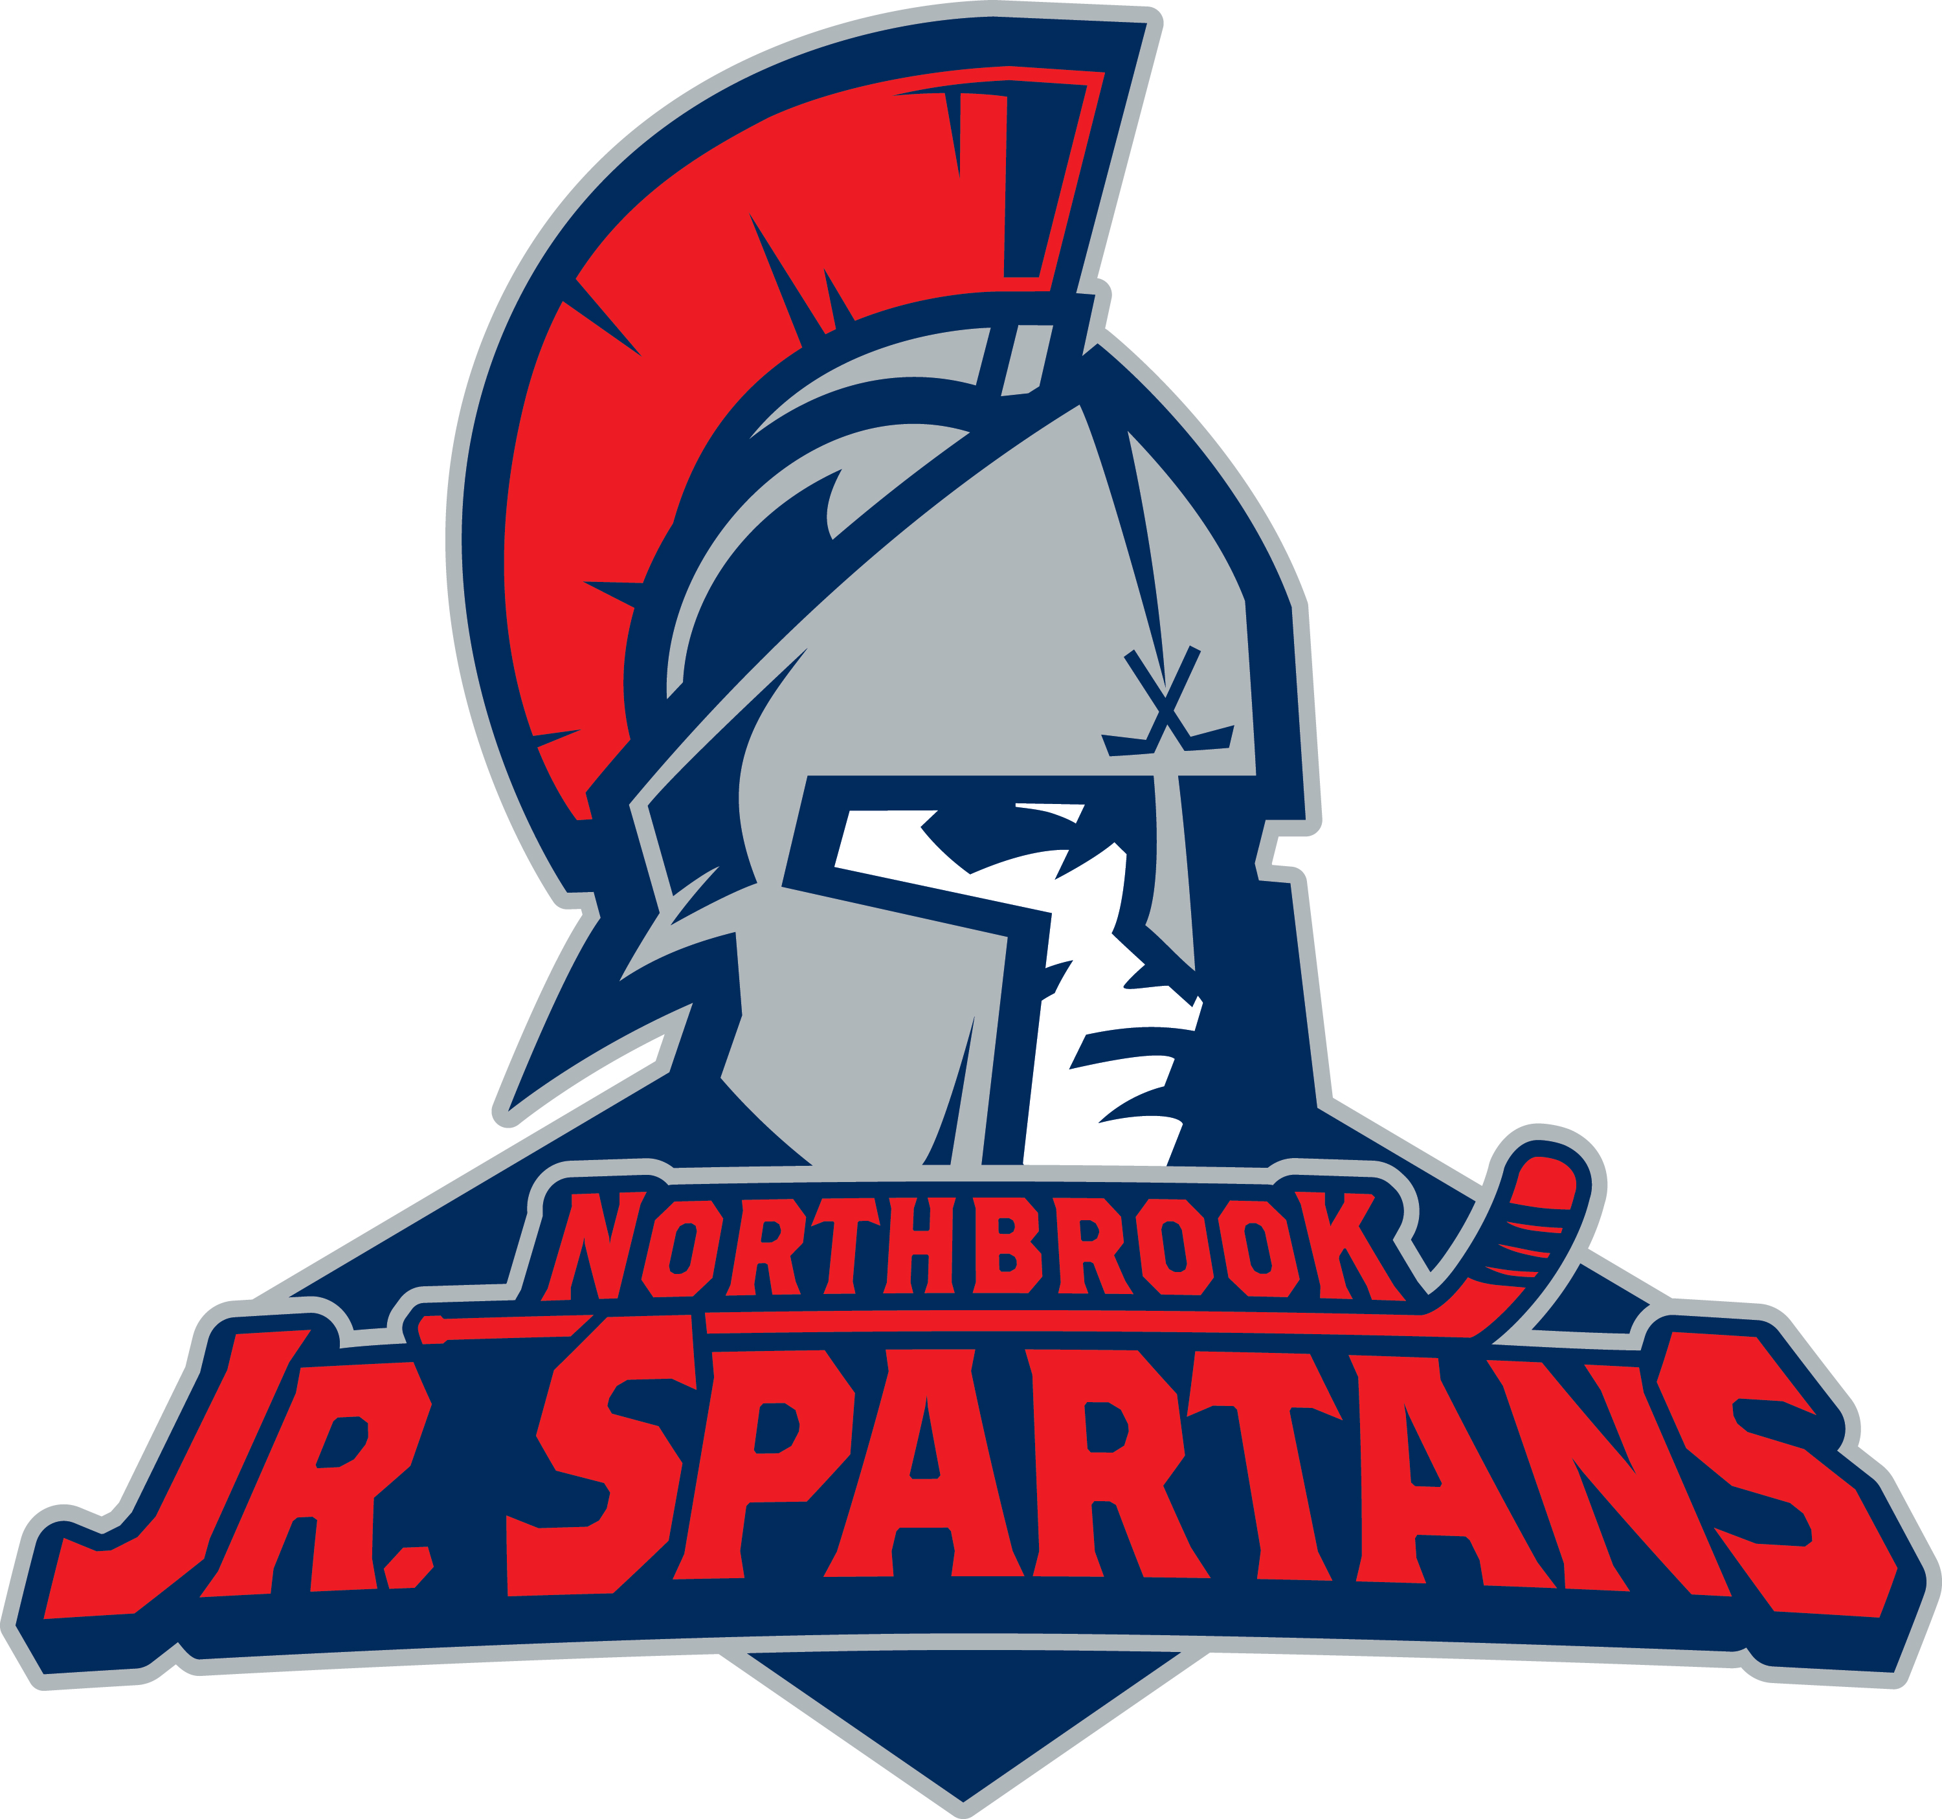
$18 per ticket includes*…
- Free Wolves hat for each ticket holder
- Free Wolves jersey for each travel player

Order deadline is February 5, 2017
Tickets distributed on a first come, first served basis.

*A portion of each ticket price goes to Jr. Spartans!

Player’s Name: _________________________
Parent’s Name: _________________________
Phone #:_______________________________
Email:_________________________________

# of Tickets = _______ at $18 = $ ___________

Circle one: Mite Travel Team AA, A or A2

Checks payable and forms due to:
Northbrook Jr. Spartans Hockey Club
c/o Randi LeBoyer
316 Southgate Drive
Northbrook, IL 60062

? Questions ? Email randi021@att.net

