View hundreds of FREE game descriptions & videos!

What's New—January 2016?
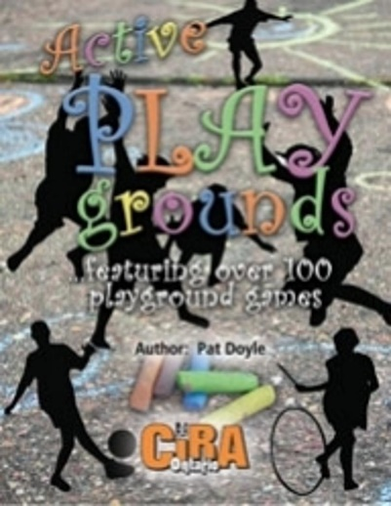 |  | 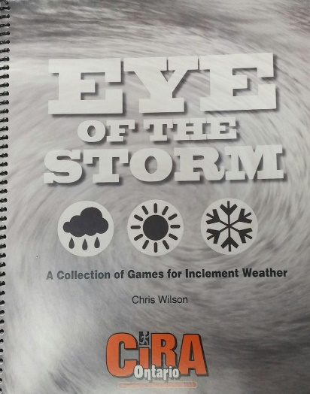

President’s Message:
Making the Good Better and the Better Best
Our lives are on a journey. Organizations and country’s lives are on a journey. We make choices along that journey. Some are good and some are not so good. We live in a world where we sometimes live in fear of what is to come; because people are making bad choices. But intramurals are a place where we can share good choices. Choices about encouraging fun, active, participation for all. Blessings as you make 2017 a year where we help make the good better, and the better best.

$1,000 gift card to be given away in April. Register for free.

Canada is celebrating 150 years of making choices. Are there intramural opportunities to make this country better? Love to hear your ideas of what you are doing and what we can do to help make this country better through intramurals. Send us a note at: ciraontario@gmail.com
The Canadian Lacrosse Association is Canada’s oldest sport association. This Association is also celebrating 150 years. To further connect with them view their website.
For some intramural lacrosse ideas check out the CIRA Bulletin from 1989 on Page 16:  - Lacrosse game for intramurals,  - Warm-up game called Little Thieves, and  - Lacrosse Golf rules | 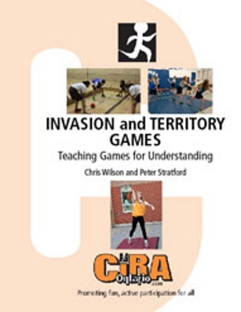  Lacrosse is an invasion game. Be sure to check out over 50 invasion games from the CIRA Ontario:  - Book  - Website
The Nationwide Lacrosse is a business begun four years ago, and is run by a pair of professional lacrosse players playing in the National Lacrosse. Their goal is to introduce, teach, and grow the sport of lacrosse. Over the past four years they have run over 200 camps, leagues, clinics and taught lacrosse in schools across Ontario, reaching out to almost 30,000 students.
In a typical day would they will work with 6-7 classes throughout the day. They talk about the history of the sport in our Country as well as their paths in life through sport. They provide enough sticks and balls for 30 students. They teach them the fundamental skills that are most important to play lacrosse. There is absolutely no contact and they get all the kids to work on their skills individually so no one feels superior or inferior. At the end of the class they break the students into groups where they finish with a relay race that incorporates all of the skills that they taught them during the class. They show them some tricks, let them see their Gold Medals and autograph a poster for each student. View flier with pricing on the next page
Brad Self 716.383.2332 Shawn Evans 705.768.8828

We are looking for Nominations for various awards—Please add your suggestions by January 5 | Be sure to learn more intramural ideas at our upcoming conference. View the back page, save the date, and take advantage of early bird registration.

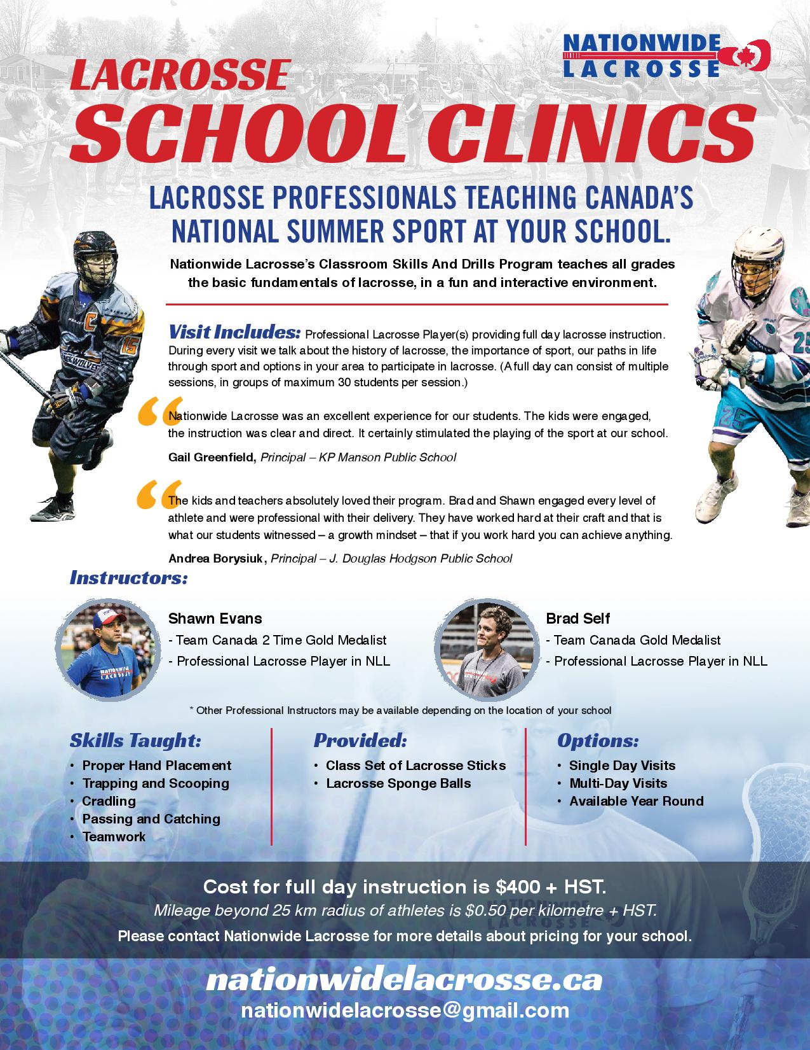

Click on the icons to like us at:

