Attack Announce Captains for 16/17 Season
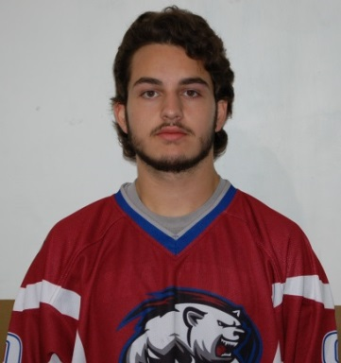
Arlington, Texas: The Arlington – Midlothian Attack have proudly announced Beau Rehonic as the team’s Captain for the 2016/2017 Season. Rehonic, a junior center, is a quiet leader, whose two way selfless play serves as a model for the younger skaters on the club. This marks Beau’s fourth season of lighting the lamp with the team. He started with the team as a JV winger and made the jump to varsity in the 14/15 season, proving to be a contributor as a freshman on the Varsity Gold squad. Rehonic embodies the true spirit of team captain, putting his teammates first in their development. This is not surprising as he spends his free time with the fire academy, preparing for a life of meaningful service as a fire fighter and first responder. Beau is the type of leader who is rushing in when everyone else is rushing out. Over the past four seasons, he has led by example, logging as many assists as goals, despite his laser forehand. At the same time, due to his calm demeanor, he rarely frequents the penalty box, being called for only five infractions last year, despite pulling nearly 22 minutes of ice time each game. Rehonic fills the void of tremendous past leaders including Clarke and Allen. There is no doubt he will leave his mark on this team and help to shape the leaders of the next generation of Attack skaters!

Arlington, Texas: Jonathan Loggins receives the nomination of Alternate Captain. Loggins, a defenseman from Martin High School, follows his older brother Zach as he dons the Crimson Polar bear. Known for his precise puck handling ability, Jonathan acts as a general in the defensive zone, calling out the plays and executing the break out with precision. His mere presence on the ice has a calming effect on his netminders and allows his offense to take chances in order to create turnovers and plays, knowing that “Loggi” will be back to defend. Number 56 started his career with the Attack moving steadily up through the JV ranks. He briefly took a contract with Mid Cities, but was successfully courted back to the Attack specifically to take a leadership role on the blueline. Loggins is an athlete scholar, seeing much success in the classroom as well. When not hitting the books or moving pucks, you might find John logging miles as a cross country standout or racing mountain bikes. Suffice to say that his experience of handling stressful situations makes him a natural under pressure in the defensive slot.

