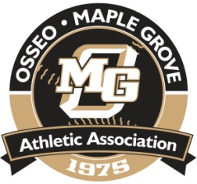
OSSEO-MAPLE GROVE ATHLETIC ASSOCIATION

SECRETARY’S REPORT

August 18th, 2016

VIRTUAL MEETING OF THE OSSEO MAPLE GROVE ATHELTIC ASSOCIATION
BOARD OF DIRECTORS

A Virtual Meeting of the OMGAA Board of Directors was conducted on August 17th and August 18th, 2016 for the sole purpose of approving the following motion:

Motion: I motion to authorize OMGAA Treasures to pay the outstanding invoices of $1,346.96 for the OMGAA Adapted Program and direct that the over budget amount be placed into next the 2017 Adapted Programs budget as an expense item.

Motion by Mike Parenteau
Second by Don Scott.

By unanimous consent of those voting, and by meeting the required minimum votes to pass, the motion has been approved.

Respectfully submitted,

Mike Parenteau,
OMGAA Secretary

Minutes are not considered official until approved by the Board at the next meeting.
Future Meetings: All meetings at the Maple Grove Community Center

