View hundreds of FREE game descriptions & videos!

What's New--October 2016?

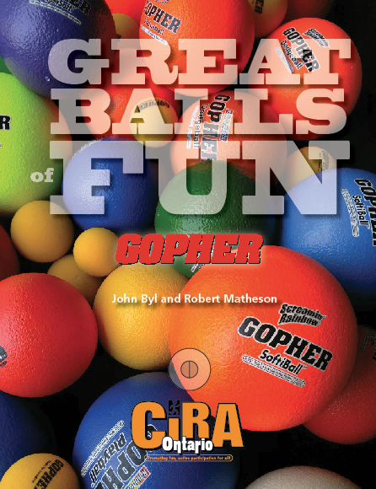
President’s Message:
In keeping with CIRA Ontario’s mandate of “Promoting, Fun, Active Participation for All,” we welcome out latest book, Great Balls of Fun. View it on our website and see a description below.

Come and experience (again for a first time) the amazing OASPHE and CIRA Ontario Conference this April. Registration is open. See attached page for dates…. Hope to see you there

CIRA Ontario is going to a simpler newsletter with this new format and calling it What’s New. Hope it works for you

Great Balls of Fun  The resource contains nearly 100 ball games that will complement any program including intramurals, physical education classes, playgrounds, recreation programs, and inter-school sports. Foam Balls are adaptable, affordable, lightweight, and available in a variety of sizes. The balls have become a regular staple in elementary schools across North America and have enabled children to learn motor skills without fear of the ball. Specific activities are listed for warm ups, target games, net/wall games, invasion/territorial games, and striking/fielding games. | Membership has its privileges  To view membership options and privileges go to the membership section of our website.
CIRA Ontario Website

In the process of making it more mobile friendly. It is a work in progress but enjoy the changes we have already made. We welcome your suggestions.
Right to Play and Play Your Part

Right to Play is a global organization that uses the power of play to inspire individuals and unite communities. Right to Play utilizes play and sport to help children in Africa, Asia, the Middle East, Latin America and North America, build their life skills. (see www.righttoplay.com for additional information).

Play Your Part is a school engagement initiative offered to schools across Canada during the current school year (January through June 2017). The program begins with a free, educational and engaging school assembly recommended for students in grades three to eight. Your students will be moved by stories from children involved with Right to Play from around the world. It’s an hour of interactive, multimedia learning that will motivate students to harness their own leadership potential.

A one day Play Your Part workshop subsequently helps selected students develop and harness their own leadership skills to create a positive school environment and translate their actions into global impact.

The culmination of Play Your Part is a fun-filled activation, wherein students and teachers who participated in the workshop organize and host a play day or similar event for fellow students. Activities will be similar or identical to activities used by Right to Play worldwide.

Interested in signing up your school or learning more? Contact us at schools@righttoplay.com.

Great Balls of Fun continues to honour our partnership with Gopher Sport as we highlight some of their amazing equipment in this new book.  $1,000 gift card to be given away in April. Register for free. | We are looking for Nominations for various awards—Please add your suggestions by January 5  Professional Award  Honorary Award  Doyle-Harkeness Award

Click on the icons to like us at:

