**2016 NWBA Women’s Development Camp**

**October 20-23**

**Lakeshore Foundation – Birmingham, AL**

*Application deadline: Thursday, October 6th*

**Registration Packet**

**Table of Contents**

Contact Information 3

Location 3

Schedule 3-4

Staff 4-5

Registration Instructions 6

Registration Form 7

NWBA Waiver 8

# Contact Information

# For more information related to the camp, please contact Brandon McBeain at [brandonmcbeain@nwba.org](mailto:brandonmcbeain@nwba.org) or (719) 266-4082 (ext. 108).

# Location

## Women

Lakeshore Foundation

4000 Ridgeway Drive  
Birmingham, AL 35209

The Lakeshore foundation is a state-of-the-art sport and recreation facility designed for persons with physical disability. In 2003 Lakeshore was designated by the United States Olympic Committee as an Olympic and Paralympic Training Site and currently serves as the home for the USA Women’s Wheelchair Basketball Team.

# Schedule

## Women

October 20th: Arrival and Check In Begins at 2pm

October 21st: Camp Begins at 8am

October 22nd: Camp

October 23rd: Camp Ends at Noon/Departures

**Camp Capacity**

If the camp capacity is reached the assigned coaching staff will select attendees from pool of applicants once the application deadline as passed.

# Staff

## Women

The women’s camp will be directed by USA Women’s Head Coach Stephanie Wheeler and staffed by current and former USA athletes and coaches.

In addition to serving as the head coach of the USA Women’s Wheelchair Basketball Team Stephanie is a two-time Paralympic Gold Medalist (’04, ’08) and is the head coach of the University of Illinois Women’s Wheelchair Basketball Team.

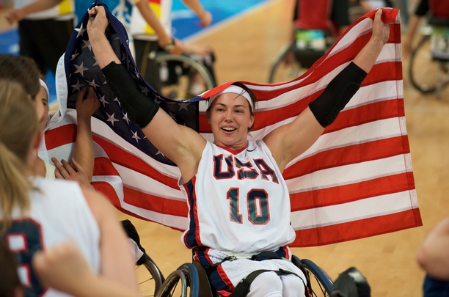

**Stephanie Wheeler celebrating winning the Gold Medal at the 2008 Beijing Paralympic Games.**

# Registration Instructions

The NWBA registration packet must be completed electronically and emailed to Brandon McBeain, [brandonmcbeain@nwba.org](mailto:brandonmcbeain@nwba.org).

## Additional Forms – Lakeshore Foundation

All athletes will also need to complete Lakeshore foundation forms. These forms may be completed electronically but must be printed and signed by hand. Athletes will not be allowed on court unless all forms have been properly completed and submitted to Lakeshore. Please click on the links below to view the forms:

[Lakeshore Foundation Code of Conduct](http://assets.ngin.com/attachments/document/0106/1234/LFTS_Code_of_Conduct.doc)

[USOC Waiver and Release](http://assets.ngin.com/attachments/document/0106/1236/USOC_Waiver_and_Release.docx)

[USOC Medical History and Question](http://assets.ngin.com/attachments/document/0106/1239/USOC_Medical_History_and_Question.doc)

**Application Deadline:**

**Women’s - Thursday, October 6th**

**Registration Fees**

The registration fee for the camp is $450 and includes transportation to and from the Birmingham (BHM) airport to Lakeshore, meals, practice jersey, and instruction from some of the best coaches and athletes the USA has to offer.

Forms will not be processed until payment is made in full.

**Checks can be mailed to:**

NWBA

Attn: 2016 Development Camp

1130 Elkton St., Suite C  
Colorado Springs, CO 80907, USA  
Phone: 719-266-4082  
Fax: 719-266 4876

**Credit card payments will be process through the national office.**

# Registration Form

First Name Middle Initial Last Name

Date of Birth (MM/DD/YYYY) Age Female

Jersey Size Small Medium Large X-Large XX-Large

Street Address City State Zip

Home Phone Cell Phone

Email Address

Emergency Contact

Relationship Contact Number

# Years Playing Wheelchair Basketball

Classification

Community Team Name

Community Team Coach Name

Contact Number Email

**Payment**

The registration fee for the camp is $450. How will you be paying the registration fee?

Credit Card Check Check # Make checks payable to the NWBA

Visa MasterCard Discover Card Number

Expiration Date Security Code

**Checks can be mailed to:** NWBA, Attn: 2015 Development Camp, 1130 Elkton St., Suite C, Colorado Springs, CO 80907, USA

# NWBA Waiver

I acknowledge that wheelchair basketball or any sporting event is an extreme test of a person's physical and mental limits and that my participation in an NWBA event can cause potential death, serious injury, or property damage. With a full understanding of the potential risks, I HERBY ASSUME THE RISKS OF PARTICIPATING IN AN NWBA EVENT. I hereby take the following action for myself, my executors, administrators, heirs, next of kin, successors and assigns:

a) I WAIVE, RELEASE, AND DISCHARGE from any and all claims or liabilities for death or personal injury or damages of any kind from the persons listed above, which arise out of or relate to my traveling to and from or my participation in any wheelchair basketball event. THE FOLLOWING PERSONS OR ENTITIES: The NWBA, camp directors, Lakeshore Foundation, sponsors, and the officers, directors, employees, representatives, volunteers, and agents of any of the above: b) I AGREE NOT TO SUE any of the persons or entities listed above for any of the claims or liabilities that I have waived, released or discharged herein; and c) I INDEMNIFY AND HOLD HARMLESS the persons or entities mentioned above for any claims made or liabilities assessed against them as a result of my actions.

**ACKNOWLEDGEMENT AGREEMENT**

I hereby agree that I will abide by the rules and guidelines regarding club affiliation as established by the NWBA in which I am applying for membership.

I hereby agree to be filmed, videotaped and photographed, and to have my name, image, picture, likeness, voice and biographical information otherwise recorded, in any media by the NWBA.

I hereby grant NWBA with no financial or other compensation due to me, full right and license to use, and to authorize third parties to use, in all media, the footage for: (1) news and information purposes, (2) promotion of the specific competition(s) in which I compete, (3) promotion of the Sport, and (4) promotion of the NWBA.

I hereby certify that the information provided is being done directly by myself for, or if representing a minor as a legal guardian, and that it is true and accurate to the best of my knowledge. I also understand that the false information is ground for denial of membership.

**PLAYER/STAFF MEDICAL RELEASE**

If, during my participation in wheelchair basketball activities, I should need emergency medical treatment, and I am not able to give my consent or make my own arrangements for that treatment because of my injuries, I authorize NWBA to take whatever measures are necessary to protect my health and well-being including, if necessary, hospitalization.

I HAVE READY THIS WAIVER AND RELEASE AND FULLY UNDERSTAND THE PROVISION OF THE RELEASE THAT I AM AGREEING TO. I UNDERSTAND THAT BY SIGNING THIS FORM, I AM SAYING THAT I AGREE TO THE PROVISIONS OF THIS RELEASE.

Participant or Parent/Guardian Date