

***Four Schools, One Community***

***Kent Knights Youth Sports Association***

***www.kentknights79@gmail.com***

**NEWSLETTER: The week of September 12th – September 16th, 2016 week #7**

All football players should have paperwork turned in. Please work with your team mom and our Registrar, Michele as all paperwork is due to the league NOW and if your child is missing paperwork, the league will not allow him to play until it is turned in.

**PRACTICE REMINDERS**: Parking at practices: This is a reminder to please park in painted stalls and do not block fire lanes. Equipment at practices: please keep your children off ALL school district equipment. This is for their safety!!!

**Come prepared to weekly games with cash as every location will have gate fees.** Below are Kent, Auburn and Federal Way gate fees. As for other locations, we don’t have them so just be prepared with cash. All spectators will pay gate fees except football players and cheerleaders dressed in uniforms. Please be respectful to all volunteers you encounter and no outside food is allowed in stadiums.

**Gate Fees:**

**Auburn & Kent: $3.00 adults and $2.00 kids/seniors/military. Be prepared for gate fees at Bellarmine, and Rogers, exact fees are unknown at this time.**

***Game Schedule for: September 17th. Please confirm with your team mom on arrival times. Games will be played at French Field, Troy Field, Bellarmine Prep, and Rogers this weekend. The addresses are:***

* **French Field, Kent Meridian High School, 10020 SE 256th St, Kent**
* **Troy Field Auburn , Auburn High School, 711 East Main Street, Auburn, WA 98002**
* **Bellarmine Prep, 2300 S Washington St, Tacoma**
* **Rogers High School, 12801 86th Ave Se E Puyallup**

|  |  |  |  |  |  |  |
| --- | --- | --- | --- | --- | --- | --- |
| DATE | GRADE | AWAY |  | HOME | TIME | LOCATION |
| 9/17/2016 | 7th | Kent Knights | vs | Vikings | 9:00am | Troy Field-Auburn |
| 9/17/2016 | 4th-5th | Kent Conks | vs | Auburn | 11:00am | Troy Field- Auburn |
| 9/17/2016 | 1st-2nd-3rd | Kent Conks | vs | Auburn | 1:00pm | Troy Field- Auburn |
| 9/17/2016 | 6th | Kent Conks | vs | Auburn | 3:00pm | Troy Field- Auburn |
| 9/17/2016 | 8th | Kent Knights | vs | Lions | 4:00pm | Bellarmine |
| 9/17/2016 | 4th-5th | Kent Falcons | vs | Lancers | 10:30am | Rogers |
| 9/17/2016 | 4th-5th | Federal Way | vs | Kent Royals | 8:00am | French Field |
| 9/17/2016 | 1st-2nd-3rd | Federal Way | vs | Kent Chargers | 10:00am | French Field |
| 9/17/2016 | 1st-2nd-3rd | Eagles | vs | Kent Falcons | 12:00pm | French Field |
| 9/17/2016 | 6th | Kent Falcons | vs | Kent Royals | 2:00pm | French Field |

**2016 Game Schedule**: The entire game schedule has been emailed. ***ALL TIMES AND LOCATIONS ARE SUBJECT TO CHANGE. Please watch for our weekly newsletters, posts on Facebook and communications from your team moms for updated schedules in case of last minute changes. Location addresses will be included in the weekly newsletters.***

**Only board members, coaches and players are allowed on the practice field. Please, no parents are allowed on the track or the practice fields. This is a school district policy. This also includes the practice fields once we have teams at the other high schools.**

**Join The Kentwood Football Team for Junior Conk Night on September 30th. Sign up online at www.kentwoodfootball.com**

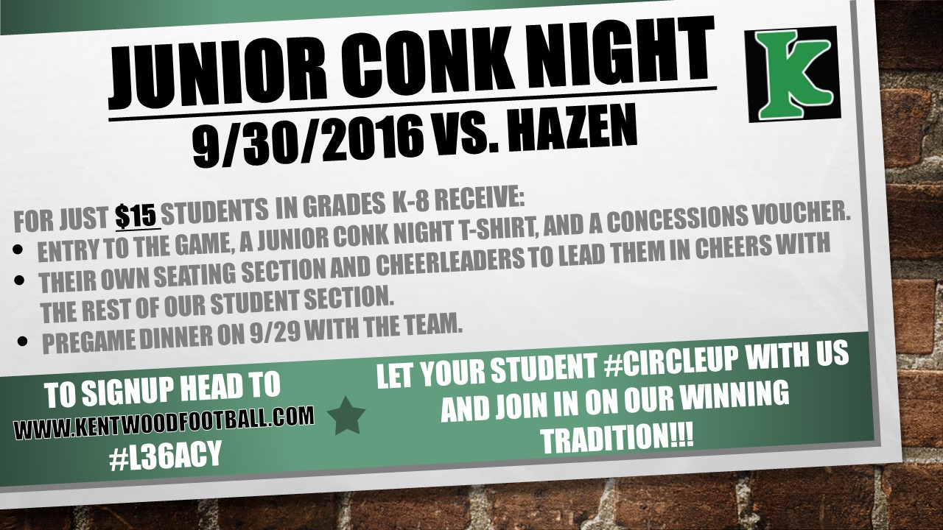

**School has started which means so has high school football. We are a part of this great community so we hope you follow and support our high school teams. The schedules can be found at** [**www.npslathletics.org**](http://www.npslathletics.org)**.**

**Football & Cheer Practice Schedule, the week of September 12th (subject to change):**

* Football: Tuesday - Thursday, 6:00pm-8:00pm.
* Cheer: Monday, 6:00pm-7:30pm at Kentwood High School, Tuesday and Thursday, 6:15pm-7:45pm at South Elite.

**WATER, WATER and MORE WATER**! For the safety of our kids, please send them to practice well hydrated and have them bring water to practices.

**WEATHER:** Send players to practices prepared for the weather. Please stay at practices if it looks like we could have thunder/lightening. If we have thunder and lightning, we will get kids off the fields and can't return until 30 minutes have passed from the last thunder/lightning strike.

**COMMUNICATIONS:** If you are not receiving weekly email communications, send us an email at [kentknights79@gmail.com](mailto:kentknights79@gmail.com) and have us add your email address. Please "LIKE" our Facebook page, KENTKNIGHTS JR FOOTBALL AND CHEER. Information will be posted on our Facebook page frequently.

**FOOTBALL GEAR:** please take care of it!! Helmets are sent out yearly for recertification so they are safe for our players. We should all know that this is a huge expense to our organization so let’s be certain that all gear, not just the helmets are taken care of. Pants can be washed and hung dry and please do not wash the shoulder pads.

**FOOTBALL GAME JERSEYS** for Pre-Registered players that were fitted for jerseys during the off season and are in the Kent School District have had jerseys ordered.

**TEAM COMMUNICATIONS** will begin to be sent out by your team mom once your coach has picked the team mom. The team moms will be a great resource to you and will work with the board communicating information to you. If you can't attend practices or games, please contact your team mom. If your team does not have a team mom as of yet, feel free to email us at [kentknights79@gmail.com](mailto:kentknights79@gmail.com) and we will pass your information on to your coach.

**PRACTICE LOCATIONS-**As a reminder, we rent the facilities from the Kent School District and have a great relationship with them.  Please take care of the fields. Park in designated parking stalls only, do not block fire lanes. Please pick up trash and no dogs are allowed on the fields.

***Not blocking fire lanes is super important. If we have an incident and need to call an emergency vehicle, they must be able to access the fields. It would be horrible if it was your child needing attention and the vehicles couldn't get to them due to a vehicle illegally parked.***

We are still looking for **volunteers** to help with a variety of duties. If you are interested in assisting with concessions, being a team mom/dad or merchandise, email us at kentknights79@gmail.com.

**Our MERCHANDISE COORDINATOR, Karah is starting to sell gear! Come check out what she has for sale and get ready to show your spirit!**  If you would like to order gear, let us know via email and we’ll put you in contact with Karah.

There will be no **REFUNDS** after August 8th

**RETURN CHECK FEES-** As a reminder, if a check is returned to us, you will be notified by email or phone and will be charged a return check fee of $25. Please take care of this immediately.