

Women’s Soccer

Men’s Soccer

Volleyball

Football

Cross Country

Cheer

Dance

Cheer

Cheerleading

## Fall Sports

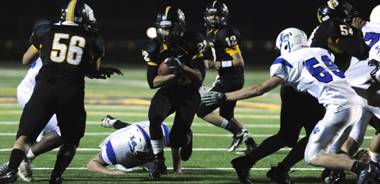

## Winter Sports

Wrestling

Swimming

Women’s Basketball

Men’s Basketball

Cheerleading

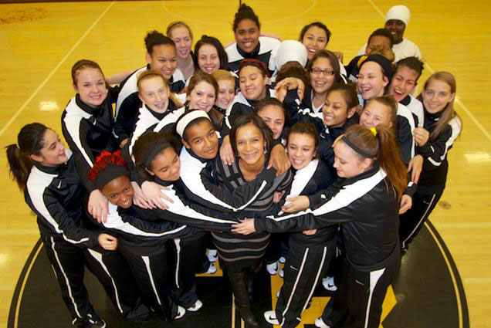

Roosevelt

Riders

2016– 2017 Season

Contact A Coach

Women’s Soccer ***Jennifer Lohse***

(503) 916-5260 jennifer@sjobeck.com

Men’s Soccer ***Victor Martin del Campo***

(503) 260-4271 V_martindelcampo@hotmail.com

Volleyball *Jill Emmert-Tricarico*

(503-916-5260 jillemmerttricarico@gmail.com

Football ***Adam Kennybrew***

(503) 310-7748 akennybrew@pps.net

Cross Country ***Jonquil Vann-Tessmer***

(503) 312-7802 jvann@pps.net

Cheer *Michelle Frost*

(503) 916-5260 frostees10@hotmail.com

Dance ***Mandy Mucci***

(503) 453-2483 mandy.mucci@gmail.com

Swimming ***James Duckworth***

(503) 916-5260 jduckworth@pps.net

Wrestling ***TBD***

TBD

Women’s Basketball ***TBD***

TBD

Men’s Basketball ***Michael Lee***

(503) 916-5260 leeandrewmichael@gmail.com

Track & Field ***Jonquil Vann-Tessmer***

(503) 312-7802 jvann@pps.net

Baseball ***Nate Grisham***

(503) 916-5260 ngrisham06@hotmail.com

Softball ***Kelsey Green***

(503) 267-2030 kgreen@pps.net

Women’s Tennis ***Karey Osuna***

(503) 312-6103 kareyofan@gmail.com

Men’s Tennis ***Jack Hughes***

(503) 951-3281 jlhtx10s222@gmail.com

Track & Field

Baseball

Softball

Women’s Tennis

Men’s Tennis

## Spring Sports

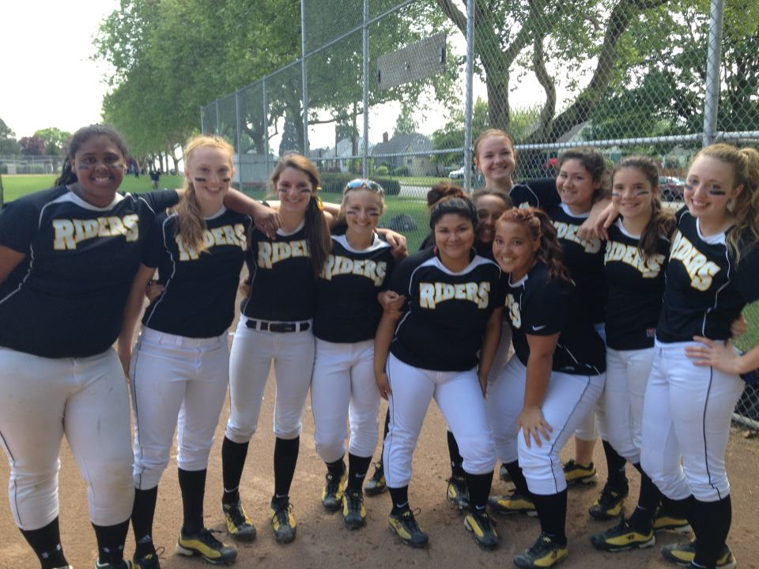

Athletic Department Coaching Staff

Athletic Director

Stuart Smith

[ssmith3@pps.net](mailto:ssmith3@pps.net)

537-220-8288

Athletic Admin:

Dan Malone

dmalone@pps.net

503-916-5260