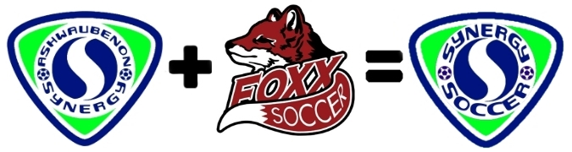
Foxx Soccer is excited to announce we are joining forces in a partnership with Ashwaubenon Synergy to provide high quality, age appropriate soccer opportunities for all players in our local communities!

This partnership is a great Synergy because our two programs have very similar philosophies.
- Our licensed coaches teach the fundamentals and work with players to develop their skills to prepare them for High School soccer & beyond!
- We work hard to keep player fees low to make competitive soccer accessible to more families
- We believe Soccer should be FUN! We encourage teamwork & multi-sport participation

The benefits of this partnership for Wrightstown soccer:
- Continuing to provide playing opportunities for Wrightstown players
  - Ability to form “all Wrightstown” teams wherever possible
- Leveraging our combined numbers to form age appropriate teams
  - In the past year, we combined up to 3 age levels to form a single team
- Using Synergy fields for fall/winter/spring training sessions
  - http://synergyfields.com/
- Using player evaluation sessions to better assign players to teams
- Access to 2-3 tournaments/year instead of 1-2
- Opportunities for fall season teams and off-season training for interested players
- Foxx’s fundraising efforts staying with our club/staying in Wrightstown
- The Foxx club maintaining its identity in WYSA
- Continuing to offer one of the lowest player fees in the area

Changes you will see:
- “Synergy teams” of combined Wrightstown/Ashwaubenon players will split field time between Ft. Howard Park and Wrightstown High School
- Player fees of $375
  - Discounts available for families with multiple players
  - Scholarships will be available
  - Additional fundraising opportunities will be offered to offset fees

Questions – Contact Scott Nicholas at 920.716.2743 or John Boettcher at 920.639.6889

