HOCKEY
BY CADEN

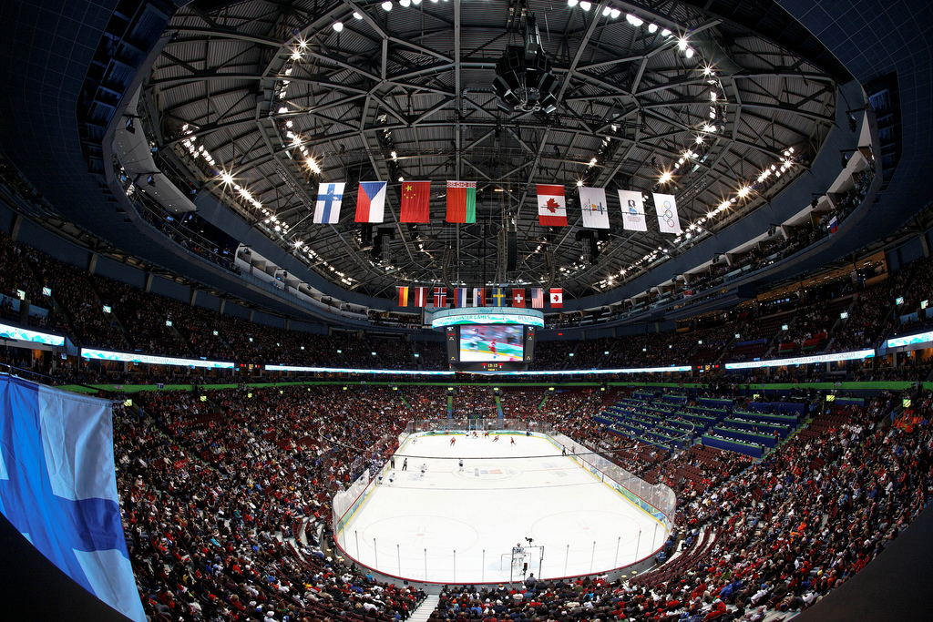

TABLE OF CONTENTS

WHAT IS HOCKEY?………………………………...1

WHAT IS A HOCKEY PENALTY?…………………1

HOW TO PLAY?…………………………………......2

WHAT GOALIES DO?………………………………2

WHAT ARE HOCKEY POSITIONS?………….......3

WHY YOU SHOULD PLAY?……………………….3

WHAT IS HOCKEY?

Have you ever seen crazy people on ice in a big place that have these weird stick things? It's probably hockey.
Hockey is a sport. There are usually fifteen to twenty five people on a kid’s hockey team.
It is played on an ice rink. A Zamboni cleans the ice so it’s not bumpy. You use skates to skate on the ice.
You use a stick to dribble the puck. You also have big pads so you don’t get hurt that easy. Warning you can get seriously hurt. If you see people kneel it’s probably because someone is hurt.
There are nine places to start a faceoff. The ref will drop the puck to start the game.

WHAT IS A HOCKEY PENALTY?

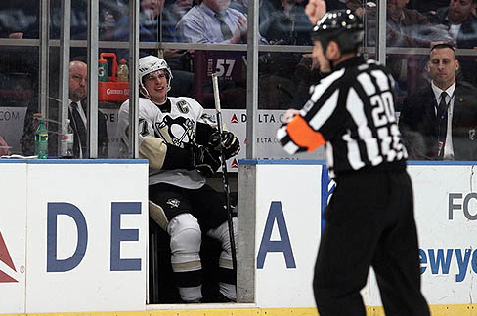
Remember the part when were I said that you could get hurt, this is the chapter were it is caused. A penalty is if someone hurts or injures someone on the other team.
There are different ways to get a penalty. One way to get a penalty is if you trip someone. If you hurt someone you will get a penalty. When you get a penalty the ref will call your number and you will sent to the penalty box for one and a half minutes long but in the NHL it’s two minutes long. Sometimes if you get a penalty instead of you going to the penalty box the other team gets a free shot on the goalie. You can only get a penalty if you go for a person and not the puck.
Off sides is when someone on the same team passes the blue line before the person with the puck does and the penalty is that they will have to start a face off.
If you get in a fight after the fight you both will be sent to the penalty box.

HOW TO PLAY?

If you were wondering how to play this is the right chapter for you. The hockey officials keep track of the score on the scoreboard. The point of the game is to score points and to pass the puck. You need to be able to skate very well if you want to play hockey.
There are three periods in a hockey game. A period is twenty minutes long in the NHL, but in kids hockey it’s twelve minutes long. They stop the clock before a face off but when the face off is over then they turn the clock back on. The shift will not end until either the goalie gets the puck or if there is an off sides or if someone scores a goal. But if it does not happen in time then they will switch the center the left wing then the right wing.
Fore checking is when you are going for the puck in the other team’s zone. Back checking is going for the puck in your zone. Crashing the net is when all forwards go to the net for a rebound. A hat trick is three goals in one game.

WHAT GOALIES DO?

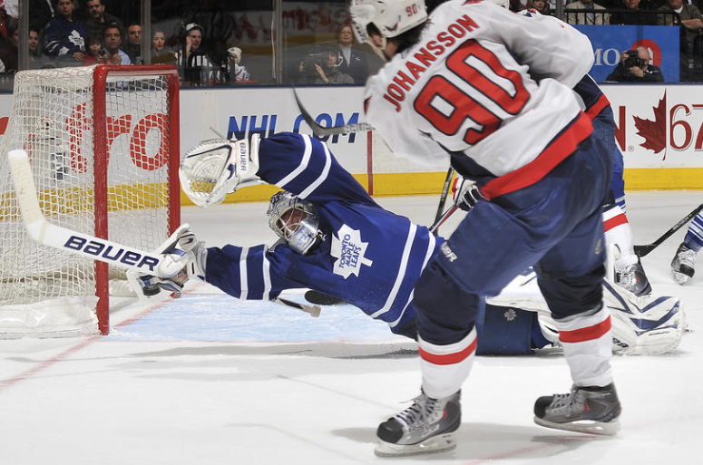
Goalies are the player that blocks the puck from going into the net. Goalies have different pads then players.
Goalies different saves are glove save, stick save, pad save, butterfly save, and skate save. If the player flicks the puck up then the goalie can save it by pad save or a glove save. If the person shoots the puck on the ice then the goalie can save it by a stick save or a butterfly save or a skate save.
The different shots are slap shot, wrist shot, and normal shot. If the goalie blocks the puck and holds on to it than the face off is at the nearest face-off circle. The dangler on the goalie is like a neck guard that dangles from the goalies helmet.
The goalie stick is different from a players stick because if the goalie is trying to do a stick save, the puck does not go over the stick.

WHAT ARE HOCKEY POSITION

Offense is when your team has the puck. Defense is when the other team has the puck. Left wing is offense on the left side. Right wing is offense on the right side. Left defense is defense on the left side. Right defense is defense on the right side. Center is defense and offense and it can be all over the ice.
Goalie you already know blocks the pucks from going in to the net. There are six people on the ice at one time counting the goalie. If there is a penalty then there are five people on the ice counting the goalie at one time. Sometimes if the team is losing by a few points then they might trade their goalie for one more person.

WHY YOU SHOULD PLAY
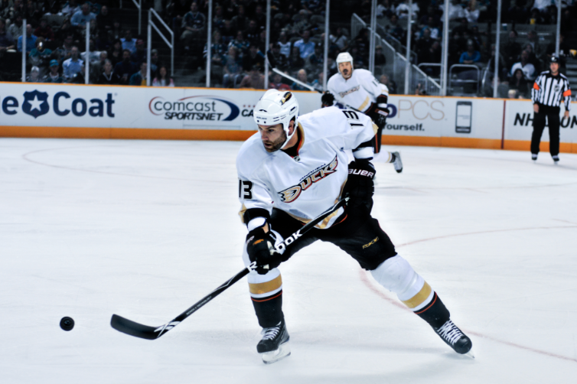
You should play hockey because its fun and you could get a six-pack. If you play hockey you deserve a six-pack.
If you play hockey for a long time you could be good enough to be on the NHL.
It is a good active sport. Make sure you go to the bathroom before you play.
If you play hockey you will be placed on the right team. You will change shifts about every minute off a brake in a game.

THE END

