Dynamic Warm-Up for Soccer Players
The purpose of a dynamic warm-up is to prepare the body for the demands of soccer. A dynamic warm-up increases your heart rate and core temperature, lengthens your muscles, and improves your body’s readiness to play. Dynamic warm-ups also help to keep you injury free.

Exercise | Description
Straight Leg March | Standing tall, reach left arm out straight ahead of you. Keep trunk stable and kick right leg up to meet your left hand. Take a step with left leg then reach right arm out straight and kick with left leg. Continue for 20 yards. | 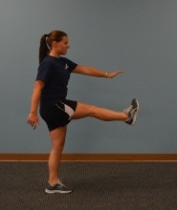
Leg Cradles | Stand tall and bring right knee into chest. Grasp your knee and foot. Pull the shin to waist height. At the same time, extend the hip of the left leg and drive foot into the ground. Hold for 3 seconds. Take a step with the right leg and perform movement on the left side. Perform 10 times total. | 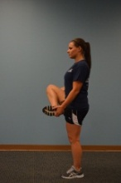
Inchworms | Get into a plank position with straight arms. Walk hands out a few inches then slowly inch your feet up towards your hands. Press heels into ground and keep legs straight. When you have inched up as far as you can, walk hands back out and repeat. Perform 10 times. | 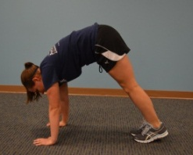
Spidermans | Get into a plank position with straight arms. Bring right foot up next to your right hand. Keep knee in and toes straight forward. Dip hips down and pick head up. Hold for 3 seconds. Bring leg back to the start and switch legs. Perform 16 total.
Lateral Shuffle | Get into an athletic base with feet shoulder-width apart and hips down and back. Side shuffle for 20 yards, stay low and focus on form. Return back to the other side. Perform twice. | 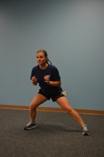
Linear Skip with Arm Swing | Skip forward while keeping arms straight and swinging them forward and back for 20 yards. | 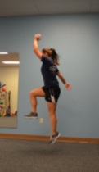
2” Runs in Place Rapid Response | Get into an athletic base with feet shoulder width apart and hips down and back. Keeping your form, perform quick feet up and down 2 inches off the ground as quickly as you can as if you are running in place. Perform for 20 seconds. | 