Dynamic Warm-Up for PASC and Phuture Phantoms Soccer Clinic
The purpose of a dynamic warm-up is to prepare the body for the demands of soccer. A dynamic warm-up increases your heart rate and core temperature, lengthens your muscles, and improves your readiness to play. Dynamic warm-ups also help to keep you injury free.
Exercise | Description
Straight Leg March | Standing tall, reach left arm out straight ahead of you. Keep trunk stable and kick right leg up to meet your left hand. Take a step with left leg then reach right arm out straight and kick with left leg. Continue for 20 yards. | 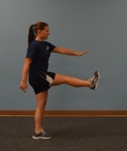
Walking Ankle Pull with Opposite Arm Raise | Squat down slightly and reach your right ankle back towards your right glute. Grab ahold of your ankle with your right hand and stand up tall. Reach your left arm straight up overhead. Hold for 3 seconds. Take a step forward with right foot and repeat with left side. Perform 10 steps. | 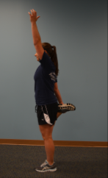
Inchworms | Get into a plank position with straight arms. Walk hands out a few inches then slowly inch your feet up towards your hands. Press heels into ground and keep legs straight. When you have inched up as far as you can, walk hands back out and repeat. Perform 10 times. | 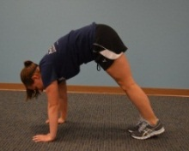
Spidermans | Get into a plank position with straight arms. Bring right foot up to your right hand. Keep knee and toes straight forward. Dip hips down and pick head up. Hold for 3 seconds. Bring leg back to the start and switch legs. Perform 16 total.
2” Runs in Place | Get into an athletic base with feet shoulder width apart and hips down and back. Keeping your form, perform quick feet up and down 2 inches off the ground as quickly as you can as if you are running in place. Perform for 20 seconds. | 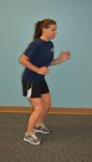
Lateral Shuffle | Get into an athletic base with feet shoulder-width apart and hips down and back. Side shuffle for 20 yards, stay low and focus on form. Return back. Perform twice each way. | 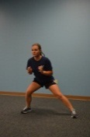
Skip with Arm Swing | Skip forward while keeping arms straight and swinging them forward and back for 20 yards. | 