PAA NIGHT AT TRENTON THUNDER
Thursday, May 19, 2016
Trenton, NJ

TICKET ORDERS DUE MAY 2
Join us on Thursday, May 19 for
PAA Night at the Trenton Thunder!
Tickets are $11/each

Last year, more than 650 players, siblings, guardians and coaches joined us for a fun-filled night at the ballpark. This year, the softball and baseball players will again walk in an on field parade prior to the game and stand with Trenton Thunder players for the national anthem.

Don't miss out on this great PAA community event!

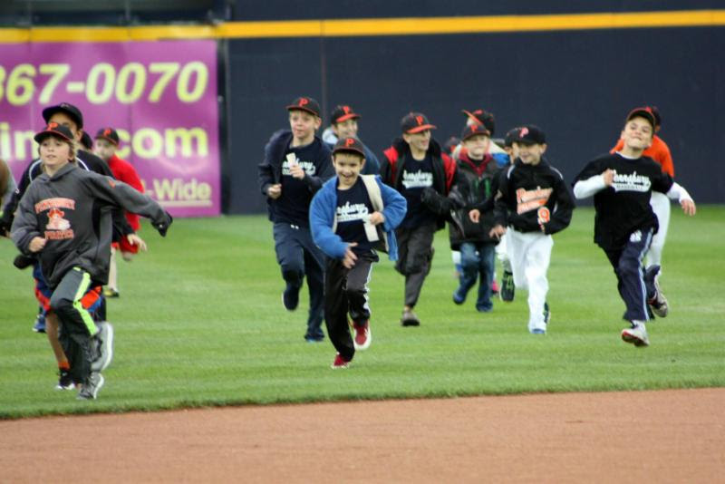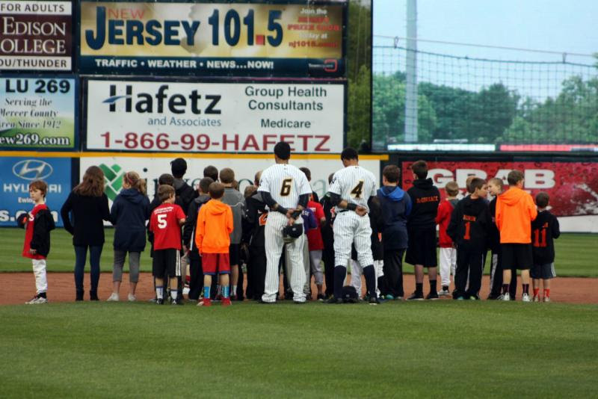

PLAYER: _______________________________________ TEAM: __________________________
PHONE NUMBER: _______________________________ COACH: _________________________
Number of Tickets: _______ x $11 = $_______________** Cash or checks made out to PAA! **

