****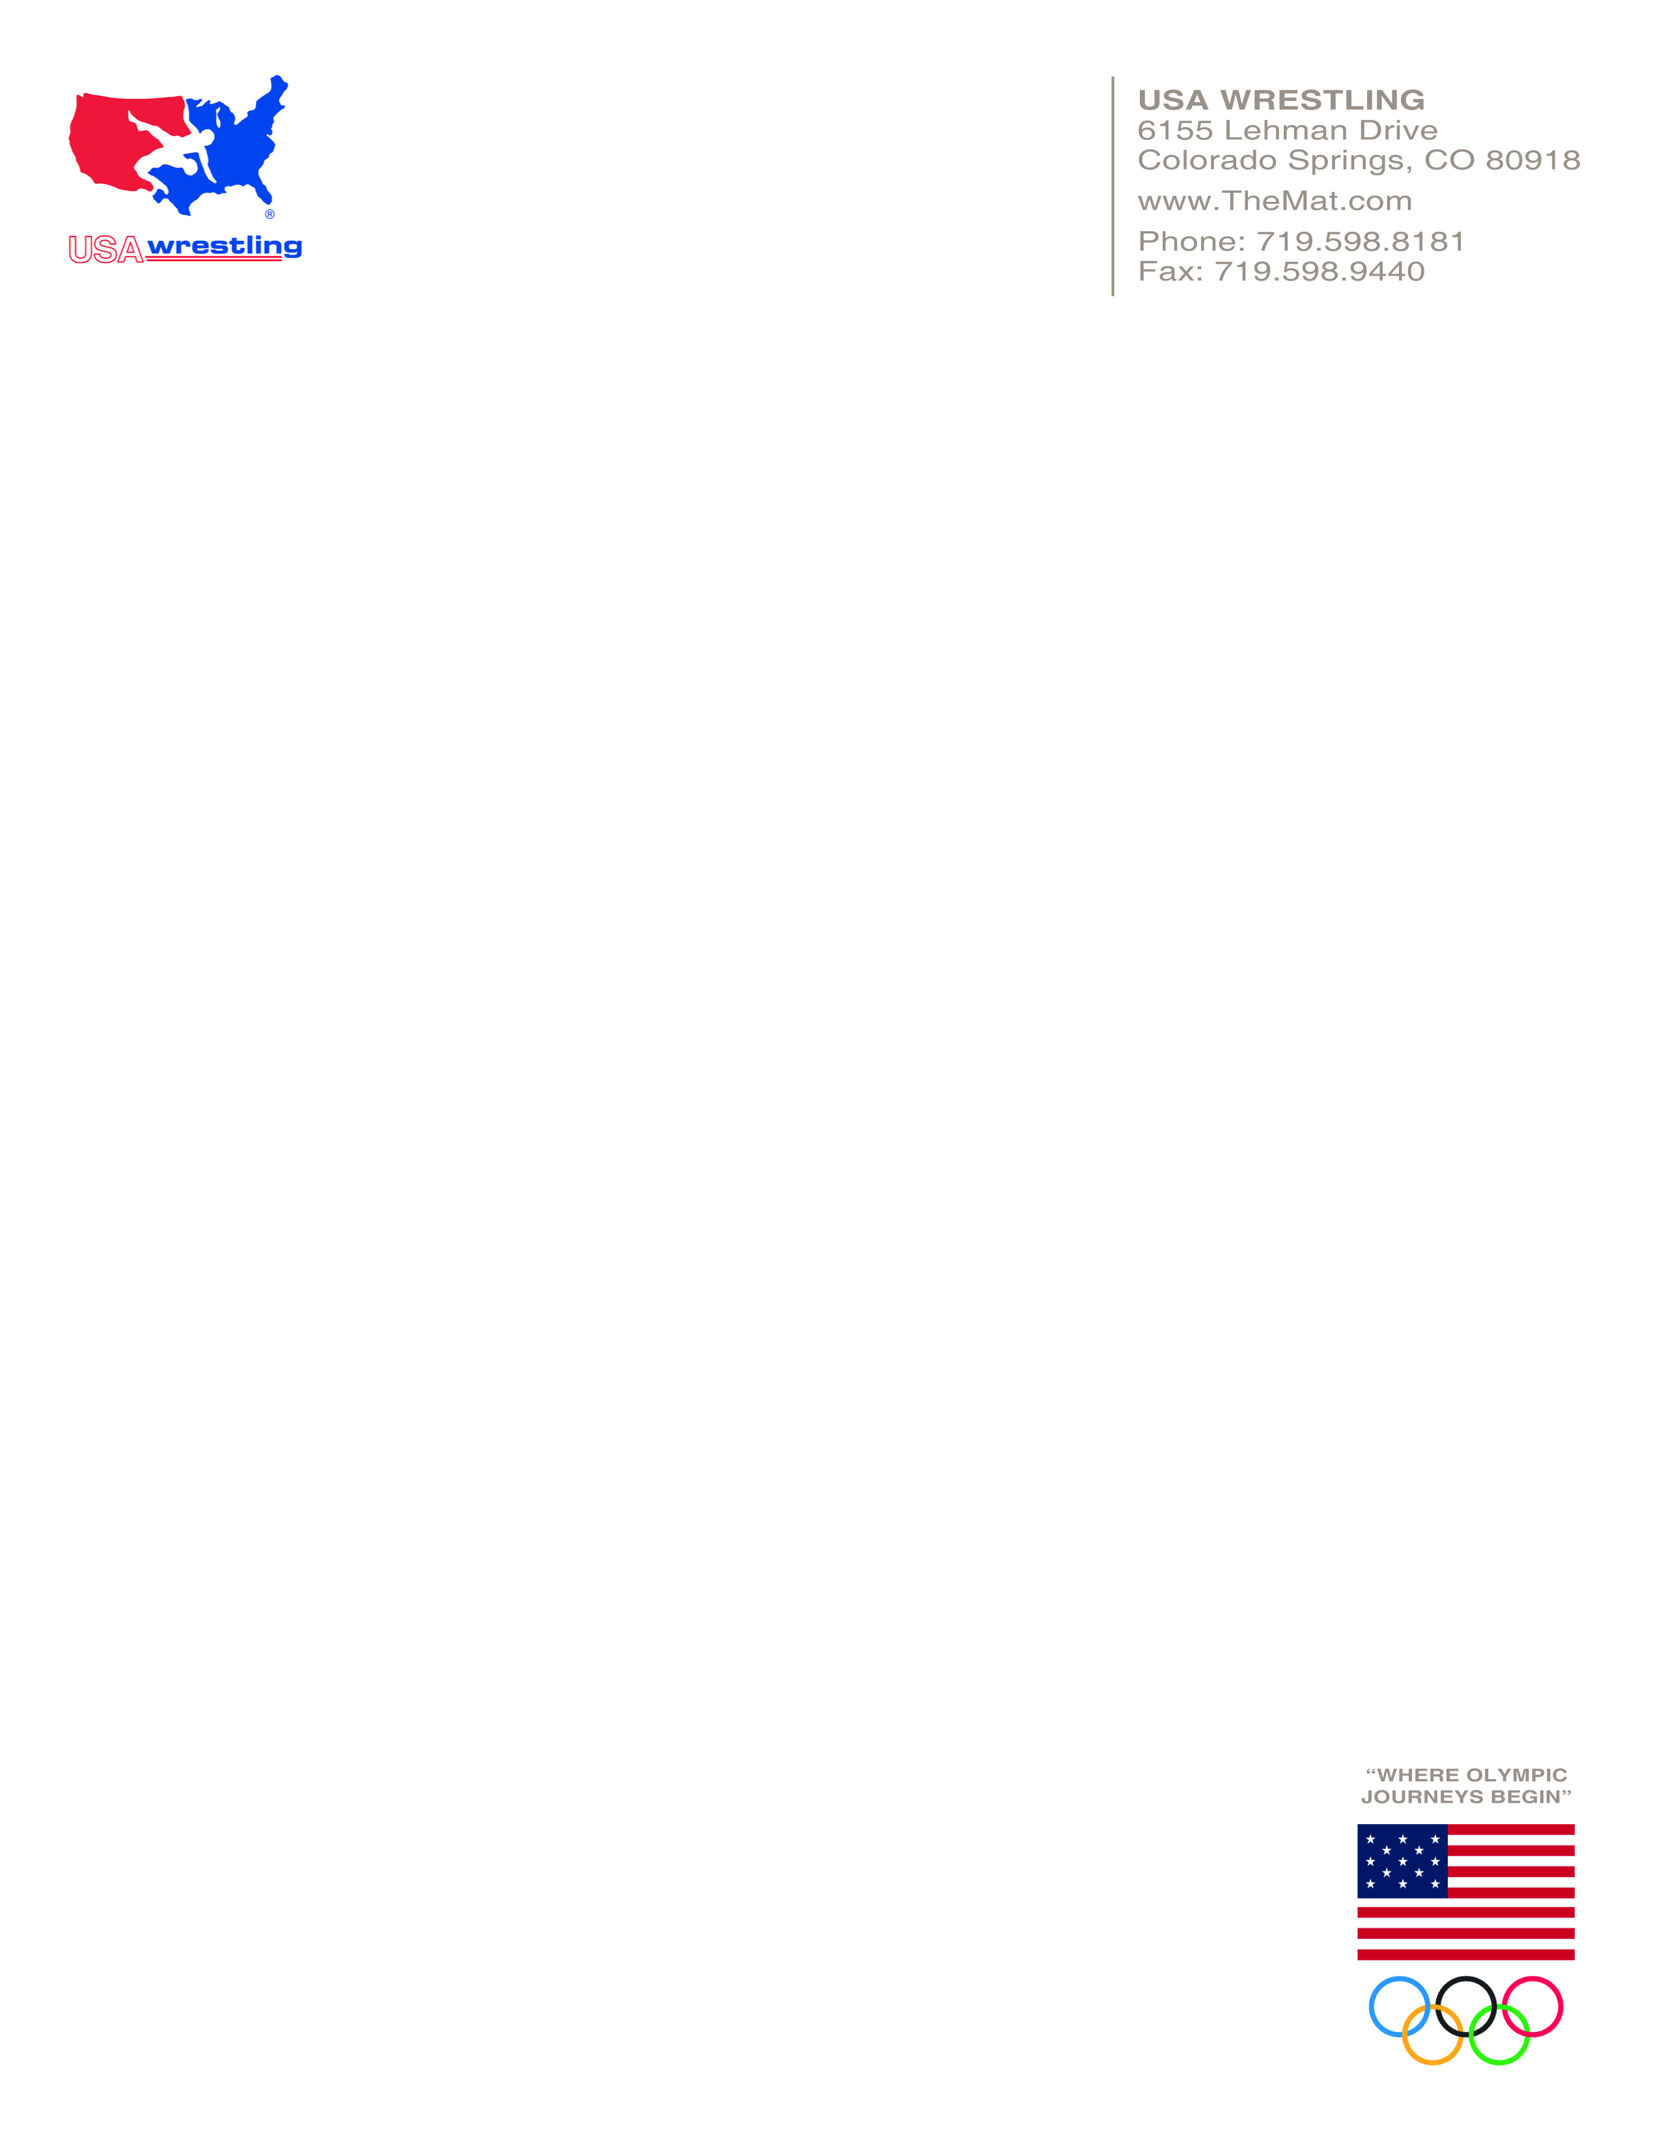

**Q. When is a license plate not just a license plate?**



**A. When it helps fund your wrestlers’ dreams of participating in a summer camp or the Junior Nationals!**

USA Wrestling is offering license plates like the one pictured above for $5 each plus shipping and handling for resale at $20 by your wrestlers. All of the profits are kept in your program to support your wrestlers’ dreams of attending a camp away from home or the Junior Nationals in Fargo, ND. These are real license plates true in size and material and ready to mount on the front of a car (where allowed by law), display in an office, bedroom or dorm or just give as a gift. A minimum purchase of 25 plates is required.

Go online to [**http://donate.usawrestling.org/licenseplatefundraiser**](http://donate.usawrestling.org/licenseplatefundraiser) and order today!

If paying by check, mail order form and payment to: USA Wrestling, 6155 Lehman Dr. Colorado Springs, CO 80918.

------------------------------------------------------------------------------------------------------------------------------------------------------

**LICENSE PLATE ORDER FORM** - Please make checks payable to **USA Wrestling**

I would like to order: 25 50 100 250 USA Wrestling License Plates @$5/each for a subtotal of $ __________.

Shipping 25-50 plates- $15.00, 100 plates- $20.00, 250 plates- $35.00 shipping total $___________

Total investment: $___________

Name: ____________________________________________________________________________________

Address: __________________________________________________________________________________

City, State and Zip code: _____________________________________________________________________

E-mail: ___________________________________________________________________________________

Attn: Steve Fraser