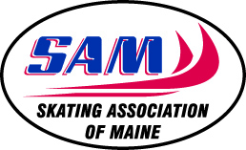

SKATING ASSOCIATION OF MAINE
PRESIDENT’S REPORT
April 3, 2016

The Skating Association of Maine (SAM) is a strong organization with over 400 members. Your membership and participation in activities allowed SAM to accomplish many goals this year.

Thank you to all of our members who again have pulled off another successful season on and off the ice. This is a volunteer organization, and it is our members’ support that makes this organization function. Your willingness to collaborate, share goals and values will allow SAM to continue carrying out our mission in the future.

Thank you to the SAM Trustees, Board of Directors and committee members who have volunteered many hours to this organization.

Please show appreciation to businesses that have supported SAM. Their support allows us to offer scholarships and affordable ice to our skaters. A list of those who have made donations to SAM is on our webpage at www.maineskaters.com.

SAM is fortunate to have the members that we do, as you all bring a unique gift to SAM. If you have a skill or interest that you would like to share with SAM this upcoming season, please contact a board member or committee member as we have many volunteer opportunities. We currently have a vacant IT position on the SAM board, please let us know if you would be willing to fill this position.

I wish you great skating this coming season!

Respectfully,

Susan T. Smith
Skating Association of Maine President
207-557-1954

