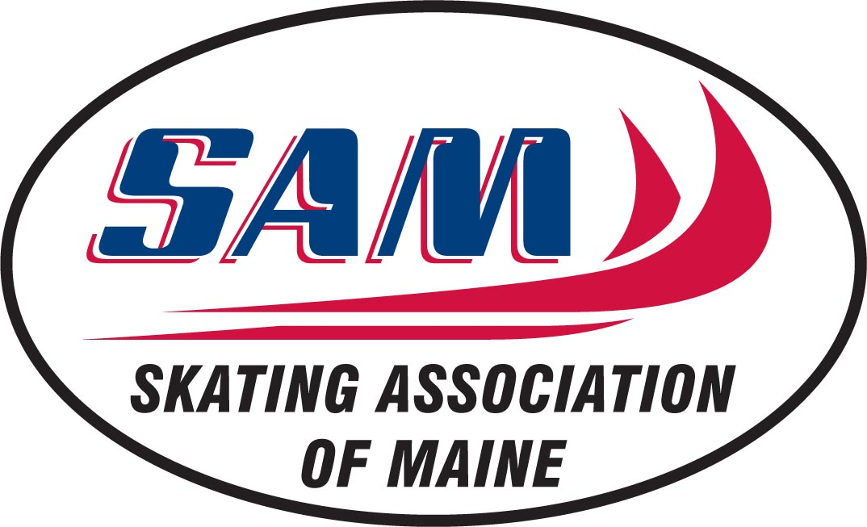

Treasurer’s Report
April 3, 2016

The Skating Association of Maine is near the end of another successful season. We continue to draw skaters from many outlying communities and welcome them to our organization.

During the season we held successful fundraising events to support our scholarship and education programs. Much of the success is contributed to having a new fundraising chair on the board of directors as well as greater participation of our members in efforts to raise funds. We thank all the businesses and individuals who are loyal to SAM and pledge that we will continue to build and maintain a strong association.

Thank you to all SAM members and volunteers who give generously of your time in support of our programs. We look forward to even more participation in the upcoming season. Your efforts and sense of community are what make SAM successful and continue to grow.

Congratulations to all the skaters for their achievements this year. They include successful competitions and test sessions for our figure skaters and hockey championships in our great state of Maine and beyond.

Happy skating,

Sandra Prescott
SAM Treasurer

