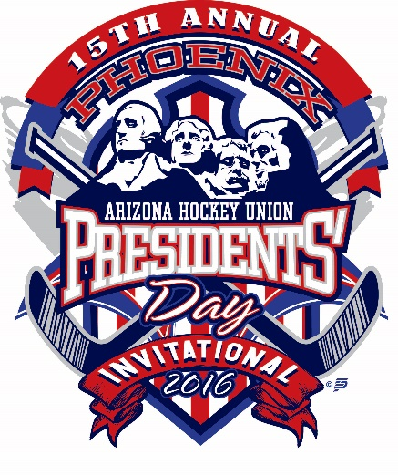
Tournament FAQs

- Do I need to bring pucks, or will warm up pucks be provided?
A. The tournament will provide warm up pucks on each bench. Pucks will be counted by the scorekeeper before and after each warm up. Please ensure that the number of pucks before the game are returned to the bucket for the next team.

- Do our players have to wear mouth guards? We don’t have to wear them at home.
A. All peewees and older (including the goalie) must wear a mouth guard in accordance with USA Hockey rules. This is without regard to equipment requirements in your home association.

- Do we have to provide scoresheet labels?
A. No, our scoresheets are automated, from the roster upload spreadsheet you provided.

- Will we be given copies of scoresheets to take back as proof our participation?
A. Each tournament venue will have a command center, and copies of scoresheets will be available after each game.
- There is a discrepancy in statistics posted on line, can we get the stats fixed?
A. The website statistics for individual players is used for entertainment purposes. The coaches must request that the scorekeeper amend any statistics on the official game record (scoresheet) during the game. Once a scoresheet has been signed and finalized by game officials, no changes will be made.

- How do I check in for the tournament?
A. Before your first game, please visit the tournament command table. Each venue will have one.
- What is the tournament command table for?
A. The command table will have locker room keys – please be prepared to provide a SET OF KEYs in exchange for a locker room key. We will NOT accept a driver’s license. We will also provide scoresheet copies, and any general assistance needed.
- Where can I find the rules to the tournament?
A. They are listed on our website, and will be included in our program.

