1st Grade Drills/Emphasis
Warm-up (3 minutes)
- Follow the Leader - Walk the kids around the basketball court explaining key lines/areas of a court. (Baselines, Side Lines, Half Court Lines, Free Throw Line, Lane, three point lines, left/right blocks, left/right free throw elbows)
- Simon (Coach) Says - Once you’re done walking around, play Simon (Coach) says “Run to the other Base Line”, “Run to the other Free Throw Line”. This will help the kids learn the keys areas of the basketball court and keep it fun. Also, “Coach says hop on one foot, two feet, etc.”

Stationary Ball Handling (3 Minutes)

- Fingertips – back and forth between hands. Start by head and move down to their feet while trying to maintaining control
- Around the World – Rotate ball around their heads, waist, both knees, individual knees, ankles
Stationary Dribbling (L/R) (5 Minutes)
- Single Hand dribbling – Feel the basketball with their hands, keep fingers wide apart, dribbling waist high, maintain control. Emphasis keeping their head up, ask them how many fingers you’re holding up
- Cross Over dribbling – Maintain control, work on pushing side to side, not straight down dribbling.
Dribbling While Walking (5 Minutes)
- Dribble Relay - Half court and back relay – Stress control. Regardless how fast they walk, always under control. Begin working on heads up, how many fingers are you holding up
- Obstacle Course – Using cones or chairs, have them dribble between the cones/chairs, switching hands using the cones/chairs as defenders. Keep none dribbling hand up to keep ball away from defender
- Stop Light - Green Light (Go), Red Light (stop, but keep dribbling), Yellow Light (back up dribbling)
- Traveling - Show/discuss what “traveling” is and why we don’t want to travel
- Double Dribbling - Show/discuss what “double dribbling” is and why we don’t want to double dribble
Shooting (10 Minutes)
- B.E.E.F - Shooting Form (2 minutes)
  - Balance – footwork, toes to the target, knees bent
  - Elbow – Keep the elbow in, not out wide (does not have to be straight up and down)
  - Eyes – Eyes on the target, pick a target on the rim or backboard
  - Follow Through – Hand/arm should look like a Fish Hook/Goose neck. Ask them to freeze their follow through so they can show you their follow through and you can help instruct them.
- Over the Rainbow - Shoot Up , regardless of form, everyone needs to work on shooting up, not at the basket like a line drive (2 minutes)
- Lay-ups – Stationary – String attached to the same side knee and elbow. Work on it multiple times; ask them to hold the lay-up position. (6 minutes)
  - Skipping - take a few steps and skip switching between hands.
  - High Five - Start at elbow and have the kids take few steps and high five you with the proper hand and leg in the air like a lay-up
  - Give them a ball and start them on lay-ups from each free line elbow.
Passing/Catching (5 - 8 minutes)
- Partner Passing Stationary – Back and forth the lane width apart work on bounce and chest passing; Two hands on the ball; push out from the chest while stepping towards their partner. (Bounce pass should bounce on the floor two thirds of the way to the partner, not half way)
  - Catching – Hands ready and open to catch with both hands
- Partner Passing Moving – Back and forth the lane width apart and start moving going to half court and back while passing the ball back and forth to each other. Focus on moving and heads up, seeing the ball.
- Triangle Passing – 3 players for a stationary triangle – Work on passing and receiving but now incorporating pivoting them to the person they are passing to.
- 3 Person Weave - Introduce 3 person weave without a basketball – Half Court and back.
Triple Threat Position
- Explain what it is, Pass, Dribble or Shoot
- Knees bent, ball on hip, swing through to the other side
- Tell them that at any point you may stop what they’re doing and say “Triple Threat Position” and they should instantly get into the position.
Defense (No reaching, stealing or hugging)(5 Minutes)
- Defensive stance – Knees bent, butt down, hands up, feet more than shoulder width apart. Keep their eyes on the dribblers chest
- Defensive Mirror - You can then dribble a basketball and have them follow you instead of mirroring your movements. They would be “defending” you. Have them between you and the basket and explain why that is important.
Shell Drill – Defensive Positioning (10 minutes)
- 3-5 cones on the three point line. Offense and Defensive player on each cone.
- Pass the ball around from player to player on each cone. Make sure they make good passes and go into Triple Threat position once they receive the ball. The Defense must move and adjust with each pass.
- The defensive players are not to steal or intercept the ball, since this is drill designed to emphasize proper positioning on the floor. The defensive players must work on proper positioning in relationship to the offensive player they are guarding. Below is a diagram of what the proper positioning should look like.
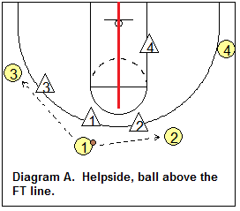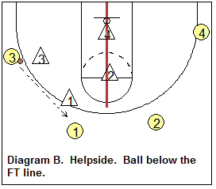
Read and React Basics (10 minutes)
- V-Cut - Introduce V cut to get open - Start with three spots on the three point line, one player or coach at the top of the key and two players on each wing. Wing players run down to each block and pop back out. Player 1 or coach passes to players 2/3 when they pop back out. Focus on hard cuts, good passes, catching to a triple threat position. See the diagram below for an example:
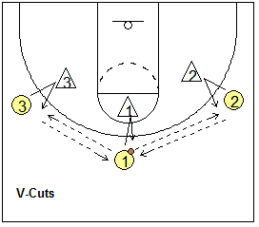
- Backdoor Cut - Introduce back cut (backdoor) – Same set up as V cut, but Player 1 will dribble at Player 2. Player 2 will cut hard to the basket, player 1 will bounce pass the ball to Player 2 and Player 2 will shoot a lay-up. Player 3 replaces Player 1. You can flip the side of the court, player 3 back cuts and player 2 replaces. Focus on hard cuts, good passes, dribble under control
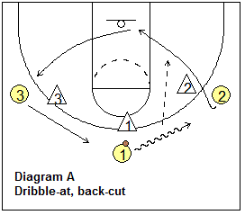
- Pass, Cut, Replace - Introduce Pass and cut – Start with three spots (you do not need 4 an d 5 as seen in the diagram below), player on each wing (2 & 3) and Player 1 at the top of the three point line. Player 1 start with the ball and passes it to either Player 2 or 3. Player 1 then cuts through the lane, Player 3 in the diagram below fills the spot player 1 just had, while player 1 will fill where player 3 was on the wing. Repeat over and over, working on passing, strong cuts, proper footwork.
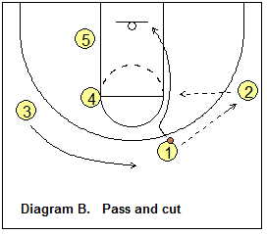

- End practice with a recap (1 minute)
  - Who remembers a drill we did today?
  - What was the best part?
  - What line is at the end of the court? (Base line)
  - Assign skills to work on at home with any kind of ball. Shooting form, dribbling, ball handling, etc.
Below is a Half Court diagram with key spots on the court to help the kids understand different locations on the court.