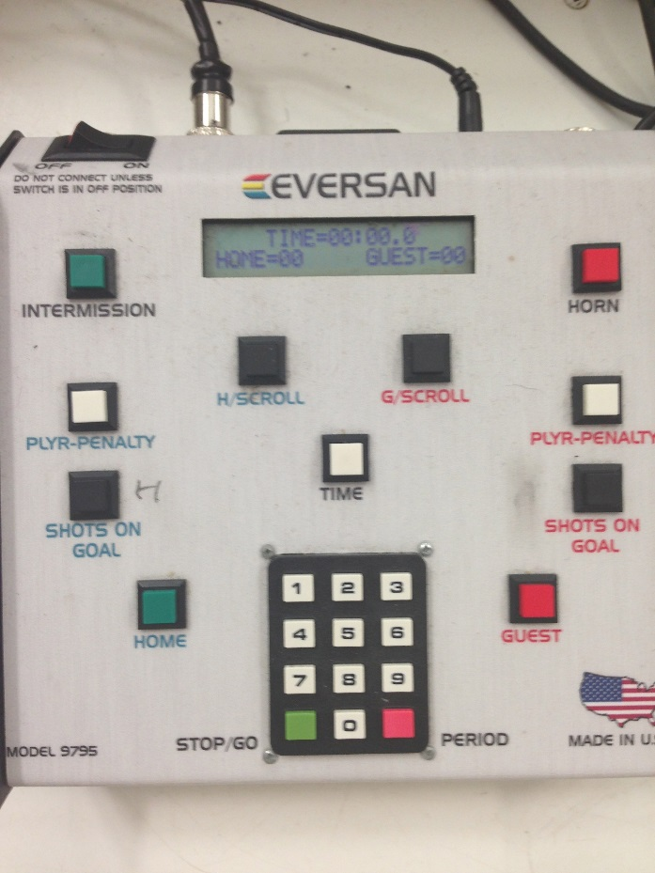

The Top Ten Things You Need to Know about the CLOCK:

When you sit down to get started hit the white TIME button and punch in the
numbers 1and 5 to get the 15:00 minute period ready on the board. You must do this at the beginning of each period.

You will also press the red PERIOD button before the start of each period so that the current period shows on the scoreboard.

The green STOP/GO button starts and stops the time. Press this button to start the clock when the puck drops and press this button to stop the clock when you hear the whistle, indicating a pause in the game.

You will use the SHOTS ON GOAL buttons to indicate when each team makes a shot on goal. This would be defined as a shot between the posts that requires an action from the goalie to keep it out of the goal. You will also press this button when a goal is actually scored. The green SHOTS ON GOAL button is for the home team the red is for the visiting team.

You will use the PLYR-PENALTY buttons to indicate when a player receives a penalty during the game. Again, the green button is for the home team and the red button is for the visiting team. When there is a penalty, hit the corresponding PLYR-PENALTY button. Then enter the player’s number (If it is a single digit enter a 0 before the number), followed by 0,2,0,0. Most penalties are two minutes. If it is something other than two minutes, the referees will inform you. Make sure you enter a 0 first, then 2,0,0!
The penalty time will automatically run down with the main clock time.

When our team scores a goal hit the green HOME button. (and the green SHOT ON GOAL button)
When the visiting team scores a goal, hit the red GUEST button. (and the red SHOT ON GOAL button)

At the end of the game before everyone leaves the ice, the numbers on the clock
should be set back to zero. If you hold the buttons down, the numbers will run
back to zero. Let off of the button when the number hits zero.

If it is your first time running the clock, please let the referees know.....they will help you.

Communicate with the person filling in the score sheet so that you are in sync with
what you are reporting.

If you are only watching YOUR child when running the clock, you will mess up.
You must pay attention to the whistle and the puck. :)

