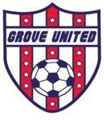

Grove United Soccer Association
Annual Board Elections – August 25, 2015
Vote for up to 4 Candidates

Place an “X” in the box next to the person you are voting for

Olbur, Daniel

Rinkers, Joe

Robinson, Will

This is a proxy voting ballot
(write an ‘X’ if Yes):

