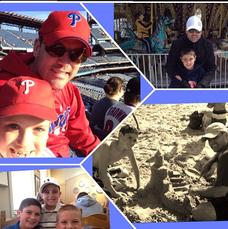

Fundraiser

**Sunday, April 12th, 2015 from 2 p.m. to 6 p.m.**

**to benefit the three boys and widow of**

**the late Middle Bucks Institute of Technology teacher**

**Christopher Tully**

For tickets, to make donations or for more information, contact [christullyfundraiser@gmail.com](mailto:christullyfundraiser@gmail.com)

or visit our Facebook Group, **Chris Tully Family Fundraiser.**

To Whom It May Concern:

I am writing this letter on behalf of the friends and family of the late Middle Bucks Institute of Technology teacher Christopher Tully, who recently passed away. Chris was an award-winning teacher who did so much for his students and the community as well. Chris has left behind three amazing boys CJ, Ryan, and Sean and his wife Kelli.

On Sunday, April 12th , from 2 p.m. to 6 p.m., at St. Cyril’s Church Hall on Almshouse Rd., we are running a fundraiser to help Chris’s sons and widow. We hope to raise money to offset bills that the boys and Kelli are experiencing as well as to put together trust funds for the three boys. There is a long road ahead of them, so we are looking to help them financially in any way we can.

Your organization can help us by providing any donations such as funding, items for donation or goods to help offset the cost of running the event. We are looking for donated items we can use for auction baskets or baskets of cheer to raffle off at the events as well.

Thank you in advance for your support.

Sincerely Yours,



Mike Speak

Brother of Kelli Tully