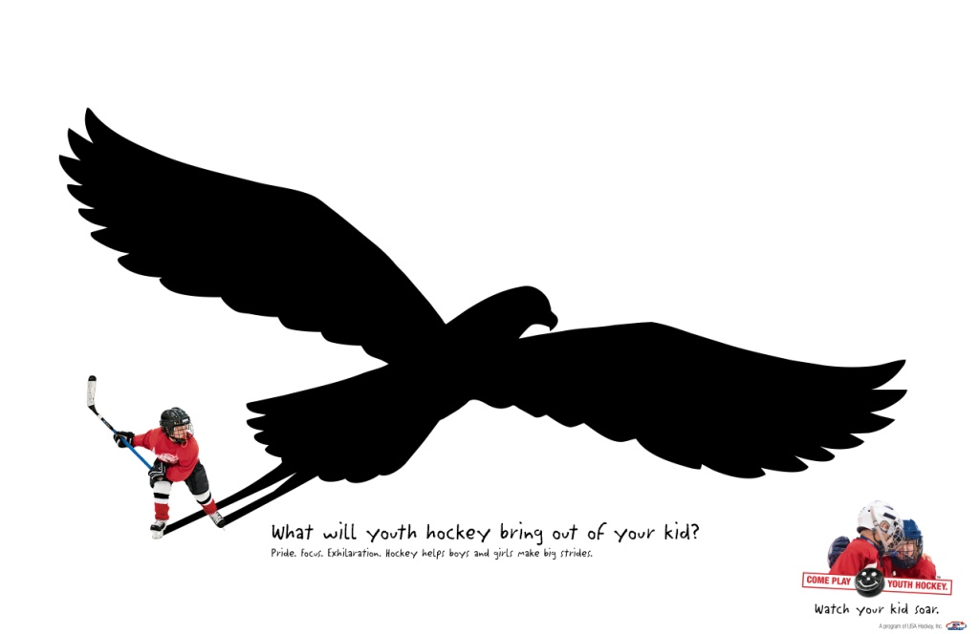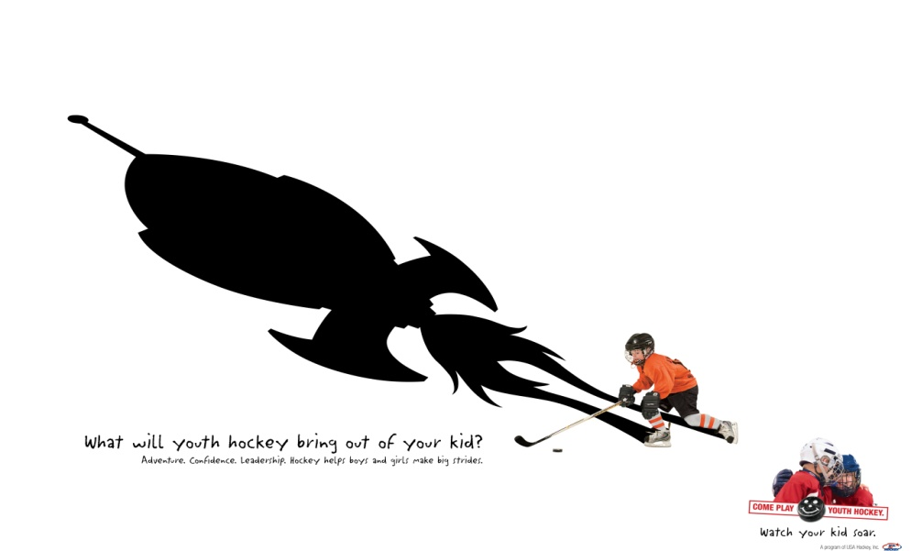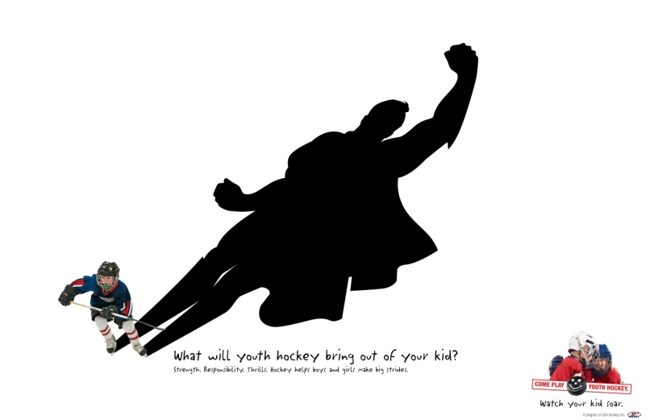

**Come Try Hockey For Free!**

Pueblo Youth Hockey Association, along with USA Hockey and Pueblo Ice Arena are hosting a Try Hockey for Free Event.

**Where:** Pueblo Plaza Ice Arena

100 N. Grand Avenue

Pueblo, CO 81003

**When:**  February 21, 2015

9:30 am – 10:30am

**Who:**  Kids ages 4-9 (not already playing

hockey for 2014/2015 season)

**Register at:**

TryHockeyForFree.com

**Please show up a little early so we can get the kids registered and geared up!**

For More Information Contact

**Gena Frazier 240-5652**

**Come Try Hockey For Free!**

Pueblo Youth Hockey Association, along with USA Hockey and Pueblo Ice Arena are hosting a Try Hockey for Free Event.

**Where:** Pueblo Plaza Ice Arena

100 N. Grand Avenue

Pueblo, CO 81003

**When:** February 21, 2015

9:30 am – 10:30am

**Who:**  Kids ages 4-9 (not already playing

hockey for 2014/2015 season)

**Register at:**

TryHockeyForFree.com

**Please show up a little early so we can get the kids registered and geared up!**

For More Information Contact

**Gena Frazier 240-5652**