AARON JOHNSON’S

Buffalo HOCKEY STP  
summer training program 2015

**Aaron Johnson’s Buffalo STP**

The Buffalo Summer Training Program is available for any Buffalo hockey player who will be a Squirt,U10,Peewee, U12,Bantam,U14 or Boy or Girl High School hockey player for the upcoming 2015 - 2016 hockey season.

Aaron Johnson’s

Buffalo Summer Training Program



*Individual Skill & Athletic Training*

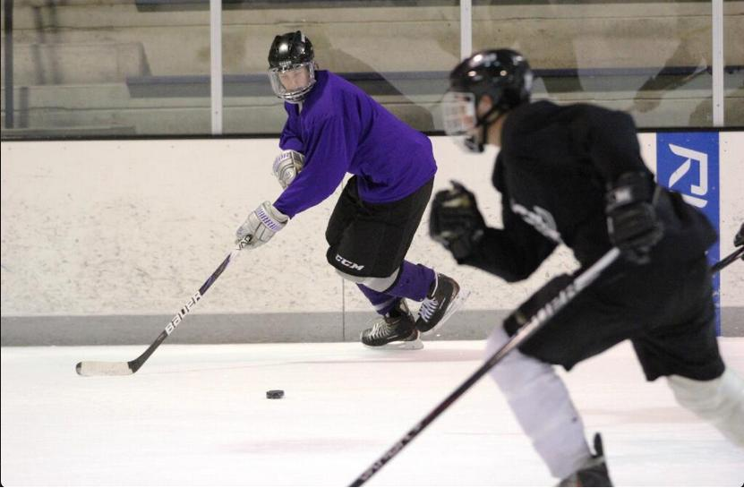

Fill out attached Registration Form and mail to:

Buffalo Summer Training Program  
3334 Xylon Ave. N.  
New Hope, MN 55427

For questions or further information  
email Coach Johnson:  
johnson.aaron9@gmail.com

Buffalo STP believes that the best way to maintain a top flight **youth and high school** hockey program is through **community based hockey** and the development of individual skills that will benefit a team game.

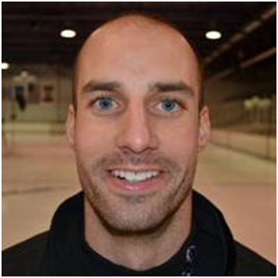

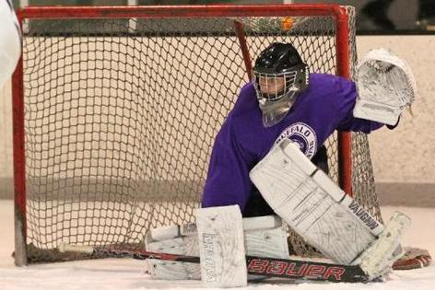





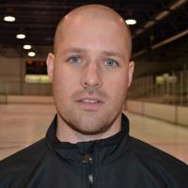





Aaron Johnson Head Coach  
Thomas Johnson Assistant Coach

Todd Weisjahn High School Hockey Coach  
Professional Goaltending Instruction will be provided

Buffalo STP

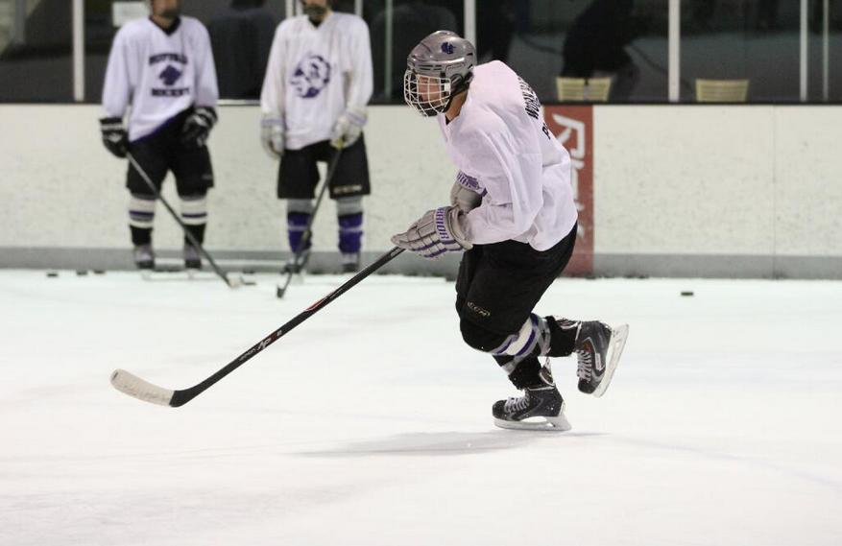

***Player Name _______***

***2014-2015 Team***

***Position***

***2014 STP (please circle one)   
 Squirt/U10 $400***

***Peewee $510***

***U12 $350***

***Bantam $510***

***U14 $350***

***Boys High School $525***

***Girls High School $400***

***Goalie Fee $250***

**\*Checks Payable to Buffalo STP**

**\*Registration Deadline May 15th-   
*$10 Late Registration Fee**

**\*A flat pro-rate may be available ONLY if discussed with Coach Johnson prior to registration.**

***Home Address***

***___________________ ______***

***____________________***

***Phone Number ____________________***

***Parent email _____________***

***Player email____________________________***

***T-shirt & Shorts Size ______***

***Parent Signature  
_____________ _________   
Please, complete and detach this portion of the   
pamphlet and mail with check.***

SIGN-UP FORM

June 8-July 2 & July 13-30

**Squirts & U10**: Tuesday & Thursday  
 On-Ice: 7:45-9:00 am  
 Off-Ice: 9:15-10:15 am

**U12 & U14**: Monday & Wednesday

On-Ice: 9:15-10:30 am

Off-Ice: 10:45- 11:45 am

**Peewee**: Tuesday & Thursday

On-Ice: 9:15-10:30 am  
Off-Ice: 10:45-11:45 am

Wednesday

On-Ice: 1:45-3:00pm

Off-Ice: 12:30-1:30pm

**Bantam**: Tuesday, Wednesday, &   
 Thursday  
 On-Ice: 12:15-1:30 pm  
 Off-Ice: 10:45-11:45 am

**High School Girls**: Monday &

Wednesday

On- Ice: 7:45-9:00 am

Off-Ice: 10:45-11:45 am

**High School Boys**: Tuesday,

Wednesday, & Thursday

On-Ice: 10:45-12:00 pm  
Off-Ice: At the High School

BUFFALO STP SUMMER SCHEDULE

Scrimmage dates with outside associations may be scheduled on additional days.

Off-Ice training will focus on hockey-specific lifting, plyometrics, core, and dry-land training. The dry-land training will include shooting and stick-handling and will also include other athletic activities (soccer, running, football, etc.) for the PeeWee group.

*Buffalo STP utilizes high-tempo, competitive practices, and skill-specific training*

Buffalo STP consists of on-ice and off-ice training to improve individual skills while implementing team skills that are used by the Buffalo High School Hockey Program. On-ice skills will include over-speed skating, shooting, and passing set in high tempo drills. Other skills developed include drills to increase on ice vision and hockey sense in small area drills and games including offensive creativity while using puck protection, creating time and space, and 1on1 skills. Defense skills will focus on angling, gap control, odd man rushes and proper stick & body checking technique to separate player from the puck.

# Buffalo Hockey STP 2015