How to Sync Calendar Schedule from Esko Hoops Club website to your iphone.

- Go to: http://www.eskohoops.org on your HOME COMPUTER
- Find your team under tabs at top
- Click on team – scroll down to the Calendar
- 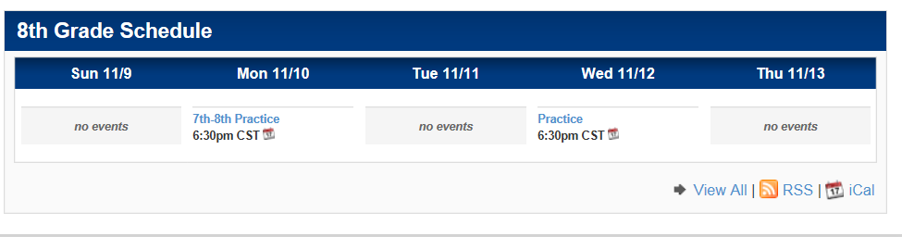
- Click on “iCal”
- This screen will appear
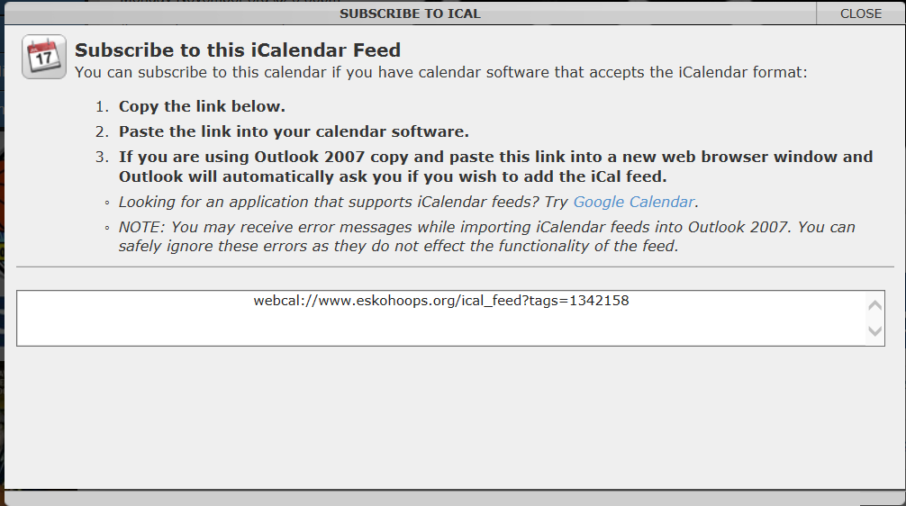
- Copy and paste the link into an email that you will send to yourself
- Open the email on your iphone and click on the link
- It will ask you if you would like to subscribe.
- Hit “yes” and your done!
- Your teams schedule will show on your calendar.
- Any updates to scheduling will automatically update on your iphone.

