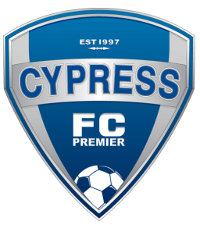

Dear Prospective Sponsor,

We are Cypress Futbol Club Premier. We represent the city of Cypress and surrounding cities in Orange County. We compete in one of the most prestigious soccer leagues in the Nation, the Southern California Soccer Developmental League. Cypress Futbol Club Premier provides an avenue for the youth of our community to compete at a very high level. We provide professional training in a positive environment. Our goal is to develop talented young athletes and provide them with the tools needed to carry their athletic careers into high school, college and beyond.

To maintain a support system for our youth soccer teams, we are dependent upon the generosity of our sponsors to help defray some of the costs necessary to equip our teams, pay for tournament fees, provide scholarships (for kids in need), and to help maintain practice and playing fields during the season. All teams are under the jurisdiction of Cypress Futbol Club, which is a non-profit public benefit corporation.

To become a sponsor, please complete the bottom portion of this form and mail your tax-deductible donation along with the bottom portion of this form to the address listed below. After you detach the bottom of this form, keep the top portion for your records. Each sponsor receives sincere appreciation and support from players, parents, and club members.

Your sponsorship will enable our players and teams to maintain a high level program of youth soccer within our club. Thank you for your support.

Sincerely,
Please Make Checks Payable to Cypress Futbol Club

Alan Furman
President
Cypress Futbol Club Premier
Tax ID Number 33-0858337

---------------------------------------------------------------------------------------------------------------------
Contact Name: ________________________________

Phone Number: _______________________________

Team Supporting: ____________________________

Player Name Supporting: ____________________

Date: __________________________________________

Company Name: ______________________________

Company Address: ____________________________

_________________________________

City, State, & Zip Code: ______________________

Cypress Futbol Club Premier DBA Cypress Futbol Club
P.O. Box 1129 Cypress, CA. 90630. (714) 767-5553

