A quick start for new users.

In order for us to be able to communicate to you it is best if you create an account on the SCGHA site http://www.SCGHA.com In order for you to access the team websites you will need to have a login account.

To do this go to www.SCGHA.com and click 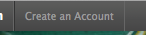 Found in the top left corner of the webpage. Then simply follow the on screen instructions. A confirmation email will be sent to you, which you will need to reply to. At that point you’ll be logged in. Next time you go to the website, just click login and use the account you just created.

To access House League teams choose “Our Hockey Programs -> House League” from the main menu.

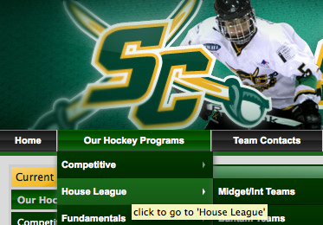

You may choose your team by choosing the division tab, and then the coloured team icon.

You may also use this page to subscribe to the individual team calendars, using iPhones, iPods, iPads, iCal, or MS Outlook. Simply click “Subscribe to iCal – calendar feed” there is one for each team and they are labeled accordingly

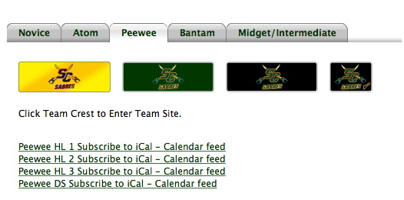

. On your mobile device, it should offer to subscribe to the calendar, simply answer OK, and then view in your calendar app.

