SHOOTER SHIRT

Front and back design

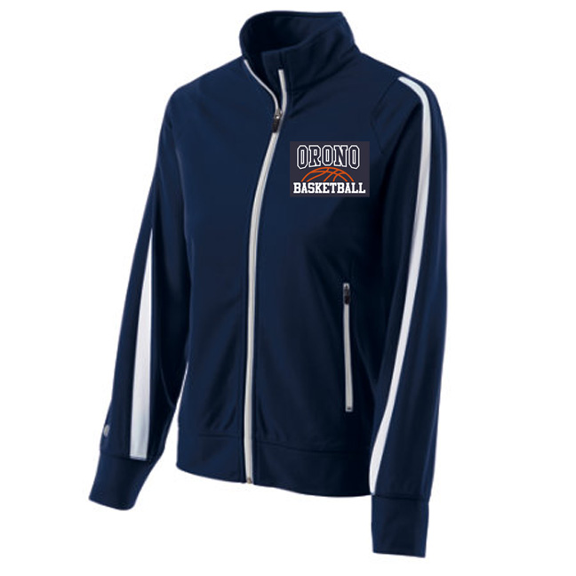

Ladies

performance practice shorts w//pockets C:\Users\TGISydney\AppData\Local\Microsoft\Windows\Temporary Internet Files\Content.IE5\V0L55VLU\MC900423171[1].wmf

MENS

Unisex

Bottoms

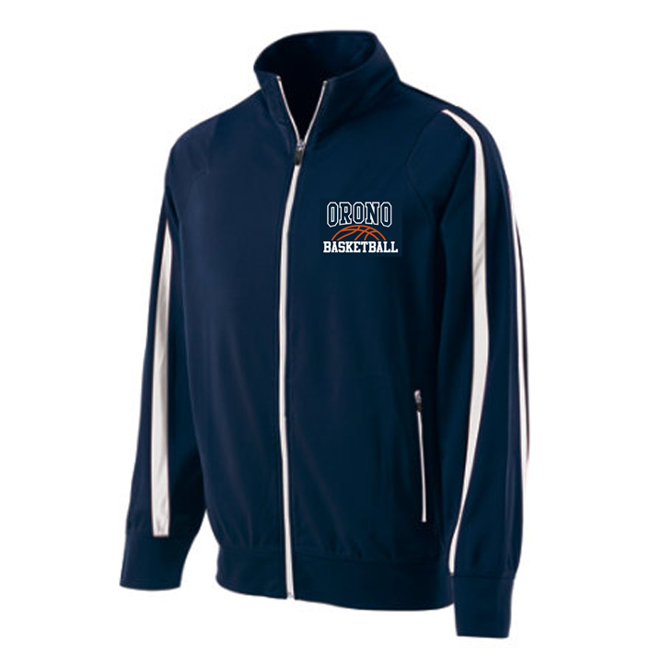

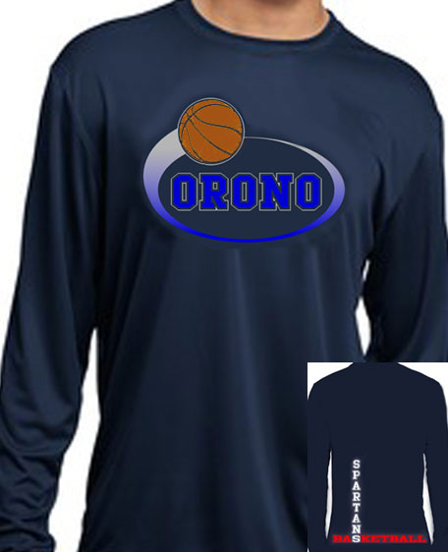

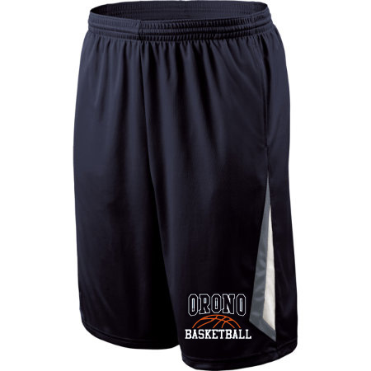

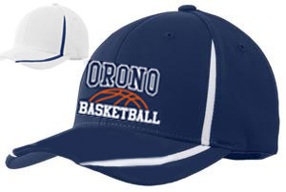

**Introducing the “NEW 2014-15” Orono Basketball line offered to you by Ittelwear. By popular demand Ittelwear will be offering warm ups for the first time. Custom fittings available for players & families.**

**Offered at “TRYOUTS” this Sat. & Sun.!**

**Middle school from 11:00am-4:30pm**

OFFICIAL TEAM WARM-UPS

youth, ladies & men’s cut

**\*\*** **buy separately or as a set**

**at a discount! \*\***

2014 unisex Team hoodie

Something for Mom

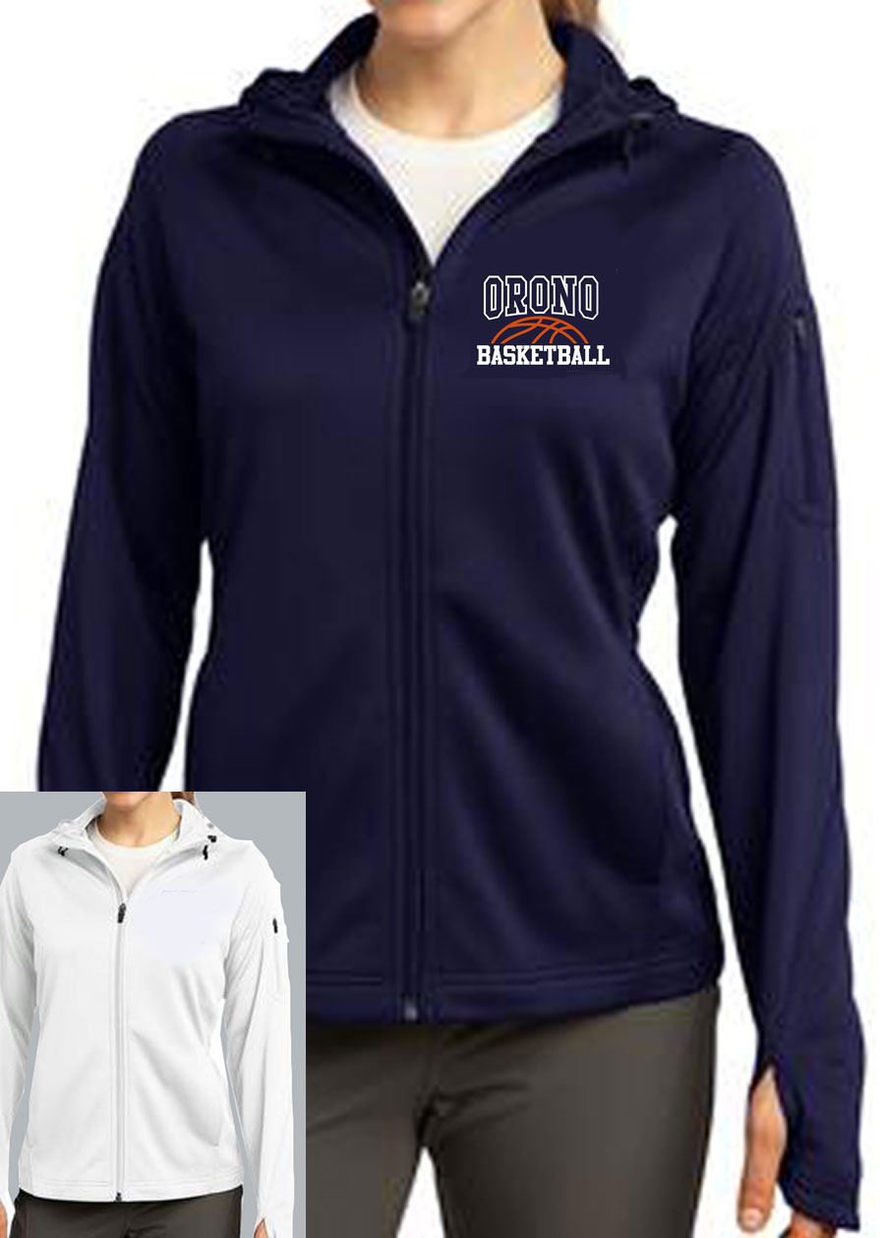

SOMETHING FOR DAD

