101 Field Day Games
A compilation of Field Day Games
From the Old Classics to some new exciting games. We’ve gathered it all! It’s fun, inclusive play through active games!
CIRA Ontario
Compiled by Bethany DeHaan

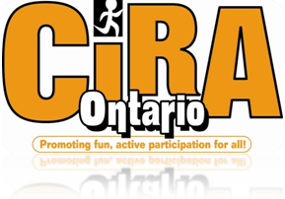

https://ciraontario.com/

Contents
Classic Games 6
Fishing Hole 6
Obstacle Course 6
Parachute game: Popcorn 6
Sack Race 6
Three-legged Race 6
Treasure Hunt 6
Truck Pull 7
Tug-o-War 7
Water Balloon Toss 8
Wheelbarrow Race 8
Track Games 9
Ball Throw 9
Discus Throw 9
Cross Country Run 9
High Dive 9
Jumping (Standing, and Running Long Jump) 9
Jump the Creek 9
Noodle Javelin 10
One Hundred Metre Dash 10
Shot Put 10
Track Race 11
Sport Games 12
Basketball Free Throws 12
Basketball Speed (Bump) 12
Blind Man Volleyball (BMV) 12
Bowling Bash 12
Croquet Golf 13
Frisbee Golf 13
Frisbee Throws 13
Kickball 14
Socci 14
Sploosh 14
Throw Volley Ball 15
Water Balloon Volleyball 15
Relay Race Games 16
Ball Hug Race 16
Beach Ball Carry Race 16
Chop Stick Relay 16
Clothes Relay 16
Cotton Ball Race 17
Duck Foot Relay 17
Egg & Spoon Race (or Apple & Spoon Race) 17
Penne Relay 18
Pizza Box Race 18
Scooter Rally 18
Soaking Wet Sweatpants Relay 19
Sponge Soaker Relay 19
Squirt Bottle Race 19
Water Bucket Relay 19
Water Shoot Out Relay 20
Water Sponge Relay 20
Wacky Waiter Race 20
Target Games 21
Bean Bag Tic Tac Toe 21
Bozo Buckets 21
Football/Frisbee Target 21
Froggy Finds a Pad 21
Hula Hoop Frisbee Throw 21
Target Toss 22
Water Games 24
Dunking Booth 24
Gopher Splash 24
Partner Squirts 24
Soaking Wet Sweatpants Relay 24
Sploosh 25
Sponge Race 25
Sponge Soaker Relay 25
Squirt Bottle Race 26
Tug Over Water 26
Waterslide 26
Water Balloon Smash 26
Water Balloon Toss 26
Water Balloon Volleyball 26
Water Bucket Relay 27
Water Shoot Out Relay 27
New Fun Games 28
Animal Tag 28
Balance Beam/BeanBag Walk 28
Balloon Burst 28
Bean Bag Challenges 28
Bean Bag Hunt 29
Bicycle Derby 29
Cage Ball 30
Clean Your Room 30
Cup Stack Tower 30
Diving for Eggs 30
Fifty Yard Scream 31
Frisbee Pancake Flip 31
Hula Hoop Marathon 31
Hula Hut 31
Marble Toes 32
Noodle Socci 32
Noodle Soup 33
Nuke Walk 33
Ping Pong Ball Blow 33
Plunger Challenge 34
Pyramid Battle 34
Rope Jumping Race 34
Rubber Chicken Throw 35
Shoe Kick 35
Sneaker Hunt 35
Sweep It 35
Tarps 35
Toe Tag 36
Trolley Walk 36
Ultimate Steal the Bacon 36
Watermelon Seed Spitting 36
Yarn ball Toss 37

Classic Games

Fishing Hole
Set up a fishing hole of paper fish and let the students "catch" as many of the fish as they can. To set up the game, you will need a large plastic pool, several paper fish, paper clips, tape, small round magnets, string and sticks to use as fishing poles. Tape a paper clip to each of the paper fish and put them in the pool. Set up the fishing poles with a small round magnet on the end of the string. Have students stand around the pool and fish for a predetermined amount of time, trying to catch as many of the fish as they possibly can.
http://kids.lovetoknow.com/wiki/Field_Day_Ideas_for_Elementary_Schools

Obstacle Course
Get creative with your obstacles. Find ladders, garbage cans even old lounge chairs, to crawl over, under, around and through.
http://www.nyrrf.org/ycr/events/field.asp

Parachute game: Popcorn
Toss multiple small rubber balls on the fabric while held taut, see how long your team can keep them popping!
http://blog.volunteerspot.com/volunteer_guru/2011/02/best-field-day-games-and-ideas-fabulously-fun.html#axzz2TNLvX8gg

Sack Race
Line up all the kids inside burlap sacks, or old pillowcases, hop to the finish line, first 3 win.
http://blog.volunteerspot.com/volunteer_guru/2011/02/best-field-day-games-and-ideas-fabulously-fun.html#axzz2TNLvX8gg

Three-legged Race
Divide into teams of two, tie up with ribbon and race in groups of 3 around a barrel of water and back.
http://blog.volunteerspot.com/volunteer_guru/2011/02/best-field-day-games-and-ideas-fabulously-fun.html#axzz2TNLvX8gg

Treasure Hunt
Divide the children into two teams. At the starting point, give each team a card with a picture of where the next clue is located. Provide different clues for both teams, except for the last clue. The team that reaches the location first wins. If you have a large number of children, divide them into three or more teams.

Truck Pull
When you do the truck pull make sure it is monitored very carefully by at least 3 volunteers to make sure there are no chances for accidents.
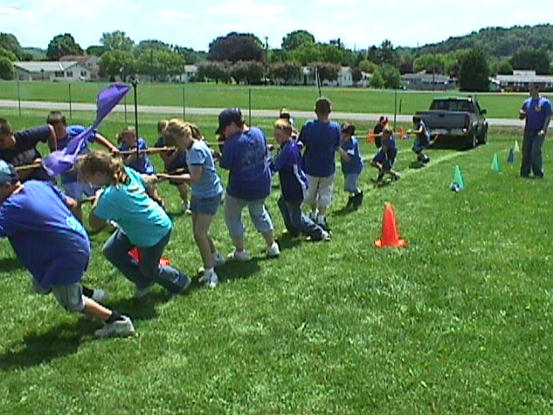
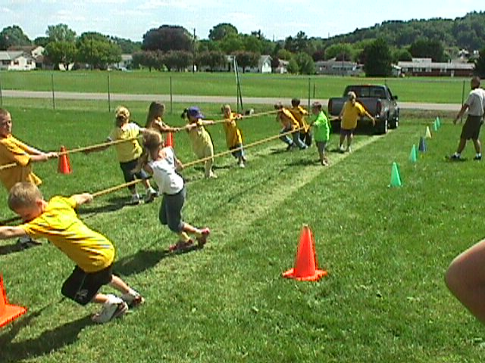
Set-up: Use a truck that belongs to a staff member, parent, or yourself. Set the truck up at a starting line with one end of my tug of war rope attached to the rear hitch (or to wherever you can attach). Be aware of how the ground is slanted. Have the truck on a slight grade downward opposite the direction it is being pulled, so the truck cannot roll in the direction of the pullers unless they are pulling. Set up cones to mark boundaries to keep waiting students from wandering into a danger area. Make sure you volunteers monitor these boundaries. To begin, teams will get hold of the rope, but must be behind a safety mark on the rope that ensures the driver of the truck can see ALL the students. On the signal, the class will be timed on how long it takes them to pull the truck (not running, but in neutral), from the starting line to the finish line, which is about a distance of 40 feet. Keep 1 volunteer behind the truck to make sure students keep a safe distance from the truck and to make sure to let the driver know if any students have fallen. Keep another volunteer to make sure students who are waiting do not come near the truck or track. And of course, a third volunteer is in the truck to steer, brake, and return the truck to the start line after each pull. Each class will get two attempts with the overall fastest time being the winner.
http://mrgym.com/Field_Day/Truck_Pulls.htm

Tug-o-War
Find a soft rope and tie several knots in each side. Divide into teams and place a large puddle of water in between the teams. First team to touch the water Loses
http://blog.volunteerspot.com/volunteer_guru/2011/02/best-field-day-games-and-ideas-fabulously-fun.html#axzz2TNLvX8gg

Water Balloon Toss
Field Day is all about being outside in the fresh air and hot sunshine, making water-themed games a must! For this game, have students pair off and line up about 6 feet away from one another. First students toss their balloon and those who do not drop their balloon stay in the game, taking two steps back to increase the distance from one another at each round. Continue until there is only one team left. See also Water Games.
http://www.roommomspot.com/2013/05/01/field-day-games/

Wheelbarrow Race
The wheelbarrow race is another great classic field day event that helps kids learn to work together. One child holds on to the other child’s ankles while they try to crawl on their hands to the finish line.
http://www.blisstree.com/2009/05/21/sex-relationships/10-fun-activities-for-field-day/

{Back to Table of Contents}

Track Games

Ball Throw
You can do a regular ball throw or you can change it up and use something else to throw. For ball throw try and use a foam ball. It will not go as far and might make things a little bit more even between contestants. With all track games remind kids to shoot for their personal best and do not compare to others.
http://www.kidactivities.net/category/games-outside-play.aspx

Discus Throw
Switch things up and use a paper plate! It makes their throw less predictable and it will even things out between kids. With all track games remind kids to shoot for their personal best and do not compare to others.
http://www.kidactivities.net/category/games-outside-play.aspx

Cross Country Run
Students will run around the hard top, (around the cones) must run around 8 times (1/2 mile). First one back wins.
http://teachers.net/gazette/MAY02/russo.html

High Dive
Each player stands on a chair (or faces the chair back-rest and then kneels chair seat) with ten clothes pins and drops them into an empty bottle. The player that gets the most wins.
http://www.kidactivities.net/category/games-outside-play.aspx

Jumping (Standing, and Running Long Jump)
Kids love to jump around and be active! Challenge them to jump as far as they can while standing, and while taking a running approach. Check out Jump the Creek for a fun alternative to Running Long Jump.

Jump the Creek
This is a fun alternative for the typical Standing and Running Long Jump events. Students will for a line in front of the creek. The object is to clear the “creek” without getting wet. A student is wet: 1) if they touch the rope which begins the creek, 2) if any body part touches between the rope and mat, or 3) if the student does not land on two feet safely. After each student has had a turn jumping, the rope is moved back and the creek widens. Depending on the number of students that remain in the contest, move the rope 6 inches or one foot. Jumping continues until there is a boy and girl champion for each class.Start at 4 feet for each class. If any students miss the first try, tell them why they would be out, but allow them to jump at the next distance. If a student is out, they should watch and cheer for the rest of the jumpers. If there is time left over, let everyone try again for fun!
http://www.perocks.com/gpage19.html

Noodle Javelin
Join rings into a colorful target for noodle javelins, flying disks, soccer balls, and more. Stakes keep the target upright and if you don’t have noodle rings tape can hold a makeshift ring in place. Assign different point values to the rings for an extra challenge. You can also lay the station on the ground to play hopscotch or beanbag toss or to use it as part of an agility course.
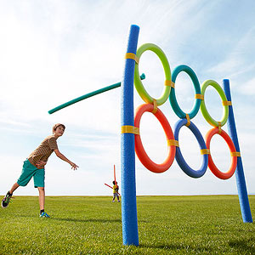
http://www.parents.com/fun/activities/outdoor/pool-noodle-backyard-games/?page=3

One Hundred Metre Dash
Using a field, create lanes using lime or white line paint. Measure out one hundred metres and have kids race against each other or run it twice to try and make a personal best time and beat their first time.

Shot Put
Switch things up and use a balloon! It makes their throw less predictable and it will even things out between kids. With all track games remind kids to shoot for their personal best and do not compare to others.
http://www.kidactivities.net/category/games-outside-play.aspx

Track Race
Each player lines up at the start line and race by placing the heel of one foot against the toe of the next.
The first one to the end of the track and back wins.
http://www.kidactivities.net/category/games-outside-play.aspx

{Back to Table of Contents}

Sport Games

Basketball Free Throws
See how many baskets you can make from a certain distance. Give everyone 10 shots only. Have them shoot from different distances: three meters away (just measure using your stride) then four, and five meters.
http://teachers.net/gazette/MAY02/russo.html

Basketball Speed (Bump)
This outdoor game requires minimal setup. All you need is two basketballs and a basketball hoop. Have children line up behind the free throw line of the basketball hoop. Give a basketball to each of the first two players in line. Play begins when the first student shoots the ball. As soon as the first player shoots, the second player can begin shooting. If the first player misses the basket, he continues to shoot. Once he makes a basket, he gives the ball to the next player in line and moves to the back of the line. If the second player makes a basket before the first player, the first player is out of the game. Play continues down the line until only one player remains.
http://www.ehow.com/list_6717729_list-field-day-games-kids.html
Blind Man Volleyball (BMV)
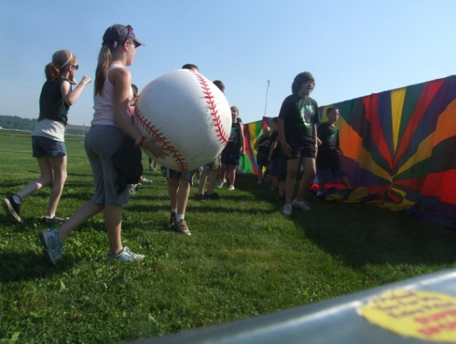
String up a rope to two poles and throw a parachute or tarp over it (You can also use a volleyball net). Have each team scatter on their own side of the net. Flip a coin to see which team will server first. The game begins when one team serves the ball over the net. Play continues, as in volleyball except each team has an unlimited number of hits to get the ball back over the net. Team must serve in order to get a point. Teams are allowed to help their own player's server. First team to 5 wins.
http://mrgym.com/Field_Day/Volleyball.htm
Bowling Bash
Set up 20 to 30 bowling pins. (Two-litre plastic soda bottles filled with an inch of sand make perfect bowling pins.) How many pins can students knock down in three rolls of the ball? Students in different grades might use different types of balls; for example, students in the primary grades might use a volleyball while older students use a softball. Mark with lime the location of the pins so they are reset in the same places each time. You might set up several games in a single location, each with a different monitor, so multiple students can bowl at the same time. Extra monitors might be on hand for pin set up. A net set up behind the pins makes the job of chasing down "bowling balls" a bit easier.
http://www.educationworld.com/a_lesson/03/lp315-01.shtml

Croquet Golf
Set up a series of croquet wickets. Make sure wickets are set at natural angles to make the course flow smoothly. You might use lime to mark the direction of the course. Provide each student with a croquet mallet and a ball of a matching color. How long does it take each student to hit the ball through the course? If you have a group of parents to supervise this station, multiple students can play at one time. Establish rules appropriate for the age of students. Following are some suggestions:
- Time each student. No reshooting allowed. If a student misses a wicket, he or she keeps going, but receives a 15-second penalty.
- Award a point for each wicket the ball goes through on the first try.
- Add up the number of strokes it takes a student to make it through all the wickets. To keep the game going smoothly, do not replay missed wickets; instead, missed wickets earn a 2-stroke penalty.
http://www.educationworld.com/a_lesson/03/lp315-01.shtml
Frisbee Golf
This game is set up with hula hoops, cones, and a small swimming pool. Set the cones on a course in the grass and lay a hula hoop next to each cone. The swimming pool is a water hazard. Give each student a pencil and small piece of tag board paper to keep score. Children toss their Frisbees to the first hoop. The score is how many tosses it takes to get the Frisbee in the hoop. If the Frisbee lands in the pool, it adds three points to the score. Lowest score wins.
http://suite101.com/article/ten-ideas-for-games-for-field-day-summer-camp-or-picnics-a247097
Frisbee Throws
Two partners throw a Frisbee and when one person catches it they both take one step back. The two that throw it the furthest and catch it win. (Might have two pairs throw at the same time, if space permits three or four pairs.)
http://teachers.net/gazette/MAY02/russo.html
Kickball
Play a game of Kickball game at the baseball diamonds. Same rules as baseball apply. The difference is the pitcher rolls a soccer/foam ball to the hitter/kicker and once it is kicked the inning begins.
Socci
This is played like a regular game of soccer except the nets, ball, and playing area is different. The nets are round basket-like goals. A goal is scored when the ball is kicked into the net. Boundaries can be set up according to the number of players, but it is relatively smaller playing area than an outdoor soccer game. The ball typically used for this game is a hacky-sack-like ball that is a bit smaller than a regular sized soccer ball. Soccer balls may be used in this game as well.
http://socci.net/
http://socci.net/the-sport/
Sploosh
Set-up a Volleyball net and court. Place a 5 gallon bucket of water at the end of each half of the court. You will also need 4-8 large sponges for this game, which will start off in the bucket. On the signal, players will begin throwing their water soaked sponges over the net to the opposing team. Players will then attempt to catch the sponges that are thrown to their side. After a catch, or a drop, the player will run the sponge to the water, where they will dunk the sponge and throw it back over the net.
The object of the game is to have the fewest strikes against your team. A strike occurs each time a sponge lands in bounds on your side of the net or each time your team throws a sponge that lands out of bounds. The activity of this game can be varied by the number of sponges that are in use. After the start of the game, there is no signal to throw, players just toss them as they receive and refill them. Scoring can be done in different ways. You can play with a time limit and the team with the lowest score at the end of the time is the winner. You could also play to a certain number, where the first team to reach a predetermined number ends the game. See Water Games for more water fun!
http://mrgym.com/MyField.htm
http://mrgym.com/Field_Day/sploosh.htm
Throw Volley Ball
Teams need to make one pass, before they throw it over. Up to three passes are allowed. Follow the same rules as in a regular game of Volleyball!
http://teachers.net/gazette/MAY02/russo.html

Water Balloon Volleyball
This is a water activity that children will enjoy. Set up a volleyball net in a grassy area and divide children into two teams. You will need balloons filled with water as well as a towel for each pair of children. Partners hold opposite ends of a towel and use it to catapult water balloons back and forth over the net. Use the same basic rules as in regular volleyball. This includes making 1-3 passes before tossing the balloon over the net. See also Water Games.
http://www.ehow.com/list_6717729_list-field-day-games-kids.html

{Back to Table of Contents}

Relay Race Games

Ball Hug Race
Each student will place a ball between his/her knees and race to the opposite line and back again. Use a smaller ball for the younger students and change the distance for different age groups.
http://www.pecentral.org/lessonideas/ViewLesson.asp?ID=1784

Beach Ball Carry Race
You and another person from your team must carry the beach ball to a cone and back without using your hands. If the ball drops you may use your hands to put it back in place, but while in motion you may not use your hands. Once you get back to the start line the next pair from your team goes.
This relay can be done as a team race. Pair people off with each group having one beach ball and mark out a distance with a start and finish.
http://www.pecentral.org/lessonideas/ViewLesson.asp?ID=1784

Chop Stick Relay
Students line up in three teams with the first person from each team standing on a poly spot. Give the first student in line two "chopsticks" (rhythm sticks). On the signal to begin, the first student will pick up the rubber chicken from inside the hoop using only the chopsticks. (They may not use hands or stick the chop stick inside the chicken). They will have to bring the chicken down to their stir fry pan, then return the sticks to the next student in line, who then goes to the pan and must bring the chicken back to the group and the process continues until everyone has had a turn. Equipment needed: Event sign, 3 hula hoops, 3 rubber chickens, and 2 chopsticks per line, 3 stir fry pans (which can be hula hoops).
http://www.pecentral.org/lessonideas/ViewLesson.asp?ID=2247 http://www.roommomspot.com/2013/05/01/field-day-games/

Clothes Relay
The group is divided into relay style lines. Each group has one set (pants, shirt, hat) of adult sized clothes. On "go," the first person in line puts on the oversized clothes. They then run to a cone (approx. 10 yards) and back. When they get back, they take off the clothes and the next person in line repeats the process. One team is not "done" when they all go once. The relay is done for a period of time. There is too much fun to worry about who is going faster!
http://www.pecentral.org/lessonideas/ViewLesson.asp?ID=1783
Cotton Ball Race
Materials Needed:
Lots of cotton balls, Vaseline, 2 or 4 bowls, tissue paper. Put a handful of cotton balls in one of the bowls. Put the bowl at one end of a rug or mat that is on the floor (Or just play on floor). Put the other empty bowl on the opposite end of the mat. Rub Vaseline on the child’s nose and have them put their nose in the bowl with the cotton balls. The object of the game is to get as many cotton balls as possible on their nose without using their hands. After cotton balls are stuck to their nose—they crawl over to the empty bowl --- and take them off their nose with their hands-- kids then put them in the bowl. Wipe the Vaseline off with a tissue or napkin. If you play with TEAMS set a time limit, and see who moves the most cotton balls from one bowl to the next.
http://www.kidactivities.net/category/games-outside-play.aspx

Duck Foot Relay
Craft two pairs of webbed feet. To make, draw the outline of a duck foot (about 14 inches from heel to toe) on the cardboard and use a craft knife to cut it out (a parent's job). Make the matching foot by placing the first one face-side-down on the cardboard and tracing around it. Cut the tissue box into halves and glue them on top of the feet with the box bottom facing up. Paint the feet bright orange or yellow. To race, divide a group of kids into two teams. On the far side of the room, set up a chair for each side. The first player from each team, wearing duck feet over his shoes, must circle his team's chair and return to the starting point while quacking and flapping his arms. The next child in line puts on the shoes and takes a turn. The first team to finish wins.
http://spoonful.com/family-fun/duck-foot-relay

Egg & Spoon Race (or Apple & Spoon Race)
Incorporating speed and coordination, this game really has kids howling and cheering for one another. Line students up in two side-by-side lines, give the first two a wooden spoon with an egg or apple on it and have them race to a finish line without dropping what they are carrying. 2 or even 3 teams, and use different types of objects to carry, try giant marshmallows, ping pong balls, potatoes. Or use chopsticks to carry items.
http://www.roommomspot.com/2013/05/01/field-day-games/
http://blog.volunteerspot.com/volunteer_guru/2011/02/best-field-day-games-and-ideas-fabulously-fun.html#axzz2TNLvX8gg

Penne Relay
Set Up: You will need a piece of string or rope, and 11 toilet paper cardboard rolls (without the toilet paper) for each group. On each roll write one letter of the phrase “Field Day Fun”. Set up the rope so that on one end there is the pile of cardboard rolls and the other end will be the start. Depending on the age group the distance between the rolls and the start can be changed.
To Play: Create even groups and have each team stand at the end of the rope across from their groups toilet paper rolls (which are the penne). One person at a time will run to the toilet paper rolls, grab one, put it on the rope/string, and slide it back to their group. Once they are back the next person goes. First group to have all their Penne back and unscramble the phrase “Field Day Fun” will win.
Adaptions: The part of the game that involves unscrambling a phrase can be taken out to make it a less challenging game for younger ages. To make the game more difficult you can use actual raw penne noodles on a string.
Adapted from Italy Pasta Relay: http://www.pecentral.org/lessonideas/ViewLesson.asp?ID=2247

Pizza Box Race
Start with a stack of 10 empty pizza boxes for each team and teams of 10 kids. Two kids at a time run the pizza boxes to a finish line and stack them, first one box at a time, then two, then three then four. There must be 4 hands on the box(es) at all time (2 kids). When all 10 boxes make it to the finish line, the team elects two kids to bring the entire stack back – as fast as possible.
http://blog.volunteerspot.com/volunteer_guru/2011/02/best-field-day-games-and-ideas-fabulously-fun.html#axzz2TNLvX8gg

Scooter Rally
Set-up - set-up a rally course that is in a "M" configuration (You can design your course to your liking). Provide 2 scooters to each group. Use cones to mark the course. You may also draw arrows and start/finish lines, with chalk, to show the students which way to go and where to change drivers.
The Game - Have each group line up single file behind their own scooters at the start line. Students will complete the course in pairs with one person on the scooter and the other acting as the “Motor”. To start, have the 1st student from each class board their scooter, the next person in line is the motor. The motor can push, pull or move the scooter however they feel is best. However, they are never allowed to let go of the scooter. On the start signal, the first set of riders and motors from each class will start the race. At the halfway point, the riders and motors must switch places. When the first group reaches the finish line, they will take their scooter to the next pair of racers on their team.
The first class to finish the allotted number of laps is the winner.
Helpful Hints - In order to know who will be the last racers, have the last crew wear a vest/pinny/flag. Also, if you want the game to go faster, at the beginning, start a second set of racers from each team when the first set reaches the switch mark. Just make sure you made the lanes large enough for all your racers. Of course, you can time racers or groups instead of having all groups go at once.
Adapted from: http://mrgym.com/Field_Day/Scooter_relay.htm

Soaking Wet Sweatpants Relay
Prepare two pairs of adult sweatpants and two buckets of water. Divide into two teams, first person up, dips the sweatpants into the bucket completely drenching them. Then puts them on and runs to a designated marker and back. Takes the pants off and hands them to the next kid who also dunks the pants and puts them on. And so on till the last kid on the team makes it back. See also Water Games.
http://blog.volunteerspot.com/volunteer_guru/2011/02/best-field-day-games-and-ideas-fabulously-fun.html#axzz2TNLvX8gg

Sponge Soaker Relay
Each team needs two buckets of water and two large sponges. Each team lines up with a bucket of water at the front of the line. The team passes the wet sponges over their heads to the end of the line. At the end of the line the last person squeezes the sponge out into the other bucket--and then runs to the front of the line and starts it again. You can have two sponges going at the same time. Give it a time limit 5 min or so. See also Water Games.
http://web.archive.org/web/20030713130914/http://schools.eastnet.ecu.edu/pitt/ayden/wateractivities.html

Squirt Bottle Race
Teams use squirt bottles to try and squirt a ping pong ball or balloon across a line about 10 yards away. See Ping Pong Ball Blow for dry variation of this game. See also Water Games. http://web.archive.org/web/20030713130914/http://schools.eastnet.ecu.edu/pitt/ayden/wateractivities.html

Water Bucket Relay
Teams carry water from one bucket to another using cup. Some variations of this game use a Styrofoam cup with a pinhole in the bottom to make it more difficult. See also Water Games.
http://web.archive.org/web/20030713130914/http://schools.eastnet.ecu.edu/pitt/ayden/wateractivities.html

Water Shoot Out Relay
Using a high-power water gun, kids try to knock a foam ball off a cone some distance away. For older kids, have teachers or a parent squirting a stream of water back at the kids – they’ll try to squirt the adults defensively and will have a harder time completing their task. Start with the filled water blaster some distance from the starting point in a hoop on the ground. Kids have to run to get their ‘weapon’ and then replace it in the same hoop – refilling before putting it back. See also Water Games_Relay_Race_Games.
http://blog.volunteerspot.com/volunteer_guru/2011/02/best-field-day-games-and-ideas-fabulously-fun.html#axzz2TNLvX8gg
Water Sponge Relay
Place large sponges in a bucket of water. Children race to fill an empty clear plastic Gatorade bottle. See also Water Games .
http://web.archive.org/web/20030713130914/http://schools.eastnet.ecu.edu/pitt/ayden/wateractivities.html

Wacky Waiter Race
Setup: You'll need a starting line, a designated turnaround point, and two teams (with at least two players per team). Also, a large plastic dinner plate and a Ping-Pong ball for each team.
To play: The first runner on each team places the Ping-Pong ball on top of the plastic dinner plate. Holding the plate waiter-style (one hand underneath the tray; younger racers can use two hands), the player carries it to the turnaround point and back to tag the next teammate, who does the same. If a player drops the ball, she picks it up, puts it back on the plate, and resumes. The first team to finish wins.
http://spoonful.com/family-fun/wacky-waiter

{Back to Table of Contents}

Target Games

Bean Bag Tic Tac Toe
Create a board or draw a square target with 6 boxes inside (3 by 3). Have two different coloured bean bags at this station. Mark one colour X’s and the other colour O’s. Children can play by themselves and try to get 3 bean bags in a row. Children can also play against each other: one player being X’s, and the other O’s. Make the square bigger for younger children.
http://www.primosportsandgames.com/toss-games

Bozo Buckets
This toss game gets more challenging the longer kids play but gives everyone a chance to win! Take ten or twelve good size buckets or pails and line them up in two rows (for two kids to play at once). Kids will each be given a ball and a chance to toss it into the closest bucket, repeat for the next closest bucket and so on until they’re aiming for the last and farthest bucket. Offer consolation prizes to the all who make it into one bucket and then a grand prize to kids who get it in the furthest one.
http://www.roommomspot.com/2013/05/01/field-day-games/

Football/Frisbee Target
String up several Hoola Hoops at different levels. Assign a point value to each hoop. High Hoola Hoops will be worth more. Children will throw both a Frisbee and a football two times each meaning they will get a total of 4 throws. Since Frisbees are a little more difficult to throw, every point scored with a Frisbee is worth double (multiply the point value of hoop by 2). Every point scored with a football is just as is.
Adapted from: http://www.teachnet.com/lesson/health/fieldday051899_2.html

Froggy Finds a Pad
Give each student five beanbags; each beanbag represents a frog. Spread over the game area a dozen lily pads. (Upside down Frisbees might represent the lily pads.) How many frogs can each student toss onto a lily pad? Award 2 points for each bulls eye (a frog that rests entirely on a Frisbee) and 1 point for each frog that has less-than-total contact with a Frisbee.
http://www.educationworld.com/a_lesson/03/lp315-01.shtml

Hula Hoop Frisbee Throw
Spread on the ground -- or hang from a tree or clothesline -- a number of Hula Hoops. Give each student five chances to toss a Frisbee into (or through) one of the hoops. You might vary the game for older students by assigning each hoop a different point value. Students add up the points they earn for their five Frisbee tosses. Students who get the most Frisbees into hoops or the most points are recognized during the award ceremony.
http://www.educationworld.com/a_lesson/03/lp315-01.shtml

Target Toss
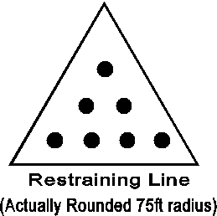
Target toss is played on a triangle shaped area, using 7 or 8 fifty-five gallon drums or barrels, and as many tennis balls as possible. The triangle shaped area has a radius of about 75'. Position (4) 1 point drums about 15 feet from the throwing line, (3) 5 point drums about 20-25ft away, and (1) 10 point drum about 30-35 ft away. Adjust to the age level of your students.
On the signal to begin, the entire class will throw until all of the balls are gone, or until a given time limit. If you are limited on balls, allow some students to be retrievers for their class, this will reward classes who work together. One version of this game is to play where students may retrieve a ball, but must hand it to another player to be thrown. This may be another way to handle the game with a limited number of tennis balls.
To make the restraining line, I pin one end of a string to the ground, then measure the distance I want on the string. I then drag the free end of the string in a semi circle as we paint the restraining line.
1. Position one class behind the restraining line. All tennis balls are on or behind the restrianing line as well.
2. On your signal, students will begin to throw the tennis balls, from behind the restraining line, into the barrels.
3. Students will continue throwing balls until all the balls are gone.
4. After all the balls have been thrown, tally the points from each barrel to get the teams total score.
5. Record the teams total score on your score sheet. The class who scores the most points wins
http://mrgym.com/MyField.htm

{Back to Table of Contents}

Water Games

Dunking Booth
Children toss water soaked sponges at their favourite teacher or better yet, the Principal!
http://web.archive.org/web/20030713130914/http://schools.eastnet.ecu.edu/pitt/ayden/wateractivities.html

Gopher Splash
Much like Gopher Bash or Whac A Mole this version is called Gopher Splash. It is super easy to set up and easy to store. Use “ T post” metal fence posts and pound them in with a post driver. Take plastic tarps and cut out squares(do not do circles) so it would be easier to tape and reinforce the tarp. Students put their heads through the holes (but they will pull on holes and that is why you must tape both sides of tarp) and try not to get splashed. You can create as many holes as you like so students can bounce back and forth between holes. The moles put on safety glasses or goggles. The sprayers use water cannons and refill their guns from a baby pool. Check out the video on the following website for a look into how it works.
http://www.peuniverse.com/Videos/VideoDetail/tabid/221/IndexID/9064/Default.aspx

Partner Squirts
Everyone has a partner, one blindfold and one squirt bottle (dish soap bottle, ketchup bottle...) filled with water. We run another hose to this area to refill the bottles as needed. One partner stands in front and is blindfolded. They hold the squirt bottle. The other partner stands in back of the blindfolded partner and holds on to their shoulders. On "go," the back partner directs the front partner toward other partners. When the back partner thinks that the front partner is "within range," they tell them to "squirt." The front partner then squeezes their squirt bottle. After a few minutes of fun and laughter, the partners trade places.
http://www.pecentral.org/lessonideas/ViewLesson.asp?ID=1783

Soaking Wet Sweatpants Relay
Prepare two pairs of adult sweatpants and two buckets of water. Divide into two teams, first person up, dips the sweatpants into the bucket completely drenching them. Then puts them on and runs to a designated marker and back. Takes the pants off and hands them to the next kid who also dunks the pants and puts them on. And so on till the last kid on the team makes it back. See also Relay Race Games.
http://blog.volunteerspot.com/volunteer_guru/2011/02/best-field-day-games-and-ideas-fabulously-fun.html#axzz2TNLvX8gg

Sploosh
Set-up a Volleyball net and court. Place a 5 gallon bucket of water at the end of each half of the court. You will also need 4-8 large sponges for this game, which will start off in the bucket. On the signal, players will begin throwing their water soaked sponges over the net to the opposing team. Players will then attempt to catch the sponges that are thrown to their side. After a catch, or a drop, the player will run the sponge to the water, where they will dunk the sponge and throw it back over the net.
The object of the game is to have the fewest strikes against your team. A strike occurs each time a sponge lands in bounds on your side of the net or each time your team throws a sponge that lands out of bounds. The activity of this game can be varied by the number of sponges that are in use. After the start of the game, there is no signal to throw, players just toss them as they receive and refill them. Scoring can be done in different ways. You can play with a time limit and the team with the lowest score at the end of the time is the winner. You could also play to a certain number, where the first team to reach a predetermined number ends the game. See also Sport Games for more games like this!
http://mrgym.com/MyField.htm
http://mrgym.com/Field_Day/sploosh.htm
Sponge Race
Fill up a baby swimming pool, 4 5-gallon buckets, 4-5 large car wash type sponges. Each team must race to the pool, fill the sponge with as much water as possible run back to the buckets and squeeze out the water, then passing to the next teammate....and so forth until all players have gone. See also Relay Race Games.
http://web.archive.org/web/20030713130914/http://schools.eastnet.ecu.edu/pitt/ayden/wateractivities.html

Sponge Soaker Relay
Each team needs two buckets of water and two large sponges. Each team lines up with a bucket of water at the front of the line The team passes the wet sponges over their heads to the end of the line. At the end of the line the last person squeezes the sponge out into the other bucket--and then runs to the front of the line and starts it again. You can have two sponges going at the same time. Give it a time limit 5 min or so. See also Relay Race Games.
http://web.archive.org/web/20030713130914/http://schools.eastnet.ecu.edu/pitt/ayden/wateractivities.html

Squirt Bottle Race
Teams use squirt bottles to try and squirt a ping pong ball or balloon across a line about 10 yards away. See Ping Pong Ball Blow for dry variation of this game. See also Relay Race Games.
http://web.archive.org/web/20030713130914/http://schools.eastnet.ecu.edu/pitt/ayden/wateractivities.html

Tug Over Water
Play Tug of War across a kiddie pool filled with water.
http://web.archive.org/web/20030713130914/http://schools.eastnet.ecu.edu/pitt/ayden/wateractivities.html

Waterslide
Useful for a variety of activities!
Water Balloon Smash
Fill up balloons with water and have contestants place the balloon between their legs. On "GO" they travel to the finish line where they must sit on and bust their balloons.
http://web.archive.org/web/20030713130914/http://schools.eastnet.ecu.edu/pitt/ayden/wateractivities.html

Water Balloon Toss
Field Day is all about being outside in the fresh air and hot sunshine, making water-themed games a must! For this game, have students pair off and line up about 6 feet away from one another. First students toss their balloon and those who do not drop their balloon stay in the game, taking two steps back to increase the distance from one another at each round. Continue until there is only one team left. See also Classic Games.
http://www.roommomspot.com/2013/05/01/field-day-games/
http://web.archive.org/web/20030713130914/http://schools.eastnet.ecu.edu/pitt/ayden/wateractivities.html

Water Balloon Volleyball
This is a water activity that children will enjoy. Set up a volleyball net in a grassy area and divide children into two teams. You will need balloons filled with water as well as a towel for each pair of children. Partners hold opposite ends of a towel and use it to catapult water balloons back and forth over the net. Use the same basic rules as in regular volleyball. This includes making 1-3 passes before tossing the balloon over the net. See also Sport Games.

Water Bucket Relay
Teams carry water from one bucket to another using cup. Some variations of this game use a Styrofoam cup with a pinhole in the bottom to make it more difficult. See also Relay Race Games.
http://web.archive.org/web/20030713130914/http://schools.eastnet.ecu.edu/pitt/ayden/wateractivities.html

Water Shoot Out Relay
Using a high-power water gun, kids try to knock a foam ball off a cone some distance away. For older kids, have teachers or a parent squirting a stream of water back at the kids – they’ll try to squirt the adults defensively and will have a harder time completing their task. Start with the filled water blaster some distance from the starting point in a hoop on the ground. Kids have to run to get their ‘weapon’ and then replace it in the same hoop – refilling before putting it back. See also Relay Race Games.
http://www.educationworld.com/a_lesson/03/lp315-01.shtml

{Back to Table of Contents}

New Fun Games

Animal Tag
Start the game by calling one of your runners "it" and naming an animal to imitate. All players must then move like that animal. The player who's "it" tries to tag as many players as she/he can before a new "it" and a new animal are chosen. Tagged players, players who step out of bounds, and players who forget to move like the animal are out and should wait on the sidelines until the next round. Once a new player is "it" and a new animal is named, all players return to play. Call a new "it" and animal every 15-20 seconds to keep the game fast paced so everyone gets a lot of exercise. Make sure everyone has a chance to be "it." Remember that the game is most fun when everyone sticks to their animal running forms.
http://www.nyrrf.org/ycr/ars/activity/middle/games/m51.asp

Balance Beam/BeanBag Walk
Students place a beanbag on their heads. How many times can a student walk the length of the balance beam without letting the beanbag fall? Each student who can walk the beam five times (up, back, up, back, and up again) is recognized during the award ceremony. Younger students might need to walk the beam fewer times.
http://www.educationworld.com/a_lesson/03/lp315-01.shtml
Balloon Burst
Several balloons and string needed. Each player is given two balloons to be inflated and tied around each ankle with a piece of string. Object of game is to burst the other players balloons with their feet—no hands allowed. Winner is last person with a balloon or balloons. Game can be played with or without boundaries.
http://www.kidactivities.net/category/games-outside-play.aspx

Bean Bag Challenges
Put up a chart with the below challenges. See who can complete the list!
- Throw a beanbag in the air, turn around, and catch it again.
- Throw the beanbag up and backwards over your head and try to catch it behind your back.
- Throw the beanbag in the air, clap your hands once, and catch it. Now try clapping your hands twice, then three times, and so on. How high can you go?
- Throw the beanbag in the air and clap your hands under your right leg before catching it. Now try with your left leg. Now clap behind your back. Invent some more challenges.
- Throw the beanbag up, jump, and try to catch it. Jump twice. Jump three times!
- Throw it up, kneel down and try to catch it.
- Throw and catch with just your right hand, then with just your left.
- Try throwing it up and catching it with your eyes closed!
- Balance the beanbag on your right foot, then throw it up and catch it from there. Can you do it with your left foot too?
- Can you throw the beanbag up and catch it on your left foot?
- Can you run with a beanbag balanced on your head? Can you jump? Can you twist around? Can you kneel down and stand up again, or sit down? Can you climb the stairs? Can you do any of these things with two beanbags balanced on your head? Or three?
- Try balancing a beanbag on each shoulder while you walk, run, jump etc.
- Sing one of your favorite songs or rhymes while you throw the beanbag up and catch it, or pass it round a circle of children.
- Set up a variety of hoops, containers and targets and have some throwing practice. How far can you throw the beanbag? Does it make a difference if you throw over-arm or underarm?
http://www.kidactivities.net/category/games-outside-play.aspx

Bean Bag Hunt
Set up a variety of different coloured items (like bean bags) hidden in the playing area underneath cones or buckets, etc. Multiple groups are on the search for the same colored bean bags. Instruct the students to use various locomotors to move along play area. Students are allowed to look under only 1 cone/bucket per turn. Check out the video on this website for a better understanding of the game!
http://www.peuniverse.com/Videos/VideoDetail/tabid/221/IndexID/8993/Default.aspx

Bicycle Derby
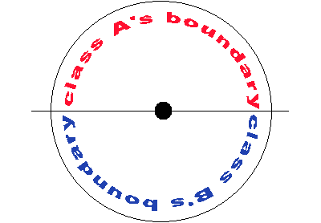
Every child has to bring their own helmet, but they have a few people bringing in bicycles to use for the event, and the kids will share bikes. Have the children go through a derby course that helps teach them safety rules, such as stopping before crossing a pretend intersection, signalling to turn right or left, and the proper side of the street to ride on.
http://www.blisstree.com/2009/05/21/sex-relationships/10-fun-activities-for-field-day/

Cage Ball
For cageball, paint a circle 35' in diameter, then split it in two equal parts with a line. (the line does not extend past the circle as shown in the picture). In the center of the circle, paint a ball start line or circle. For this game, use a 6' cageball, but any size would work fine.Position each team on the outside line of the circle. (On their own side). On your signal, students will move Crab style only, in an attempt to move the ball across the boundary line on the opposing teams side of the circle. After each point, reset the ball to the center of the circle and the students to their outside boundary line. Play the best of 3. First team to get 2 points wins the game. Students must move in a crab walk only. However, they may strike the ball while seated. Students may only kick with one foot at a time. Students are allowed to use their hands. Stress safety, especially students who are kicking and hitting without regard to the safety of other players.
http://mrgym.com/MyField.htm

Clean Your Room
Students will be divided up into two teams. Soft yarn balls will be put in an area; they are to throw the balls of yarn over to the other side. The team with the most yarn balls on the other side wins.
http://teachers.net/gazette/MAY02/russo.html

Cup Stack Tower
Equipment: Several packages of large plastic party cups (the disposable kind are fine, although they might crack if the kids are too rough on them!) This activity can be done one child at a time, two at a time, or several at a time.
Description/Objective: On “GO”, each student has one minute to make a tower using the cups, but stacking them, first one up, second one on top of first one and up-side down, third one on top facing up, fourth one on top and upside down, etc…..
See who in your group can make the tallest tower in one minute! If your tower falls, you must start over! (Note: It's a good idea to set up a long table near a wall, and tape a tape measure to the wall, so students can see how tall their tower is)
http://www.pecentral.org/lessonideas/ViewLesson.asp?ID=10167#.UZZBcKPudr4

Diving for Eggs
Drop into a plastic wading pool a large number of different colored eggs; the eggs should be glued shut so they don't come apart during the activity. There should be the same number of eggs (6-10) of each color. Cover the eggs with Styrofoam packing peanuts, popcorn, or sand. Arrange students around the pool. Assign each student a different color. Then give students a time limit (maybe 2 minutes) to uncover as many eggs as they can of their assigned color. If a student uncovers an egg of a different color, he or she should rebury the egg so the student who is looking for that color will not be able to grab it from the surface of the pool. At the end of the time limit, count the number of eggs each student uncovered. At an award assembly, recognize students who found the most eggs. Alternative Equipment: Bury marbles, golf balls, tennis balls. How many marbles does each student uncover within the time limit?
http://www.educationworld.com/a_lesson/03/lp315-01.shtml

Fifty Yard Scream
When the leader calls go, everyone runs for as far as they can as they scream. They are only allowed one breath, so as long as they are yelling they may continue to run. Once they stop screaming, they must stop and sit down. Once the last player as sat down you will be able to see how far everyone got. Recommended playing area for this game is a full sized soccer field. You can then have the group go back and try to beat their distance in a second round.
http://www.ultimatecampresource.com/site/camp-activity/fifty-yard-scream.html

Frisbee Pancake Flip
Provide each student with a Frisbee and a beanbag. The beanbag should be different colors on each side; or mark the sides with the letters X and O. Students place the beanbag on the Frisbee. Then they have one minute to flip the beanbag into the air and catch it in the Frisbee as many times as possible. (You might give students a few practice flips, so they get the hang of the activity.) Students earn a point each time the beanbag lands inside the Frisbee on the opposite side from the side it was on before the toss. Tally the number of points each student earns. Recognize students with the most points at the award ceremony.
http://www.educationworld.com/a_lesson/03/lp315-01.shtml

Hula Hoop Marathon
How long can students keep a Hula Hoop spinning around their bodies? Record the time each student keeps the hoop spinning; stop the clock the first time the hoop contacts the ground. Students with the longest spinning times are recognized during the award ceremony.
http://www.educationworld.com/a_lesson/03/lp315-01.shtml

Hula Hut
The object of the activity is to be the first team to build three hula huts that are standing at the same time. In the beginning of the game, each team will stand with a foot inside a large hula hoop. When the game begins, the students will attempt to collect hula hoops for building huts, each team must throw balls at a target (Socci goals). If the target is hit, then the student who hit it may get a hula hoop and take it to their team’s construction site (one of the large hula hoops).
Building the Hut – Once the team has collected 6 hoops, they may begin building their hut. The first hoop is the base and lays on the floor. The next two hoops build the first walls. The hoops should form a triangle above the base. The next two hoops form the other sides of the hut and rest on the first two walls. The final hoop rests on the top of the four walls.
Protecting or Knocking Down Huts – Once the huts are built, the team must protect their huts while attempting to knock down any huts built by the opposing team. If any hut is knocked down, it must be rebuilt.
http://www.perocks.com/gpage19.html

Marble Toes
Mark with lime or paint an area on the grass a foot or two in diameter. Cover the area with marbles. (You could set up several areas so groups of students can do the activity at the same time.) Students take off their shoes and socks and attempt to pick up marbles using only their toes. How many marbles can each student pick up in 60 seconds? At the award ceremony, recognize students who pick up the most marbles.
http://www.educationworld.com/a_lesson/03/lp315-01.shtml
http://www.perocks.com/downloads/Rules-OutdoorFD.pdf

Noodle Socci
Split the classes into 6 even teams. Each team will have a basket that is filled with noodles. On the top of each basket will be 2 coloured flags. The first two people in each line will hold a flag. The flag indicates whose turn it is. Once the teams have been created, the leader will need to choose 4 students to be the defenders. The defenders will move to the middle of the playing area and pick up a demi-noodle. The defenders will use the demi-noodles to protect the Socci goals (To see a Socci goal visit: http://vimeo.com/37187987) by hitting the noodlettes that are thrown by the other students. When the game begins, the students with the flags may pick up ONE noodlette and run to the middle and try to throw it into the top of the Socci goal. If the shot is made, the player will earn 2 points. Each player will keep their own score. After taking the shot, the player will return to their team and hand the flag to the next person in line. After about 2 minutes, stop the activity, quickly clean up the noodlettes, and choose new defenders. The players shooting may NOT pass over the defensive line (a line of cones around the Socci goals). Students may only pick up noodlettes that are in their baskets (NOT ones that they find on the ground).
Variations: Many variations of games can be played with Socci Nets. Check it out at http://vimeo.com/37187987.
http://www.perocks.com/downloads/Rules-OutdoorFD.pdf

Noodle Soup
Split the class into 4 equal teams. The students may line up behind the cones facing the center of the game area. Two players will be picked to be the “crazy chefs”. The “crazy chefs” will attempt to protect their noodle soup (small noodle pieces) from the hungry students by hitting them with their spoons (longer noodle pieces). Each team will have two players at a time attempt to collect the food in the middle (they may only take one noodle piece at a time). The players who are attempting to collect food will hold a flag in their hands. If the “crazy chef” tags another player, the student must go back to their team without food and let another player go. After a few minutes, pick two new “crazy chefs” and continue the game. See how many pieces of soup each team can collect.
http://www.perocks.com/downloads/Rules-OutdoorFD.pdf

Nuke Walk
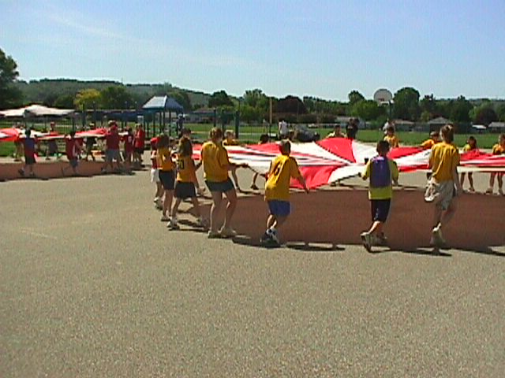
This is a cooperative team game. Set up requires setting up a course with cones, platform in the centre of the parachute, and a refill station for the water. With the parachutes on the ground, and the platform centered in the parachute and cups full, students will get hold of their won parachute. On the signal, students must work together, to walk their nuclear material down and around the cones and back, without a spill. If there is a nuclear spill, the class must lower their parachute to allow the designated player to get the cup for a refill. You can designate one player to wear a vest (life jacket can be used) and be the Licensed Nuke Re-filler. When there is a spill, this team may not continue until their cup has been refilled and place on the platform. The entire team must go around the cone, make 1 full spin, and return to their starting area. The first team to return to their spot, and set their nuclear material down safely, will be declared the winner.
http://mrgym.com/MyField.htm

Ping Pong Ball Blow
Set up a track using boards; or mark a track on pavement using chalk, or on grass using lime. The width of the track should be no wider than a foot. Provide each student with a ping-pong ball and a plastic straw. Students blow through the straw to move the ping-pong ball from one end of the track to the other without moving it outside the borders of the track. At the primary grades, recognize at the award ceremony all students who complete the track. For older students, recognize the fastest times. See Squirt Bottle Race for Water Game variation.
http://www.educationworld.com/a_lesson/03/lp315-01.shtml

Plunger Challenge
Beginning with 4-8 plungers, have students pass a ball back-and forth as many times as possible with the plungers. Younger kids do this while standing in a circle, older kids while running toward a finish line. Kids compete for lowest score – one point is awarded each time the ball hits the ground.
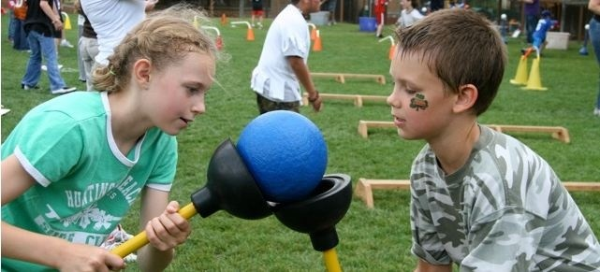
http://www.roommomspot.com/2013/05/01/field-day-games/

Pyramid Battle
This is a great game to get kids active and use math skills! Students battle one on one as they role the dice to get the higher number. If they get the higher number they advance to the next level. When they get to the top of the pyramid and win, they get a point for their team. Materials: -15 Hula Hoops, 30 dice, 6 cones, Hurdles, noodle, way to keep score. This game has been used for classes with 20-80 students. It is great for large classes and gets all students involved. This is a game that integrates all 6 National PE Standards with classroom Math standards. This game has been used with grades K-5. This is such a great game and kids love it! Check out the video on the following website to understand this game better!
http://www.peuniverse.com/Videos/VideoDetail/tabid/221/IndexID/824/Default.aspx

Rope Jumping Race
Provide each student with a jump rope. Students count aloud as they jump. Record the number of jumps each student completes before missing. You might provide a time limit (for example, two minutes) and record the number of jumps made during that time; that way, students who jump faster -- at more risk of missing -- have a better chance of completing more jumps. The three students who jump the most times within the time limit are recognized at the awards ceremony.
http://www.educationworld.com/a_lesson/03/lp315-01.shtml

Rubber Chicken Throw
How far can students throw a rubber chicken? Give each student a toss or two and record the farthest distances thrown by boys and girls for each grade. Recognize the farthest throws at the award ceremony.
http://www.educationworld.com/a_lesson/03/lp315-01.shtml

Shoe Kick
Have students loosen one shoe so their toes still are in it. From a marked starting line, students kick that shoe into the air. Record the distance the shoe travels. Students might take a running start, or not; they are disqualified if they take a running start and kick from the wrong side of the starting line. Students in each grade who kick the longest distance are recognized at the award ceremony.
http://www.educationworld.com/a_lesson/03/lp315-01.shtml

Sneaker Hunt
Everyone takes their sneakers off and piles them up at one end of the area. On "go," everyone tries to find their sneakers and put them back on and run back to the start. The entire group is timed. Kids are encouraged to help others find their sneakers, because they, as a group are trying to beat their previous time. No one "wins" by getting their sneakers first. They just try to cooperate to continue to improve their group's time.
http://www.pecentral.org/lessonideas/ViewLesson.asp?ID=1783
Sweep It
Equipment: Broom (child size broom for younger children) and bean bag, small soft toy or stuffed animal, or small foam ball, or whatever object you would like to use to ‘sweep’ across the floor.
Objective: Each student starts sweeping object from point A to point B. It’s fun to set up cones so students have to go between or around them! Let’s see who can do it the fastest in each group!
http://www.pecentral.org/lessonideas/ViewLesson.asp?ID=10167#.UZZBcKPudr4

Tarps
Split the class into two equal teams.Each team will have a tarp and will stand on top of it. The objective is to flip the tarp over without having any member of the team touching the floor. The instructor can provide tips or hints if the students are having a difficult time. Discuss how important it is to communicate and work together in order to be successful at the task. Start with the tarp completely spread out and then each round fold it in half to make it smaller and more difficult with less space for a team to stand on.
http://www.perocks.com/downloads/Rules-IndoorFD.pdf

Toe Tag
Everyone is "it" at the same time. Runners tag each other by stepping lightly on their toes. Once tagged, players are out until there is a single winner. Players are also out if they go out of bounds. The game is best with five or more players. Stomping is not allowed! The best way to avoid being tagged is to keep the feet moving quickly. Keeping the playing space small will encourage short, quick, and agile movements.
http://www.nyrrf.org/ycr/ars/activity/middle/games/m49.asp

Trolley Walk
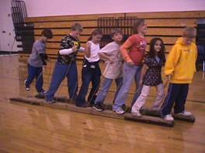
This game requires a lot of cooperation and teamwork. Place the two trolleys on the start line. The objective is for the students to move the trolleys as far as possible in their allotted time. All players must be aboard the trolleys in order for the trolley to move. All players must have one foot on each trolley. If a player falls off a trolley, the trolley must wait until they re board before moving again, but they DO NOT need to start from the beginning. Use cones or markers to track where each group ended, so that other groups may have a distance to try to beat.
http://mrgym.com/Field_Day/Trolley%20Walk.htm

Ultimate Steal the Bacon
A fun new twist on steal the Bacon using a Tugball. Two students from each team step forward and find a grip on the Tugball. The first team to tug the ball close enough to knock off a ball on the outside of the circle wins (or gets a point). See the following video for a visual demonstration.
http://www.peuniverse.com/Videos/VideoDetail/tabid/221/IndexID/9077/Default.aspx

Watermelon Seed Spitting
Give participants pieces of watermelon. Whoever can spit their seed the furthest wins or encourage them to make a personal best “shot”.
http://7onashoestring.com/2013/05/outdoor-field-day-games-for-kids.html

Yarn ball Toss
Provide students with a ball of yarn. Each student must hold onto the end of the strand of yarn and throw the ball. How far does the yarn ball go? Measure the yarn from the student's hand to the spot where the yarn ball lands. At the award ceremony, recognize the longest throws by boys and girls at each grade level.
http://www.educationworld.com/a_lesson/03/lp315-01.shtml

{Back to Table of Contents}

