

HINGHAM LITTLE LEAGUE
TEACHING
BASEBALL
FUNDAMENTALS

Thanks to:
Reggie Smith - Reggie Smith Baseball Centers
Rob Glushon - Campbell Hall School

Introduction

It is important for all managers and coaches to teach the proper fundamentals of baseball in a positive environment. Even experienced coaches should confirm that they are using the fundamentals properly and adapt drills, techniques and practice plans to the age level of their players.

Although everyone's level of baseball knowledge is different, there should be a common desire to improve - to learn - to understand - and to make adjustments in order to help your players and your team.

Understanding baseball fundamentals is only part of the process. Coaches need to effectively communicate their knowledge and utilize practice drills to try to get their players to apply such knowledge. This is perhaps the greatest challenge for youth baseball coaches because they are working with younger players with different levels of ability.

While coaching philosophies and styles may differ, there are certain common teach ing fundamentals used by successful coaches:

TEACH TO THE AGE GROUP

Don't try to teach 5-6 yr olds to turn the double play.

DON'T ASSUME YOUR PLAYERS KNOW

A player will comprehend 5% of what is instructed the f irst time . Even if they say they know, make sure.

REPETITION

The more they throw, catch, field, hit and run, the more they will learn, improve and perform during games.

HAVE A PREPARED PRACTICE PLAN

Prepare a practice plan that incorporates your teaching goals for that session and repetition from prior sessions. Be realistic based on the time you have.

REMEMBER, THIS IS LITTLE LEAGUE BASEBALL!

Baseball is a great and challenging game that is not only fun, but teaches many great life skills and lessons. Our goal at Hingham Little League is to keep as many kids enjoying and playing baseball for as along as possible.
The goal is to have fun, while teaching children proper baseball fundamentals. Our coaching performance metrics are based on teaching proper fundamentals and player retention - NOT on wins & losses.

Throwing & Catching

This is the most important activity you can do to develop and improve your players' baseball abilities. Playing catch - using the proper fundamentals - teaches and reinforces the two most important aspects of the game: throwing and catching the ball.

When kids are taught to throw, often the instruction is watered down into just a couple of steps. The act of throwing a baseball is not that simple. Throwing requires the entire body to work together in order to throw the ball accurately and to put something on it. All positions on the field require the ability to throw the ball accurately. Good throwing mechanics will enable you to make plays. When you warm up with the team before practice or play catch in the back yard, make sure you work on your mechanics and strive to improve your accuracy.

The Grip

Grip the ball across the long seams of the baseball with your index finger and long (middle) finger. From the thrower’s perspective, the seams should look like the letter “C” when held out in front of the body. His/her fingertips should be in contact with the seams to improve grip and accuracy. For younger players, it is recommended to use 3 fingers. The thumb should be underneath the ball. This is called a 4-seam grip.

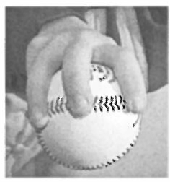

Though the actual mechanics of throwing with the fingertips is difficult with small hands, it is still an important concept for them to understand as they progress.

Throwing Motion

- Line the shoulders up with the target
- Break hands down your belly button
- Throwing fingers on top of ball
- Establish the back foot as your pivot foot
- Step with throwing side foot perpendicular to target , open slightly
- Stride toward the target with glove side foot
- Throw with over the top or 3/4 arm action
- Follow through toward the target

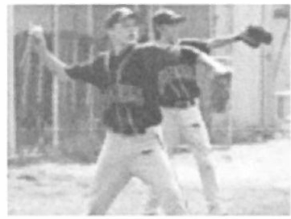

Throwing Drills (for all ages)

Wrist Flips
(1.) Place 2 players facing one another 5-10’ apart, depending on age;
(2.) Have each player bend his/her arm at the elbow, creating a Cobra position;
(3.) Support the elbow with the other hand;
(4.) Flip the baseball to a partner using only the wrist.
This strengthens the wrist as well as acclimating the player to his/her wrist movement when throwing. This drill can be performed standing or kneeling; as the player’s strength increases, so does the distance he/she throws.
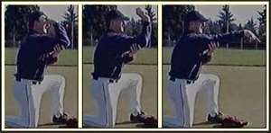

Knee Drill
Players get on one knee (throwing arm side) about 15 feet from their partner.
The player with the ball will rotate his shoulder toward the target, bring his arm back with his hand on top, use a good circular motion and throw the ball. His back shoulder should follow through and point to the target. Build on the wrist flip drill, making sure the player bends his elbow and uses his wrist.
.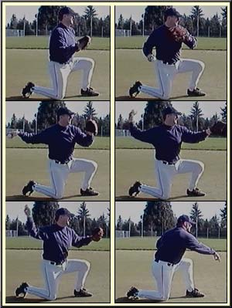

Feet Planted Drill

- With both feet planted shoulder width apart and pointing toward partner about 20´ apart, rotate and throw to partner. Start with ball in glove at chest.
- Pay attention to starting in an athletic position (knees slightly bent), hand break (hands should break palms down), arm angles (upper arms parallel to the ground, equal bend in the elbows, palms facing away from each other) and upper body rotation (front shoulder should point at partner).
- Pause at hand break to check form, then throw.
- Glove position during throw (glove should stay near chest during throw).

Step and Throw
After a few minutes of each drill above, have the kids now step towards their targets while continuing to build on the proper fundamentals taught in the preceding drills. Focus on accuracy as opposed to velocity.

Long Toss
You should introduce long toss at the AAA and Majors levels. Done properly, long toss will both reinforce proper fundamentals and build arm strength. Generally there are two ways to do long toss - both do the job.
- Airing it out - Players slowly stretch out the throwing distance between them (while throwing with an arc) until they have maxed out their distance. Once they have reached their peak distance, they slowly decrease the distance and the arc.
- Throwing on a line - Same as above, but the players try to keep the throws on a line, allowing one-hop on their max distance.
- **It is important that the focus is on both being loose and accurate and NOT on velocity. Remember, you are warming up to throw, not throwing to warm up.

Coaching Keys:

- Keep throwing arm elbow up above shoulder
- Throw the ball "out front" and "down hill"
- Accelerate the shoulder and arm through the throw
- Finish with the throwing shoulder pointed toward the target
- Momentum should be going towards the target

Catching the Ball

- Athletic position (feet apart , knees slightly bent, weight on balls of feet)

- Both hands out in front to give "Target"

- Move body in front of and "Go to the Ball"
- If t h e ball I s above the waist , catch "Fingers Up"; if below waist , "Fingers Down" Throwing and catching should be done as a team - and at the beginning of practice. Players should pair up starting about 20-30 feet apart along the outfield foul line with enough distance between both groups to ensure safety.

)(-------------------------------)(

)(-------------------------------)(

)(-------------------------------)(

)(-------------------------------)(

)(-------------------------------)(

)(-------------------------------)(

After about 2 minutes of playing catch, the players in the outfield should move back to increase the throwing distance to 40-60 feet. After another 2 minutes, increase the distance to 60-80 feet. For older players (ages 11-12), increase the distance to approx. 100 feet.

Note: In T-Ball and Jr Farm coaches should throw to players divided into 2-3 groups.

Encourage players to aim for their partners’ chest

Coaching Keys:

- Anticipate inaccurate throws and use feet to move to the ball
- Use both hands to learn quicker transfer to throwing hand
- Learn to catch above and below waist throws
- Older players may begin to incorporate a “crow hop” when throwing
PRACTICE DRILLS

- "Hit the Target"

This is a drill in addition to, not instead of, practice warmups.

Using the same pairing of players for warmup throwing, have each player give his/her partner a target (in the middle of the chest) with an open glove. Have each player make 10 throws and count how many times each can hit the glove without it moving. Have the winners do the same against each other until there are 1 or 2 winners .

- "4-Corner"

Make a square of 4 players about 30-40 feet apart. If you have 12 players, then you have 3 squares separated enough for safety .

One player starts the throwing clockwise around the square. After a few minutes, start again but go counterclockwise. Suggestion: Make it a race; for example, the first group to throw it “around the horn” four times is the winner.

- "Relays"

Make lines of 3 players that are 40-60 feet apart. Have the 151 in line throw to the middle player who throws to last in line. Repeat starting with the last in line. After a few minutes, rotate so that each player has been in each position.

The key here is to promote footwork and quickness while still catching the ball and making accurate throws.

Again, you could make this a race, in which case, might work better with longer lines of 4-5 players. The first line to complete throws all the way up and back is the winner. Players will see the importance of accurate throws, hitting their targets around the upper torso. More advanced players can practice relay and cutoff technique (i.e., catching the ball with the body turned sideways, moving into a throwing position).

- "Knee Drill"

Same format as practice warmups but players only about 20 feet apart with throwing side knee on the ground. Emphasis here is upper body throwing mechanics.

Infield

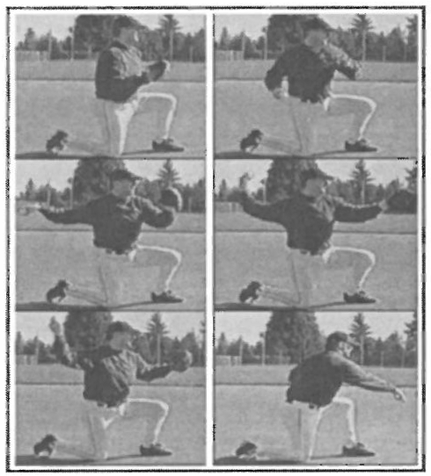
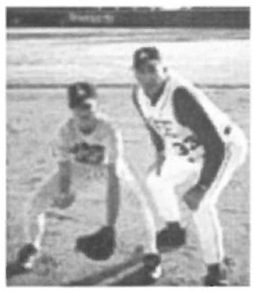

At youth league levels, it is important to keep it simple and focus on proper stance (Ready Position), Footwork, Fielding and Throwing.

Stance

- Athletic Position: Player's feet are slightly wider than his/her shoulders
- Weight evenly distributed and on balls of feet- not heels
- Bent at waist with glove open

Footwork

- Balanced -ready to go to left or right
- Use throwing side foot as pivot foot to throw

Fielding

- Glove open using two hands- glove slightly ahead of throwing hand
- Get in front of ball whenever possible; bring throwing hand down into the glove as if it is the top of an alligator’s jaw and the glove is the lower part of the jaw; younger players will respond well to reminders about “the alligator” when fielding a ground ball.

The Throw

- Use same fundamentals for playing catch above

Coaching Keys:

- Stay low to ground
- Use both hands for quicker transfer to throwing hand
- Be aggressive to get to the ball
- Remind players about the importance of anticipation (i.e., “Always expect the ball to be hit in your direction”)

PRACTICE DRILLS

- "Soft Hands"

Divide players into 2 or 3 lines on the dirt infield closest to outfield grass. Have a coach for each group on the infield grass roll grounders to players. Coach should kneel, sit on a bucket or stand.

Each player has to show his/her "stance" and then field the ball without a glove using both hands- and then pivot and throw back to the coach.

- "Player-Player" Grounders

For players in Minors and Majors (Ages 10-12) , divide players evenly into 2 lines of players opposite each other between 3b and 2b - and another 2 lines between 1b and 2b.

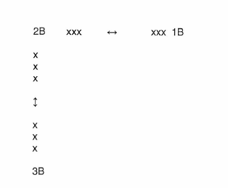
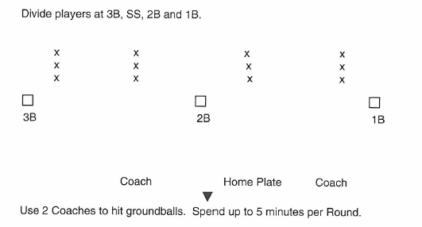
Each player rolls a grounder to 1st player in opposite line - who fields grounder and rolls grounder to the next player in line as players rotate to the back of their line. Grounders should be to glove side and then after several minutes have grounders thrown to the other side for backhand fielding

"2-Fungo" Grounders

Rd 1: Coach to left of Home Plate hits to SS (throws to 28) Coach to the right of Home Plate hits to 3B (throws to 1B)

Rd 2: Same as above but SS throw to 1B
Same as above but 3B throws to 28 (This fungo first for safety)

Rd 3: Coach to left of Home Plate hits slow roller to 1B who throws to 38 Coach to right of Home Plate hits to 28 (throws to SS)

Rd 4: Coach to left of Home Plate hits to SS (toward 3B hole) who throws to 38
Coach to right of Home Plate hits to 28 (toward 1B) who throws to
18

This has a faster pace than conventional infield practice and players will get more groundballs and throws. Consider using a catcher for Round 3 and have 1B play up and throw home.

If you have two additional "dad" coaches, use them to receive throws and act as a feeder on each side of Coach fungo hitter.

- "9" Outs

Grounders to all infield positions with the objective of getting 9 outs without an error (fielding or throwing) . If an error occurs, start over with 0 outs.

Note: In T-Ball, Rookie, AA and AAA, the soft hand drill (without glove) is probably the most important drill to use in every practice BEFORE having drills with gloves.

In Farm, Minors, Majors and Seniors, the soft hand drill should be used in pre-season practices BEFORE other drills with gloves.

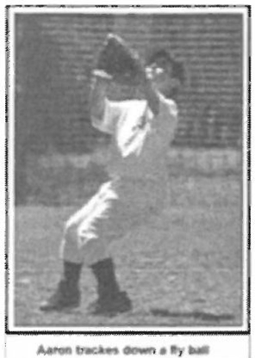
Coaches should also include "situation" grounders using live runners so that players are taught to understand where to throw the ball (i.e.: SS to 2B if runner at 1B). Remember, "force outs" are easier than a throw across the infield from 3B orSS.

Outfield

Stance

- Athletic Position: Player's feet are slightly wider than his/her shoulders
- Weight evenly distributed and on balls of feet- not heels
- Eyes to contact (hitting) zone

Footwork

- Drop Step & Cross-Over
- Sprint – do not drift (Run without glove in air)
- Run on balls of feet (so the head is not bouncing)
- Circle the fly ball
- Fielding ground balls with and without runners on base
- “Set up” behind where a fly ball or pop-up will land in order to have momentum coming into the throw

Glove

- Triangle (Field grounders like INF)
- 1 hand vs 2 hand fielding of groundballs (runners vs no runners on base)

Throwing

- Use same fundamentals for playing catch above
- Cutoffs and Relays (hit the target in the head or chest)
- Release from a totally upright and overhand position with hand on top of the ball (so the throw doesn’t sail)
- Follow through after the throw
- “Crow hop” is essential for throws from the outfield

Coaching Keys:

- Stay low to ground on ground ball hits - don't turn a single into triple
- Be aggressive to get to the ball; run at a “controlled sprint”
- Back up INF and don't assume INF will always field balls hit to them; every player has someplace to go on every play
- Do not "hold" the ball; throw to infielders

PRACTICE DRILLS

- "Dry Drills"

Players form a line in Outfield and each of them holds a ball.
First in line throws to Coach who is about 30-60 feet away from line. Player takes proper stance in ready position.
As Coach throws to left, Player runs to catch ball and then returns to end
of line. After first round, Coach throws to right side and repeat drill.

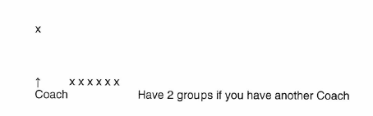
At the Minors and Majors level, or to challenge even younger players, use the same drill above but have the players use "drop step" to go back and throw the ball deeper . Important to teach running without glove up in air.

"Machine" Flys

For players in Farm, Minors and Majors, consider the use of a hitting machine for consistent fly balls at a greater distance of between 100-150 feet.

Fungo Grounders

Use same format as above with a distance of 100-150 feet and hit ground balls as players rotate. You can use another volunteer dad or player as a cutoff.
[In Majors, include a round where OF fields with one hand glove only and come up throwing to 38 and then another round throwing to home plate]

Add a round to have players field the ball hit to the fence using relays. [Use SS as relay from left of second base; 28 from right of second base]

Hitting
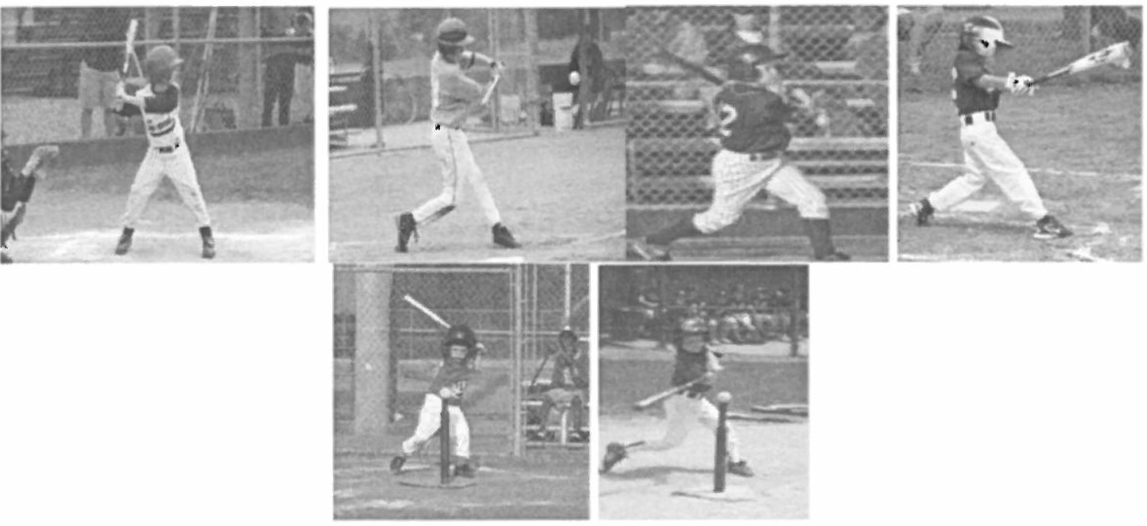

Sometimes it seems that for every hitting instructor there is a different approach . If you stick to the "basics" there are certain proper fundamentals that are common with all good hitters.

Using the Right Size Bat

Little League bats must be 32" or less and have barrels no more than 2 1A in diameter. As a general rule, the bat should not be longer than measuring the bottom of the handle on middle of chest to the player's fingers holding the bat in horizontal position.

Rule of Thumb
Division (age).............Bat length, weight T-Ba/1 T-Ba/1 Bat
A, AA and AAA (6-7) 25" to 26" -10 or lighter
Farm (8-9)..................26" to 27", - 10 or lighter
Minors (9-11). ........... 27" to 29", -10 or lighter
Majors (10-12)............28" to 32", -9 or lighter

Lighter is Better

- Bat Grip

    - Hold the bat out on the fingers - not in palm of hand
    - Middle knuckles aligned
    - Stay loose - avoid tension or tightening of grip

Stance

    - Athletic Position: Feet slightly wider than their shoulders
    - Weight evenly distributed and on balls of feet- not heels
    - Knees slightly bent. The amount of bend is batter preference
    - Foot closest to the pitcher lined up near front edge of home plate

Load & Stride

    - Stride is not part of the swing (e.g. "taking a pitch")
    - Timing
    - Keeping weight balanced -avoid "lunging"

Hips before Hands

    - Hips rotate on a level plane.
    - Hip rotation starts with the pivot on the ball of the back foot.
"Squish the Bug"
- Balance throughout rotation. Weight transfer is from back to middle. The back foot remains in solid contact with the ground.

- “Shoulder to Shoulder for Follow Through” This means that the player’s chin is near the front shoulder at the start of the swing and touching the back shoulder at the end of the follow-through.

Coaching Keys:

    - Be aggressive
    - Be closer to the plate
    - Get a good pitch to hit, especially early in the count
    - Expand Strike Zone with 1 and especially 2 strikes
    - Think "Hit the Ball Hard Somewhere"
    - “Barrel it up” – hit the ball with the “fat of the bat” to drive it
    - “See it in front” (i.e., aim to make contact with the barrel of the bat in front of the plate, especially with pitches on the inside part of the plate)
    - “Show your belt buckle to the pitcher” (i.e., at the end of the follow-through, the hips should be fully rotated)
    - Teach players to accept failure at the plate
    - Even their favorite superstars only get 3 hits for every 10 at bats.

HITTING PRACTICE DRILLS

- Single Tee

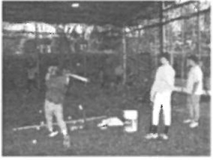 Coach kneels or sits to the side and places balls on T for players to hit. This drill can be done in batting cage or against a soft toss net or screen. Do not hit into FENCES!

- Soft Toss

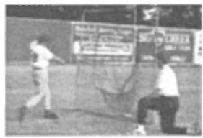 Coach tosses ball in front of plate from either the side or to the hitter about 20 feet in front of plate behind a protective screen . Include a round of swings where the hitter is instructed to have his back leg knee go to the ground after the swing. This teaches balance and avoiding lunging.

- Stride Drill

Have hitters lined up spaced at least 10 feet apart take their stance. Coach stands about 40 feet in front of the line and simulate pitcher. Hitters load and take their stride without swinging the bat.
This teaches and reinforces that you always stride- even if not swinging.

Golf Whiffle Balls

This drill is great to utilize anywhere and can be a hitting station when dividing a team up to make sure no players are just standing around. A Coach throws golf-size whiffle balls from about 20-30 feet away with other players behind the Coach as fielders as players rotate to hit 5-10 balls. The whiffle balls have more movement which promotes hand-eye coordination.

Cage Batting Practice Routine

It is important to have a "routine" which should include 2-3 rounds of 5-8 swings. For Farm-Minors-Majors, Round 1 should include at least 2 bunts. Rounds 2 and 3 can be used to simulate game-like situations. For example, Coach can call out "Runner @ 3b with 0 outs" or give hitters a count such as "1-2". You can create fun with internal competition by keeping rewarding points for execution (i.e.: advancing runner; scoring runner; getting a hit)

Lineup BP (Live Coach Pitch starting with 1-1 count)

Prior the beginning of the season -and during the season - this should be part of each practice to provide game-like situations involving all players. Divide the team into groups of 4 (3 groups of 12 players). With coach pitching, player in the non-hitting groups take their positions on defense. If shortage of players, use volunteer parents in outfield. One group hits (with Coaches at 1B and 38 if possible just like a game) . Start the count at 1-1 to promote swinging the bat at an expanded strike zone and moving things quickly. After 3 outs, start again with 0 outs. Depending on how much time you have allocated, each player should have 1-2 at bats.

Position a Pitcher behind the Coach that is pitching in this drill. This will provide even more realistic defense practice and game-like situations.

Note - Instead of practicing with just your team, we strongly recommend that you try sharing the field with another team in your division to have more practices [See examples of practice routines with 2-teams sharing a field]. If 2 teams are sharing a field, use Power Baseball as a simulated game with one team in field and the other at bat. Have each team go through % their batting order and then the other team comes up to bat. Rotate for the other % of batting order to hit. It is recommended that you use Coach Pitching (with your pitcher on defense behind the coach) and use a 1-1 count to give hitters more at bats and the defense more action while staying at a faster pace than player pitching.
BUNTING

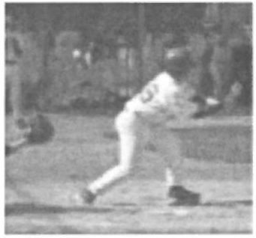

- Pivot vs Square Stance
- Push vs Drag
- Bat close to eye level in FRONT of plate- barrel slightly higher
- Bend knees and "ride the elevator down to keep bat near eye level
- Let the bat represent the top of the strike zone
- Only offer at strikes if the bunt is a sacrifice
- “Catch the ball with the bat” (“have some give…” and don’t hold the bat too tightly)

Baserunning
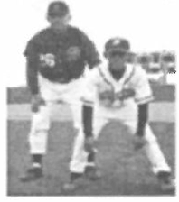
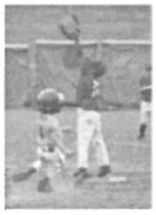
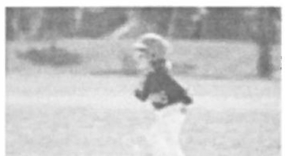

Stance

- Athletic Position: Player's feet are slightly wider than his/her shoulders
- Weight evenly distributed and on balls of feet- not heels
- Eyes follow ball to hitter

Footwork

- Shuffle and Cross-Over
- Run on balls of feet
- Running through 1B - Rounding 1B
- Hit inside of base with either foot

Sliding

Baserunning from 1B, 2B and 3B

Role of 1B and 3B Coaches

Coaching Keys:

- Be Aggressive
- Coaches need to be Vocal "Go", "Round It" and/or "Back" and use Hands
- Teach players to "read ball"
- Players should always slide on plays (when ball is being thrown) to 2B, 3B and Home

Pitching

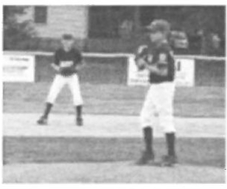

Although everyone knows the importance of pitching at the Farm-Minors Majors levels, most coaches do not spend enough time working to develop and improve their pitchers.

In addition to understanding and teaching the "mechanics" of pitching at these levels, coaches must also learn and instruct the "mental" side - which is a part of pitching development that cannot be over-emphasized.

Mechanics

  - Step Back (Windup) 2. Pivot 3. Balance Point 4. Stride & Release

5. Follow-Through [Make sure back foot stays in contact with ground]

Pitching in Stretch Position: Eliminate steps 1 & 2 [Recommended for Farm and Minors]

Pitches

- 4-Seam Fastball
- 2-Seam Fastball
- Change-Up

What Side of the Rubber? [Middle of Rubber is recommended) Pitch Counts Know and Follow HLL Rules for Pitchers
- # of pitches rather than # of innings is to protect against arm injuries
- Other variables such as pitching on club teams; pitching lessons; pitching
"to Dad"; pitching mechanics and technique

(fingers across the seams) (fingers on seams)

Mental Game

- Be Aggressive
- Be Confident
- Have Fun
- Learn not to get upset at umpire calls, errors or problems with control
- Think "Next Pitch"
- Be conscious of body language; send positive signals to teammates and demonstrate confidence to opponents
- Work at a quick pace to show command

Coaching Keys:

- Limit pitches especially early season to prevent injuries
- Encouragement and confidence from coaches are more important than trying to correct mechanics during games
- Use flat ground pitching in practices to minimize stress on arm Injury Prevention and Treatment

There is no shortage of so-called "experts" when it comes to pitching mechanics, instruction, dealing with sore arms. Even orthopedic doctors can give conflicting advice. (e.g.: one doctor might say give the arm rest for months and another might say if its "soft tissue" player needs to throw more!)

For most young players, the problem with sore arms is from both not throwing enough and overuse . Because of the consequences of serious injury, coaches need to be very careful about handling any complaints of soreness or pain in throwing arms. If a player complains of constant soreness or any single incident of pain, make sure the parents are notified and told to consult with an orthopedic doctor that specializes in sports injuries.

To prevent arm injuries, make sure that your practices include at least 1Q minutes of throwing drills using proper mechanics . Soreness in the "muscle" soft tissue area of the upper arm is frequently caused by not throwing enough throwing a lot at a Saturday practice while not throwing regularly the preceding week). Especially in the pre-season practices after initial throwing drills, consider using infield and outfield drills that do not involve throwing.
(See examples of drills that focus on f fielding but which do not include throwing).

With pitchers, limit their first few bullpens to 20-25 pitches at less than 100% intensity. Focus on form rather than velocity. Use flat ground (pitching not from the mound) to help arm strength and minimize arm stress.

TEAM PRACTICE PLANS

Successful coaches may have different styles but share the following attributes in common:

- A prepared, organized Practice Plan;
- Repetitive Drills that teach and reinforce the fundamentals
- Use of Station Drills to keep all players actively involved
- Delegate responsibilities to assistant coaches
- Make it fun!

The preparation of a Practice Plan should be based on what objectives you have for a particular practice session. At the first few practices, don't be too ambitious and remember that you will need to spend more time than you think on the basics. The challenge is to be efficient with the limited time and number of assistant coaches you have for a particular practice.

The following pages have sample Practice Plans based on having 2 practices each week prior the start of the season; and one weekly practice during the season. We have also included a sample Practice Plan for a 2-team shared practice time pre-season and during the season. Such "shared" practice times will give your players more time to improve fundamentals; work on team defense and offense; and play baseball in game-like conditions (i.e.: "Power Baseball").

Optional Off-Site "Extra Practice"

Depending on the availability of yourself and Asst. Coaches, you can have additional productive practices off-site in addition to the limited field time at HLL.

Remember, you can use any large grass area for any of the Throwing Drills; Baserunning; OF Dry Drills at one station and INF 4 Corner or Relay Drills at another station; Flat Ground Pitching; and Golf Whiffles. Consider using an "Extra Practice" offsite for just Baserunning (need 4 throw down bases) or combination of Baserunning and Throwing Drills.

Coaching Tips:

- Eliminate boredom by keeping all players active in drills

- Making drills fun, game-like and competitive

- Use batting cages for hitting to maximize field time for drills and in order to avoid players standing around

- For in-season practices, work on game “mistakes”, but don’t necessarily point them out or dwell on them

- Rotate all players on drills for both INF and OF regardless of what defensive positions they are likely to play

Farm-Minors-Majors PRACTICE PLANS
Practice #1

1 hr - 30 min Field Time [Weekday, Pre-Season]

10 min lntro Remarks to Team - Objectives and Expectations [Recommend you do this off the field BEFORE your practice time
begins to give you extra 10 minutes of field practice time]
15 min Throwing Instruction & Warmups
60 min INF and OF Station Drills -
30 minutes each and rotate INF:
10 min "Soft Hands" Instruction and Drill
10 min "Player-Player" Instruction and Drill

10 min "2-Fungo Grounders" Instruction and Drill OF:
10 min "Dry Drills" Instruction and Drill
10 min "Machine" Flys Instruction and Drill
10 min "Fungo Grounders" Instruction and Drill
5 min Water Break and rotate after 30 min. Stay on time!
10 min FIELD MAINTENANCE

30-60 min Batting Cages and Pitching Area

Avoid “down time” (i.e., kids standing around) during BP by setting up stations such as: 1) soft toss; 2) 2-ball soft-toss; 3) speed toss; 4) one-handed soft-toss; 5) wiffle-golf-ball soft toss; 6) bunting; 7) bat catch; 8) pepper; and/or 9) tee work.

Coaching Tip:

For your first practice, set aside at least 10 minutes to talk to your team, introduce coaches and discuss your objectives and expectations. If it's a weekend practice, consider having the players get to the field 15 minutes earlier than your "on-field" start time since you could give your intro remarks off the field. Then you can add another 10 minutes of drills to your first practice!

Practice #1
1 hr Field Time [Weekend]

10 min Intra Remarks to Team- Objectives and Expectations

[Recommend you do this off the field BEFORE your practice time begins to give you extra 10 minutes of field practice time]

15 min Throwing Instruction & Warmups

30 min INF and OF Station Drills - 20 minutes each and rotate

INF: 10 min "Soft Hands" Instruction and Grounders

10 min "Player-Player'' Instruction and Grounders
OF: 10 min "Dry Drills" Instruction and Drill
10 min "Fungo Grounders" Instruction and Drill
5 min Water Break and rotate after 20 min. Stay on time!
10 min FIELD MAINTENANCE- This is not extra practice time!

30-60 min Batting Cages and Pitching Area [After 1 hr field practice time]

Coaching Tip:

For your first practice, set aside at least 10 minutes to talk to your team, introduce coaches and discuss your objectives and expectations. Consider meeting the players 15 minutes earlier than your "on-field" start time since you could give your intro remarks off the field. Then you can add another 10 minutes of drills to your first practice!

Practice #2

1 hr- 30 min Field Time [Weekday, Pre-Season]

10 min

40 min

5min
25 min

10 min

30 min
Throwing Warmups

INF and OF Station Drills - 20 minutes each and rotate INF:
5 min "Player-Player'' Soft Hands
5 min "Player-Player'' Grounders
10 min "2-Fungo Grounders"
OF: 10 min "Dry Drills"

10 min "Fungo Grounders"

Water Break
and rotate after 25 min. Stay on time! Team Defense & Cutoffs
OF throw to 28, 38 and Home

Catcher throw bunts to 18 (until OF throws Home)

Tip: For Little League level only, it is recommended that you use Pitchers as cutoff to home for all OF positions

FIELD MAINTENANCE

Batting Cages & Pitching Area [After 1 Y2 hr field practice]

Practice #2
1 hr Field Time [Weekend]

15 min Throwing Warmups & One Throwing Drill

30 min INF and OF Station Drills - 15 minutes each and rotate
INF: 5 min "Player-Player" Drill
10 min "2-Fungo"
Drill OF: 5 min "Dry Drills"
10 min "Fungo Grounders"
Rotate after 15 minutes - Stay on time!
10 min Base running (to 1B; round it 1B; and from Home to 2B

5 min FIELD MAINTENANCE

30-60 min Batting Cages & Pitching Area

Practice #3

1 hr - 30 min Field Time [Weekday, Pre-Season]

10 min

30 min

5 min

15 min

30 min

10 min

30 min
Throwing Warmups

INF INF and OF Station Drills - 15 minutes each and rotate
INF: 15 min "2-Fungo" Drill
OF: 5 min "Dry Drills"

5 min Fungo or Coach Throw Flys
5 min "Fungo Grounders"
Rotate after 15 min. Stay on time!
Water Break.
Live Bunting and Bunt Defense
[Coach pitches with Player Pitcher to field along with Infielders;
Rotate players to bunt at least twice; Rotate INF and Player Pitcher]

Lineup BP
[Coach pitches and rotate groups of hitters (3-4) with all defense positions; Use "dad" coaches to fill in where needed in OF]

FIELD MAINTENANCE

Cage Hitting and Pitching Area

Practice #3
1 hr Field Time [Weekend]

10 min Throwing Warmups

30 min INF and OF Station Drills - 10 minutes each and rotate
INF: 15 min "2-Fungo" Drill
OF: 5 min "Dry Drills"

5 min Fungo Grounders

5 min Fungo (or Coach Throw) Flys
Rotate after 15 min. Stay on time!
20 min Lineup BP

10 min FIELD MAINTENANCE

30-60 min Cage Hitting and Pitching Area

Practice #4

1 hr- 30 min Field Time [Weekday, Pre-Season]

10 min

10 min

30 min

5 min 20min

15 min

10 min

30 min
Throwing Warmups

4-Corner Throws [3 groups of 4]

5 min clockwise- 5 min counter-clockwise

INF and OF Station Drills - 15 minutes each and
rotate INF: 15 min "2-Fungo" Drill
OF: 5 min "Dry Drills"

5 min Fungo or Coach Throw Flys
5 min "Fungo Grounders"
Rotate after 15 min. Stay on time!
Water Break
Team Defense & Cutoffs [Use full defense and live runners; Coach hits to OF]

Runners from Home to 28
Runners from 1B to 38
Runners from 28 to Home
Lineup BP
FIELD MAINTENANCE

Cage Hitting & Pitching Area

Practice #4

1 hr- Field Time [Weekend]

10 min

30 min

20 min

10 min

60 min
Throwing Warmups

INF and OF Station Drills - 15 minutes each and rotate

INF: 15 min "2-Fungo" Drill OF: 5 min "Dry Drills"
5 min Fungo or Coach Throw Flys 5 min "Fungo Grounders"
Rotate after 15 min. Stay on time!

8aserunning
[Use 4 INF, Pitcher, Catcher ; Need Coach for runners @ 28, 38; Another Coach hits "live" ]

Runners at 28 [When to advance and when to stay]
Runners at 38 [When to advance and when to stay]

Use "dad" coaches in OF for fly balls FIELD MAINTENANCE
Cage Hitting & Pitching Area

27

Practice #5

1 hr- 30 min Field Time [Weekday, Pre-Season]

10 min Throwing Warmups
30 min Tearn Defense
10 min OF throws to 2b, 3b and Home (with cutoffs)

10 min 151/3b Defense (use OF as live runners)
10 min Bunt Defense (use OF as live runners)
5 min Water Break

45 min Lineup BP

10 min FIELD MAINTENANCE

30-60 min Cage Hitting & Pitching Area

Practice #5
1 hr Field Time [Weekend]

10 min Throwing Warmups

30 min Tearn Defense

10 min OF throws to 2b, 3b and Home (with cutoffs)
10 min Bunt Defense (use OF as live runners)

10 min

5 min Water Break
151/3b Defense (use OF as live runners)

20 min Lineup BP (1 Round)
5 min FIELD MAINTENANCE
30-60 min Cage Hitting & Pitching Area

2-Team Shared Weekend Field Practice 2 Hrs Field Time

Throwing Warmups [Teams throw along own Foul Lines] INF and OF Station Drills - 20 minutes each Team
INF: 5 min "Player-Player" Drill 10 min "2-Fungo" Drill
OF: 5 min "Dry Drills"

10 min "Machine" Flys or "Fungo Grounders" Rotate after 20 min. Stay on time!
Water Break & Transition to Power Baseball Lineup BP
Team 1 on defense- Team 2 hits w/Coach Pitch 1-1 Count Rotate after each Team goes through 1/2 batting order
After 3 outs, reset to 0 outs

Practice Plans for T-Ball, Rookie, AA and AAA

Practices # 1 and 2
1 hr Field Time

Coaching Keys:

- Focus should be on Throwing, Catching and Baserunning

- Use batting cages for hitting for an extra 20-30 minutes

- Bring cones or other markers to show players exactly where to stand for drills

- Bring tennis balls to use for pop-up drills, especially with T-ball and Farm League players in order to boost player confidence and reduce injuries.

- Consider beginning practice with a game in which the coach yells out a position and players have to run to that position. This can be a “survivor” race where the last player to arrive at the position is eliminated from the game. Continue until only one player is left and crowned the “Survivor” champion. This is a good way to teach the location of the positions to younger players. It is helpful to place markers at the destinations so players know exactly how far they have to go (especially at shortstop and the outfield positions, since there is no base to mark them). It is also helpful to mark the locations where position players actually play; this is a good way to emphasize, for example, that the second baseman does not stand right on top of second base!

- Consider ending practice with a relay race. Line up half the team at home plate and the other half at second base. Use a baseball in place of a relay baton. The second player in line can’t leave the start position until the ball has been handed off to him/her. You can use this race as an opportunity to emphasize rounding the bases properly (with an arc). Younger players, especially, will have fun with this race!

- Remember the short attention spans of these age levels. Keep the stations moving quickly!

Practice# 3
1 hr Field Time

10 min

20 min
Throwing (Divide players into 2-3 groups with Coaches) INF and OF Station Drills - 10 minutes each and rotate

Rotate after 10 min and stay on time!

20 min
Lineup BP

Divide into 3 groups with 1 group hitting and others on defense including Pitcher

Coach pitches to hitters (except T-Ball) Play it "live" with hitters running it out.
Even if hitter is out, have him/her run at 1Band advance to next base (even if force out)

Each player should have 1-2 at bats and this is a fun game like drill that helps with defense, hitting and baserunning

AAA Advanced Practices

Practice #2 or 3 1 hr Field Time

10 min Throwing (Player-Player or Divide into 2-3 groups with Coach)

20 min INF and OF Station Drills - (Divide into 2 groups- 10 minutes each
and rotate)

INF: 5 min Player-Player "Soft Hands"

5 min Player-Player "Grounders"

OF: 10 min "Dry Drills" (Coach Throws/Hits)

30 min Lineup BP
Even if hitter gets out, he/she is runner at 1B Even is runners are forced out by next hitter, they
advance and run from next base.

This makes practice more fun with game-like situations and includes hitting, defense and baserunning.

10 min FIELD MAINTENANCE

30-60 min Cage Hitting

Practice #3 or 4
1 hr Field Time

10 min

30 min
Throwing

Team Defense- Relays and Cutoffs

10 min

10 min

10 min
OF throws to 28 (with cutoffs)

OF throws to 38 (relay if ball hit past OF) OF throws Home (relay if ball hit past OF)

[Use live runners from Home; then 18, then 28]

20 min

10 min

30 min
Lineup 8P

FIELD MAINTENANCE

Cage Hitting

Coaching Issues

- Communicating with Asst. Coaches

  - Get on same page
  - Delegate responsibility

- Communicating with Parents

  - Evening meeting
  - Set forth philosophy and role of parents
  - Parameters of communicating with you (not during game or
  - practice)
- Communicating with Players and your own Child

  - Expectations, goals and objectives
  - Use assistant coach to help communicate with your own child

- Communicating with League Officials

  - Division Rep
  - Conformance with HLL objectives and rules

- Communicating with Umpires

  - The whole world is watching
  - If you don't show respect, neither will your players and parents
  - This is Little League - not MLB
  - HLL has a “No Tolerance” policy on arguing ball, strike or out calls

rglushon@lunaglushon.com

