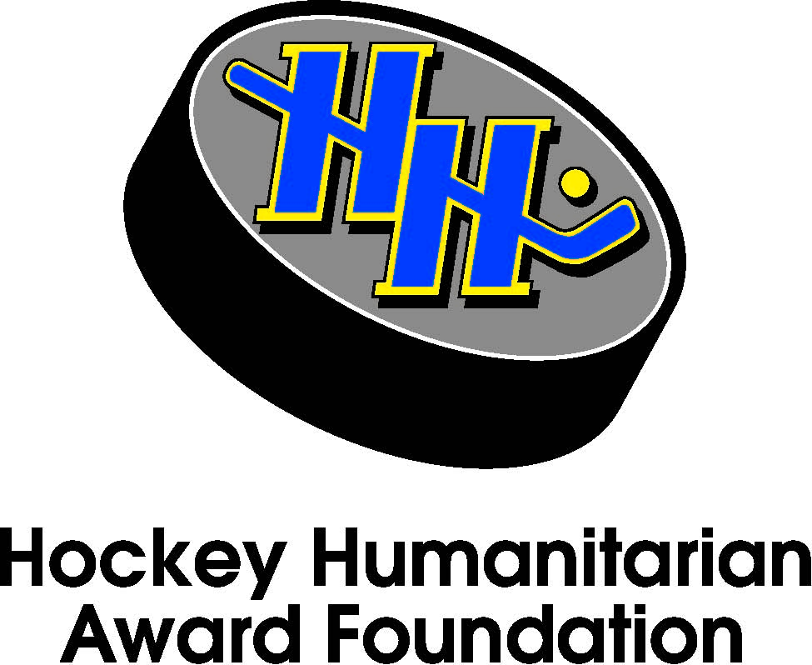

The BNY Mellon Wealth Management Hockey Humanitarian Award
2014 Nominees

The Hockey Humanitarian Award Foundation is pleased to introduce the following student-athletes as this year’s nominees:

Wade Bennett Senior University of Denver
Amanda Colin Senior Quinnipiac University
Nic Dowd Senior St. Cloud State University
Kelsie Fralick Junior Connecticut College
Alyssa Gagliardi Senior Cornell University
Jordan Heywood* Senior Merrimack College
Cole Ikkala Senior Union College
Andy Iles Senior Cornell University
Ashley Johnston Senior Union College
Mark MacMillan Junior University of North Dakota
Brandi Pollock Senior Robert Morris University
Danielle Rancourt Senior University of Vermont
Joe Rogers Senior University of Notre Dame
Jeffrey Reppucci* Senior College of the Holy Cross
Mike Santee Senior Army
Jocelyn Simpson Senior Colgate University
Max Smith Sophomore Concordia College
Kelly Wallace Senior Northeastern University

*Repeat Nominee

Finalists will be announced in February, and the 2014 recipient will be recognized in a ceremony on Friday, April 11th as part of the 2014 NCAA Men’s Frozen Four in Philadelphia, PA.

Thank you to our partners and presenting sponsor, BNY Mellon Wealth Management, for invaluable support in recognizing these collegiate hockey players and their community service.

