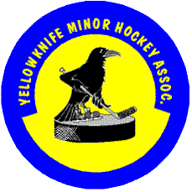

**1. COMMUNICATIONS**

Yellowknife Minor Hockey Association (YKMHA) wishes to inform families that its primary method of communications will be through:

1. Website
2. Governors
3. Coaches

**2. 24 HOUR RULE**

All teams, coaches and parents are expected to support Hockey Canada’s recommended 24 hour rule. Parents (or others) who wish to speak to a team official are required to wait 24 hours following the incident/matter before arranging an agreed upon time to discuss.

**3. RESPECT OF THOSE WHO DO**

Parents are reminded they are to respect and show appreciation for the volunteers who give their time to hockey for your child. YKMHA will not tolerate individuals who do not respect the effort of our vital volunteers or individuals who regularly speak against the efforts of the Association.