Focus On What You Can Control

As an athlete, there is only some many things we can think about and put energy into. Learning to focus on what you can actually control (or do something about), is vital in becoming a successful athlete. The following diagram illustrates what you can control and what you can’t. Successful athletes only put their energy into the items inside the box and let go of the things outside the box. Where does your energy go?

 |  | Opponents |  |  |  | Umpires
 |  | Attitude | 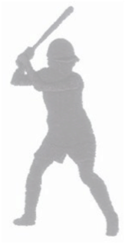 |  |  | Energy Level
Weather |  |  |  |  |  |  |  | Teammates
 |  | Communication |  |  |  | Motivation
 |  | Effort |  |  |  | Positive Thinking
 |  | Sleep |  |  |  | Nutrition
Equipment |  |  |  |  |  |  |  | Playing Time
 |  | Academics |  |  |  | Focus
 |  | Willingness to Learn |  |  | Support of Teammates
 |  | Fans |  |  |  | Field Conditions

