Conner Quiggle #10 Left Wing/Center Mid
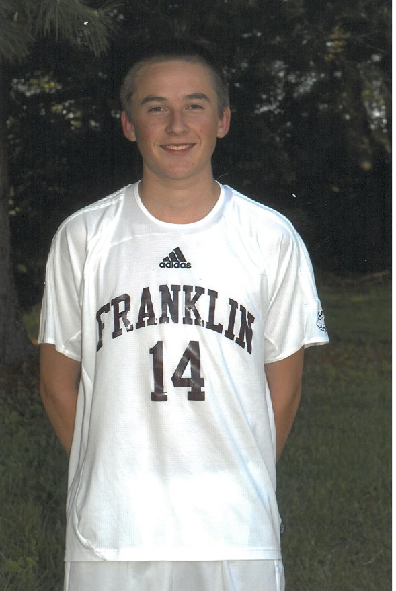
Class of 2013
1072 Moran Road Height: 5’8”
Franklin, Tn. 37069 Weight: 137 Lbs.
Home Phone: (615)373-8593 DOB: 6/19/95
Cell Phone: (615)416-1101
E-mail: connerquiggle@gmail.com

Club Soccer:
2011-2012 95 Brentwood Premier Current Coach: Bryan Johnson bryan.johnson.2@gmail.com (615) 496-6825
- 2011- Division 1 State Champion
2009-2011 95 Brentwood Premier Coach: Sandy Pollock spollo11@comcast.net (615) 579-8063
- 2010- Division 1 State Champions
- 2010- Disney Soccer Showcase Finalist
- 2010- Region III Quarter Finalist
- 2010- Central Premier League Champions
- 2010- Atlanta Cup Champions (Cup Division)
- 2009- Division 1 State Champions
2008-2009 95 Brentwood Select Coach: Ajit Korgaokar ajit18@comcast.net (615) 429-5329
- 2008- Division 1 State Finalist
- 2008- Disney Showcase Semi-Finalist
2005-2008 TNFC Blue 95 Coach: Sandy Pollock spollo11@comcast.net (615) 579-8063
- 2006- Division 1 State Champions
ODP Soccer:
2007-2012 Tennessee State ODP Team Current Coaches: Richie Grant (Memphis HC) RJgrant@mephis.edu
Paul Conway montrose36@gmail.com
- 2012 – Made the current Region III Pool
- 2012- Played in ODP Nationals (Frisco , Texas)
- 2011- Region III ODP Champions
- 2008- Made Region III Pool
- 2007- Played Up One Year on 94 Team
High School Soccer:
2010-2012 Franklin High School Varsity Starter Coach: Steve Parker stevep1@wcs.edu (615) 796-0245
(Coach Parker a Former D1 Head Coach at Akron)
- 2012 Season ( 5- goals, 8 assists ) 16 Games
Academics:
Franklin High School, Franklin, Tn.
- GPA 3.73 (Honors Courses)
- National Youth Leaders Conference
Extracurricular:
- 2008 US Club Soccer ID2 Development Program
- Christ Church Cathedral Youth Group
- Summer Youth Group Mission Trips
- Golf
- Licensed Referee
- Traveled to England with BWSC. Played Fulham, Tottenham, Southhampton and Bournmouth.
- Camping/Outdoors

