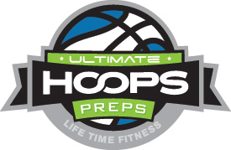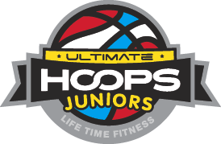

BASKETBALL TRAINING AT LIFE TIME FITNESS COMBINES SKILL DEVELOPMENT, COMPETITION AND FUN FOR ALL AGES.

Ultimate Hoops Preps gives your son or daughter an opportunity to train with world-class basketball trainers using Life Time Fitness’s state of the art facilities.

Lakeville Trainer Contact: Lorenzo Orr (651)368-2070 or LOrr@lifetimefitness.com
Please like us on Facebook @

http://www.facebook.com/lorenzo.orr.5?ref=tn_tnmn

Pee-Wee Ballers – Ages 6-7
DAY | TIME | MONTHLY FEE
Wednesday | 4:00-5:00 PM | $35

UH Basketball Class 101 – Ages 8-9
DAY | TIME | MONTHLY FEE
Wednesday/Thursday | 5:00-6:00 PM | $50

UH Basketball Class 102 – Ages 10-11
DAY | TIME | MONTHLY FEE
Wednesday/Thursday | 6:00-7:00 PM | $50

UH Basketball Class 201 – Ages 12-13
DAY | TIME | MONTHLY FEE
Friday | 6:00-7:00 PM | $60

UH Basketball Class 202 – Ages 14-17
DAY | TIME | MONTHLY FEE
Friday | 7:00-8:00 PM | $60

Group/Private Training
DAY | TIME | MONTHLY FEE
Tuesday/Friday/Saturday | By appointment only | 1 Session $70,4 sessions $240,10 session $500

Private Training (1:1 Ratio)
Athletes of all age groups will work with a basketball trainer in a one on one skill development session. Sessions are available by appointment only. Inquire about pricing and times. *Any player that is currently enrolled in private training basketball classes can participate in a weekly basketball class free of charge. All players should check the schedule for the appropriate class time.*

Ultimate Basketball Class (Ages 3-17)
Athletes of all age groups will work with a basketball trainer in a skill development session.

Lakeville Trainer Bio – Lorenzo Orr

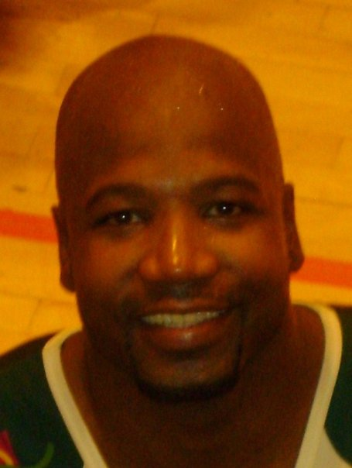

Lorenzo Orr brings 16 years of proven success playing, coaching and promoting Basketball to UH Preps. His unique blend of basketball experience compiled from playing at the top collegiate and professional levels around the globe translates to on court results for his pupils.

- Collegiate career at University of Southern California, earning All-Pac-10 honors.
- He earned League honors stateside in the IBA and overseas in Macedonia (FYA), France (N1), Switzerland (LNA), Portugal (TMN) and also made stops in Iceland and Lebanon.
- He has been training youth since his professional career ended in 2011.

What others are saying about Lorenzo:

“My son already trains with Lorenzo for hoops and by the way Lorenzo is awesome, the Lakeville South head coach couldn't believe the strides my kid has made in the gym, give Lorenzo props.”
“We are so blessed to have that kind of talent at our finger tips.”

“Lorenzo you made the difference. He made 4-5 free throws, which definitely set him apart from other kids (legs, arc & straight baby)!”

“The improvement in (my son’s) shot has been nothing short of amazing.”

“You have a great gift in teaching kids basketball skills.”

