ORONO STP
The Orono Summer Training Program is available for any Orono hockey player who will be a PeeWee, Bantam, or High School hockey player for the 2010 - 2011 hockey season.

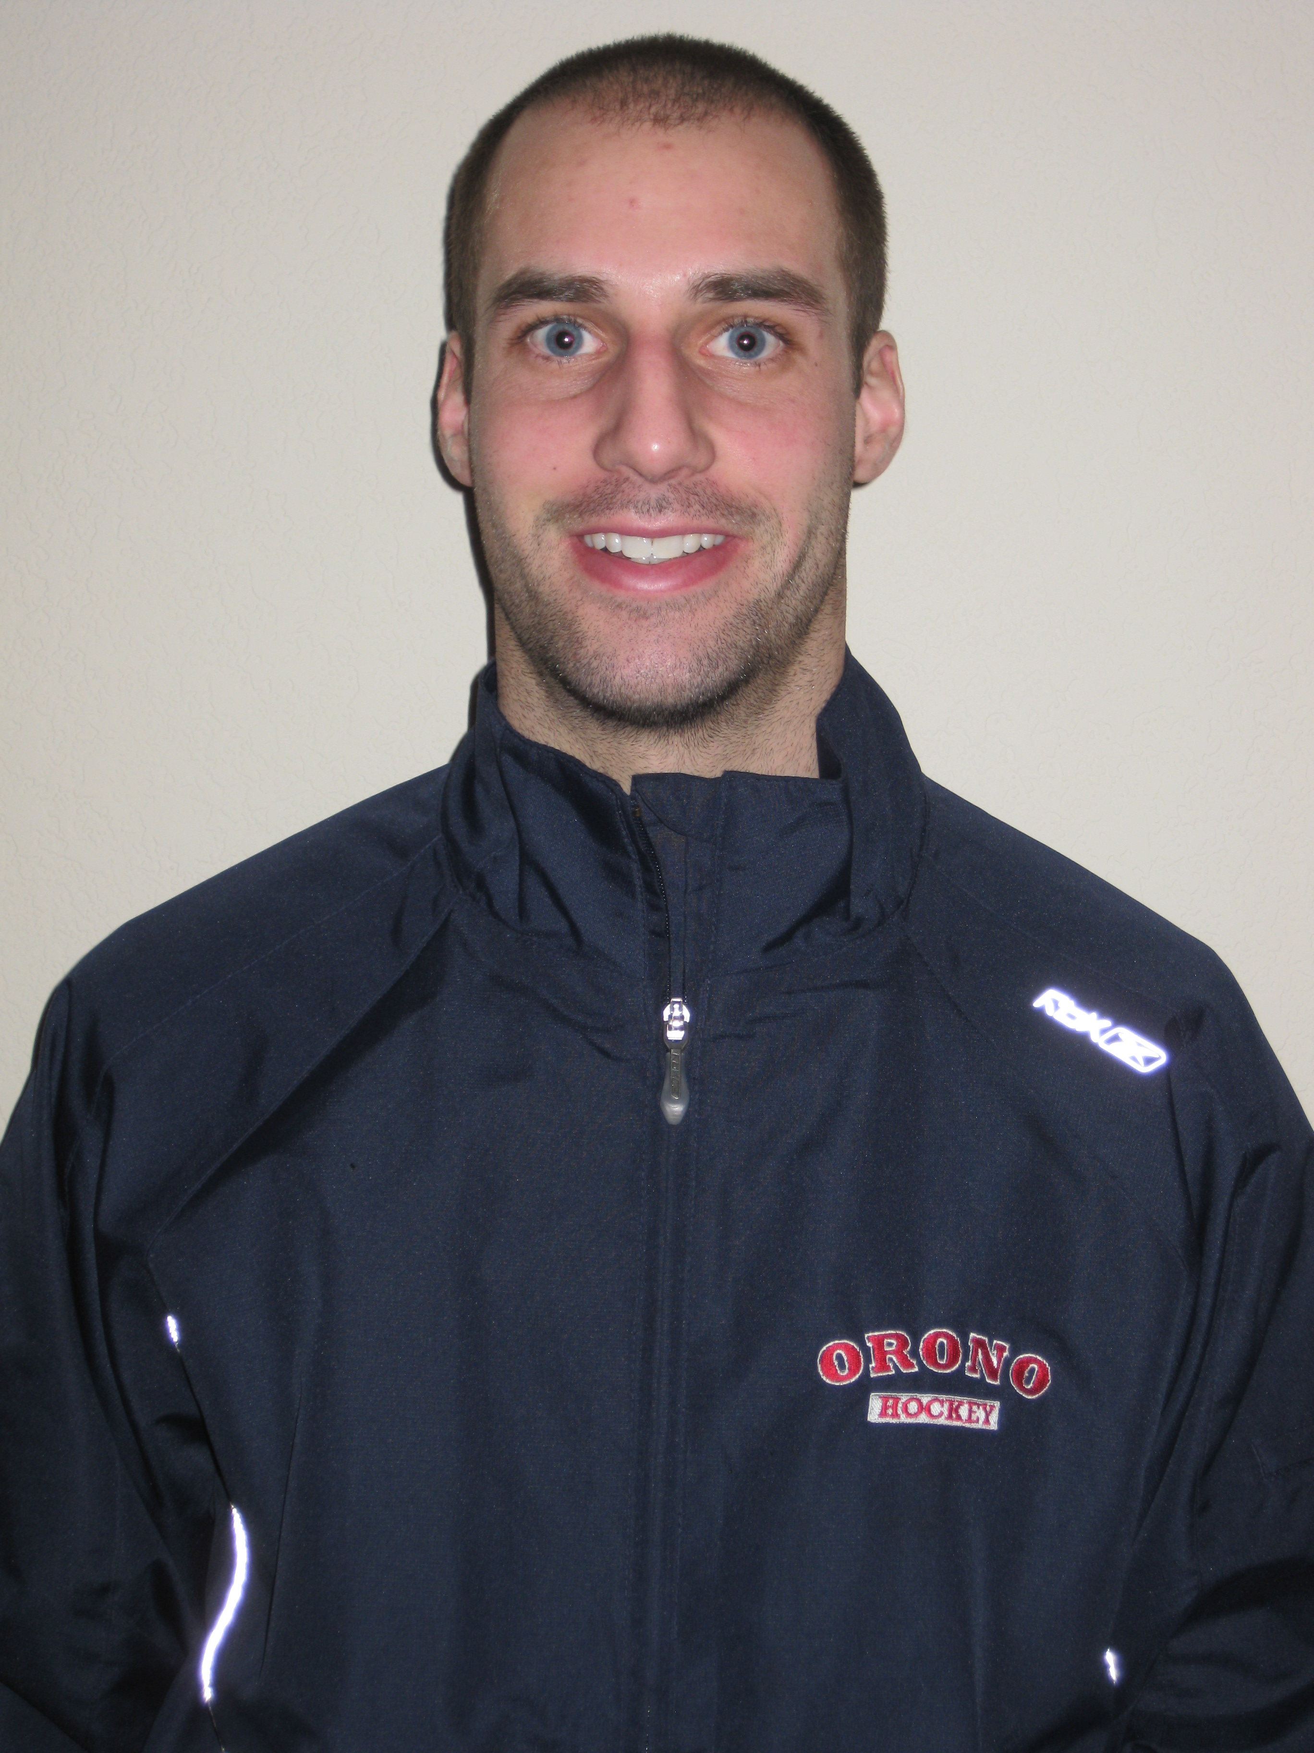

Orono Hockey

Fill out attached Registration Form
and mail to:
Orono Summer Training Program
3334 Xylon Ave. N.
New Hope, MN 55427

For questions or further information
email Coach Johnson
johnson.aaron9@gmail.com

Orono STP believes that the best way to maintain a top flight Youth and High School Program is through community based hockey and the development of individual skills that will benefit a team game.

ORONO HOCKEY
STP

ORONO HOCKEY STP

summer training program 2011

Orono Boys Hockey

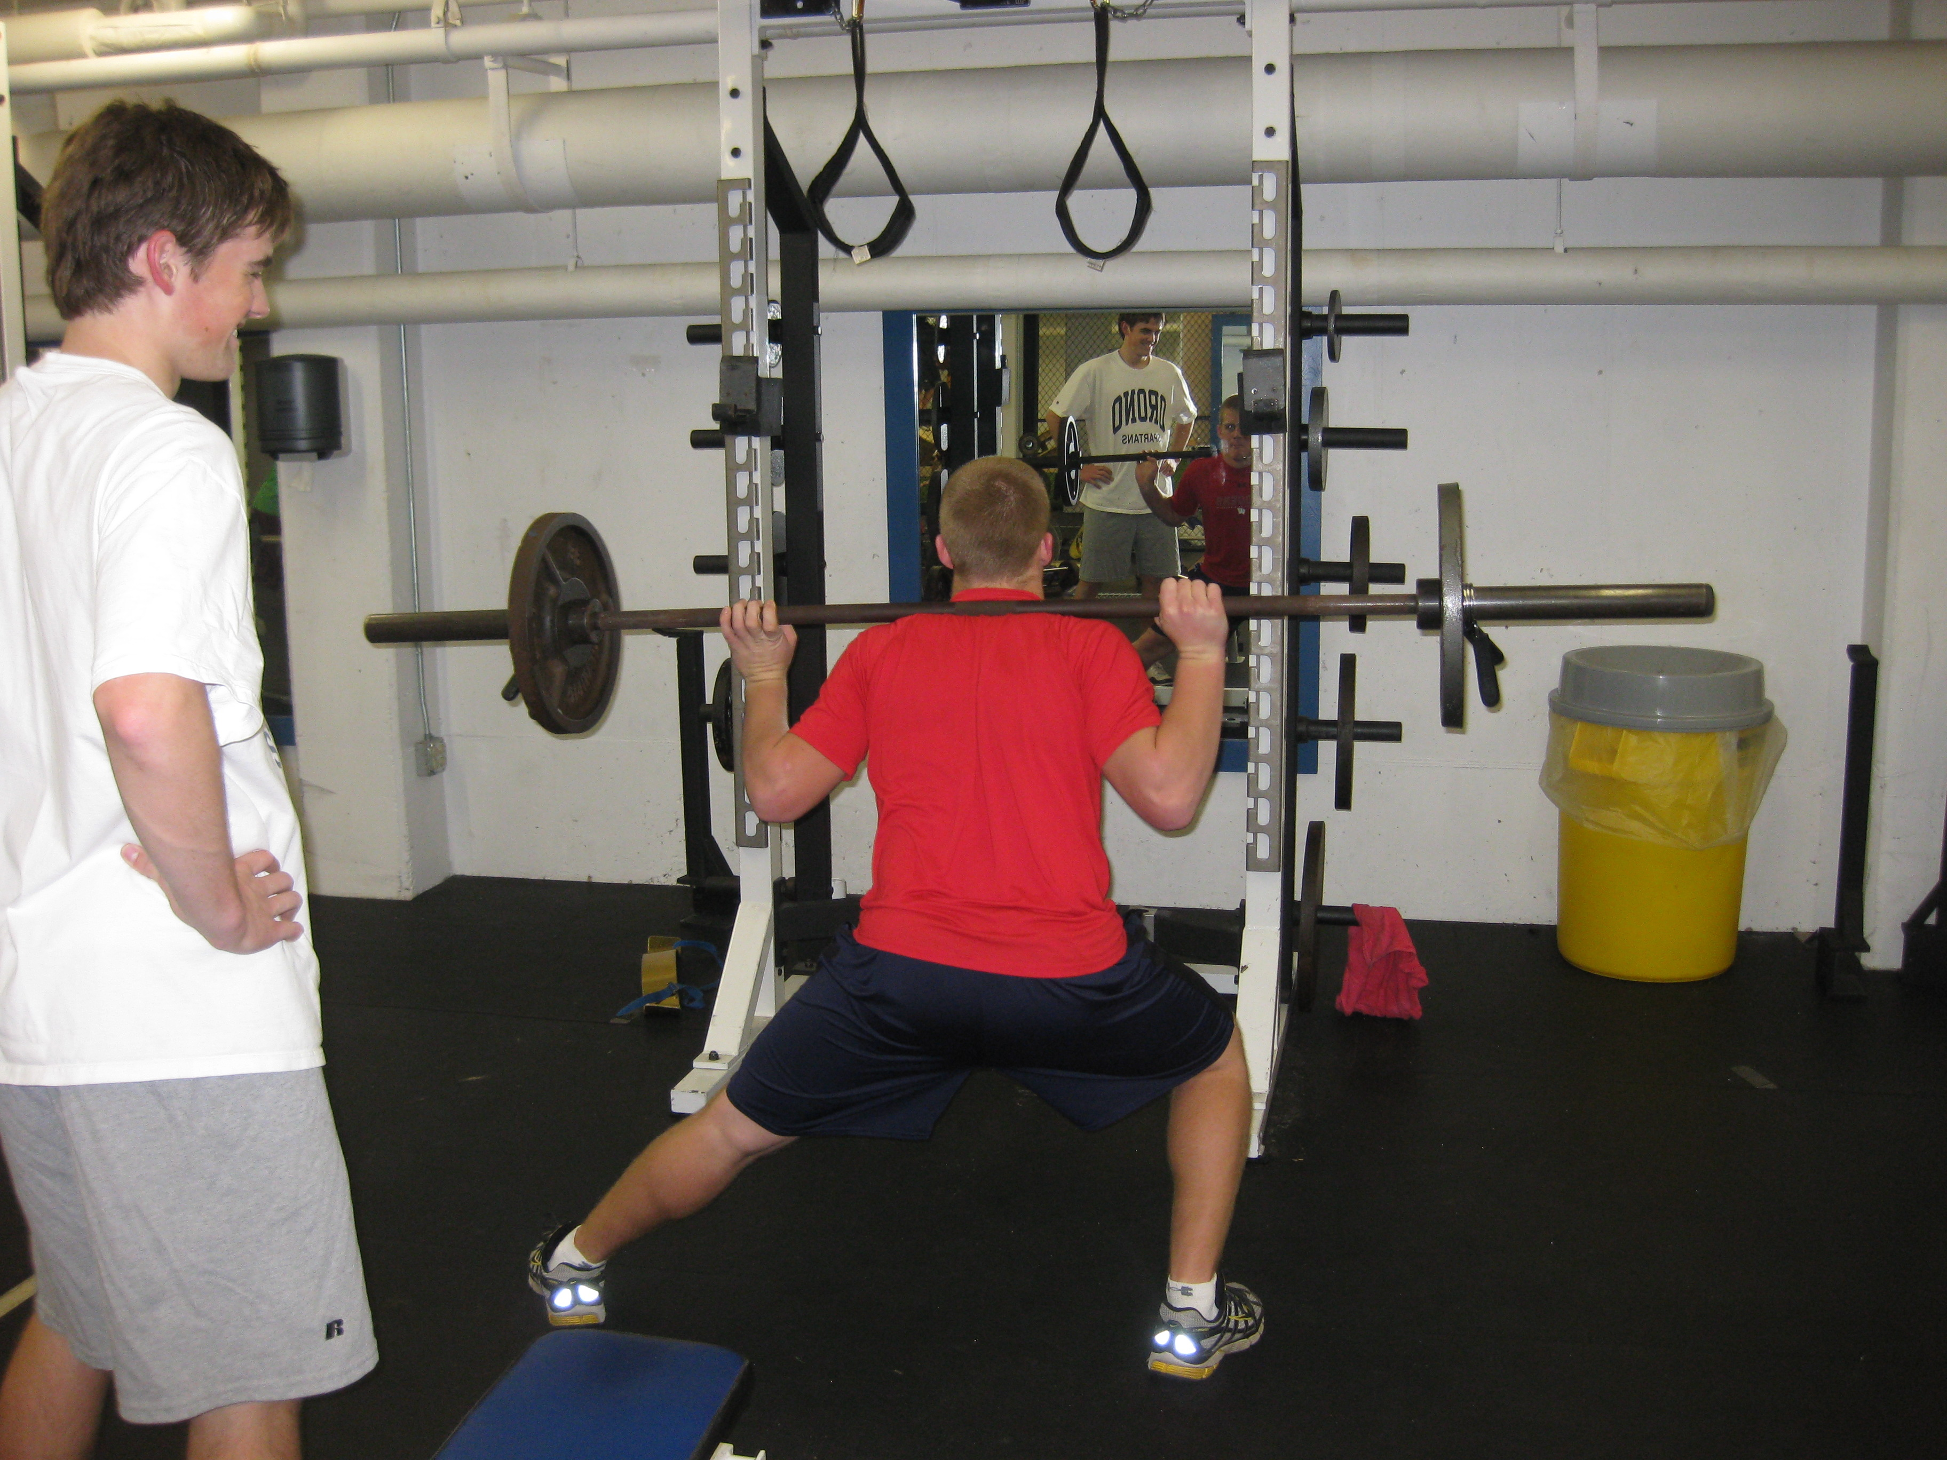

STAFF

Aaron Johnson Head Coach
Mitch Ryan Assistant Coach
Thomas Johnson Assistant Coach
Justin Loechner Goalie Coach
Former High School Hockey Players
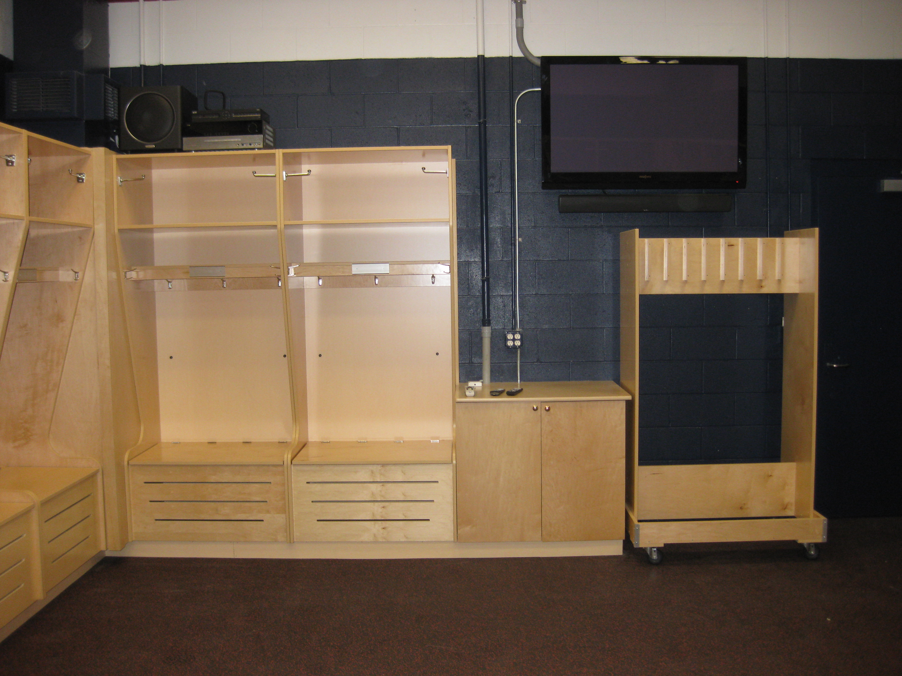

Sign-up Form
Player Name

2010-2011 Team

Position

2011 STP (please circle one)
PeeWee $475

Bantam $475

High School $475

*Checks Payable to Orono STP
*Registration Deadline May 15th / ^{Late Payment Fee $485}
*A flat pro-rate is available only if discussed with coach Johnson prior to registration

Home Address

Phone Number

Parent email

Player email_______________________________

T-shirt & Shorts Size

Parent Signature

Please complete and detach this portion of the pamphlet and mail with check.
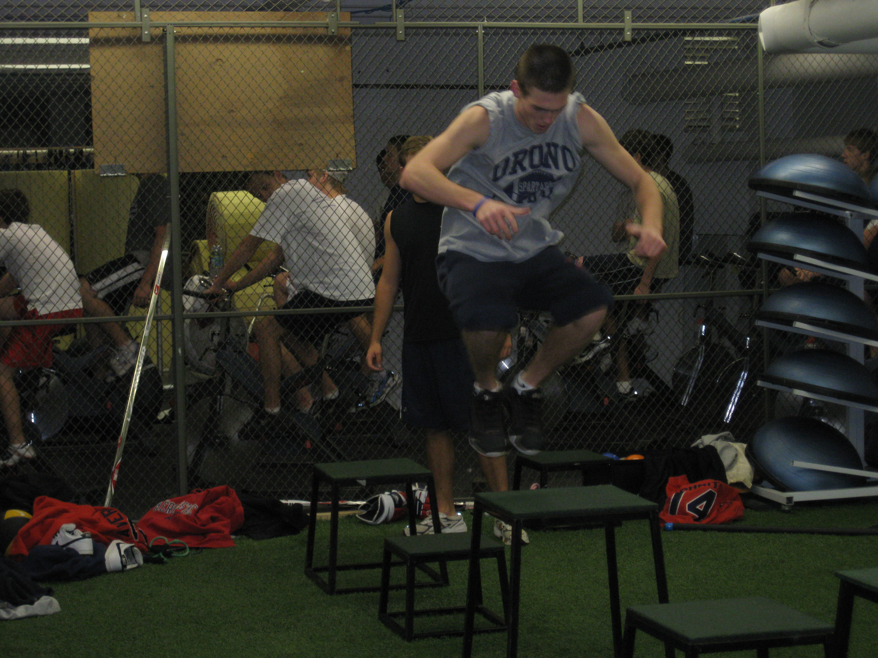

STP SCHEDULE
Orono STP Schedule

High School
8:30am-9:45am On Ice Training
10:00am-11:00am Off Ice Training

Bantam
10:00am-11:15am On Ice Training
8:45am-9:45am Off Ice Training

PeeWee
11:30am-12:45pm On Ice Training
10:00am-11:00am Off Ice Training

DATES:
June: 14th – June 30th
July: 12th – 28th
Tuesdays, Wednesdays, Thursdays

Off-Ice training will focus on hockey-specific lifting, plyometrics, core, and dry-land training. The dry-land training will include shooting and stick-handling and will also include other athletic activities (soccer, running, football, etc.) for the PeeWee group

ORONO HOCKEY STP 2010
The Orono Summer Training Program consists of on-ice and off-ice training to improve individual skills while implementing team skills that are used by the Orono High School Hockey Program. On-ice skills will include over-speed skating, shooting, and passing set in high tempo drills. Other skills developed include drills to increase on ice vision and hockey sense in small area drills and games including offensive creativity while using puck protection, creating time and space, and 1on1 skills. Defense skills will focus on angling, gap control, odd man rushes and proper checking technique to separate man from puck.

